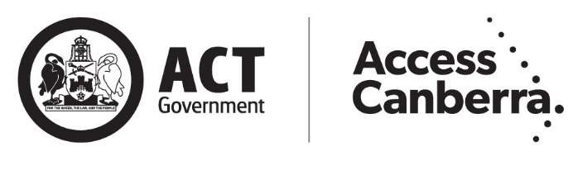
ACT Parking Infringements Guide

Disclaimer
While everything practicable has been done to ensure the accuracy of information in this guide, no liability is accepted for any loss or damage whatsoever attributable to reliance upon any of that information. Nothing in this guide should be taken to displace the need to seek professional advice.

Accessibility
The ACT Government is committed to making its information, services, events and venues as accessible as possible.
If you have difficulty reading a standard printed document and would like to receive this publication in an alternative format, such as large print, please phone 13 22 81 or email communicationsandengagement@act.gov.au
If English is not your first language and you require a translating and interpreting service, please phone 13 14 50.
If you are deaf, or have a speech or hearing impairment, and need the teletypewriter service, please phone 13 36 77 and ask for 13 22 81. For speak and listen users, please phone 1300 555 727 and ask for 13 22 81. For more information on these services visit www.relayservice.gov.au
© Australian Capital Territory, Canberra 2021
This work is copyright. Apart from any use as permitted under the Copyright Act 1968, no part may be reproduced by any process without written permission from the Territory Records Office.
GPO Box 158, Canberra City ACT 2601.
Produced by Access Canberra, Chief Minister, Treasury and Economic Development Directorate.
www.act.gov.au
Telephone: Access Canberra 13 22 81
This publication can be viewed or printed from the Access Canberra website at www.act.gov.au/accessCBR
Enquiries about this publication should be directed to:
Access Canberra - on 13 22 81

Contents
Introduction 1
Australian and ACT Road Rules 1
Objectives of Parking Regulation in the ACT 1
Powers Held by Parking Officers 2
Common Mistakes Leading to Parking Fines 2
The Parking Infringement Notice (PIN) Process 3
The Review Process 3
General Exemptions to Enforcement of Parking Rules 4
Overview of Compliance Monitoring 5
Compliance Model 6
Proactive Monitoring 6
Reactive Monitoring 6
Overview of Major Parking Offences 9
PINcode 301 Disobeying a no stopping sign 10
PINcode 302 Disobeying a no parking sign 11
PINcodes 304, 305, 306 Stopping on or near an intersection 12
PINcode 307 Stopping on/near a children’s crossing 13
PINcode 308 Stopping on/near a pedestrian crossing 14
PINcodes 314, 315, 316, 398 Loading zone offences 15
PINcode 319 Stopping in a taxi zone 16
PINcodes 320, 321, 335 Bus zone offences 17
PINcode 329 Double parking 18
PINcode 336 Stopping on a path/strip in a built-up area 19
PINcode 337 Stopping on or across a driveway or other access to or from land 20
PINcode 342 Disobey motorbike parking sign 21
PINcode 343 Stopping in parking area for disabled 22
PINcode 344 Parking continuously for longer than permitted 23
PINcodes 345, 411 Not parallel parking in the direction of travel 24
PINcode 349 Parallel parking close to dividing line/strip 25
PINcode 351 Parking so as to obstruct vehicles/pedestrians 26
PINcodes 361, 362, 370 Parking outside of marked parking bays 27
PINcode 371 Parking without displaying a valid ticket 28
PINcode 372 Parking after a meter or ticket has expired 29
PINcodes 377, 378 Displaying a false or altered ticket 30
PINcodes 387, 388, 389, 390, 391, 392, 393, 394, 395 Stopping in a permit zone without a valid permit 31
PINcode 410 Stopping on a painted island 32
PINcodes 427, 428 Removing, interfering or copying a parking permit 33
Useful Contacts 34

Introduction
This document is provided to assist drivers to understand their obligations under the Road Transport (Road Rules) Regulation 2017 in relation to parking and how parking is regulated in the Territory.
The information provided under the specific headings is provided in good faith and is intended as guidance only. You are encouraged to consult the relevant provisions of the Road Transport (Road Rules) Regulation 2017 and the Road Transport laws (referenced in each section) as it is these provisions that govern whether, in a given circumstance, an offence has been committed. For penalty amounts payable for offences, please see http://www.legislation.act.gov.au/sl/2005-11/default.asp
This publication is current as of 23 April 2021.

Australian and ACT Road Rules
The Road Transport (Road Rules) Regulation 2017 provide rules for all road users in the ACT that are substantially uniform with rules for road users elsewhere in Australia.
Parking Operations in Access Canberra is responsible for regulating parking in the ACT. A separate unit, the Infringement Team, processes and adjudicates disputes against infringement notices issued by Parking Operations.

Objectives of Parking Regulation in the ACT
There are three main objectives that are central to underpinning how Parking Operations conducts its compliance activities: safety, public and business amenity, and government.
Safety – many instances of non-compliant parking activity pose significant safety risks to the community. It is largely for safety reasons that parking is prohibited in certain areas under the Road Transport (Road Rules) Regulation 2017. Unsafe parking can pose risks to pedestrians trying to cross roads and also to motorists who can face dangers such as impaired line of sight and unexpected hazards.
Public and business amenity – it is important that parking regulations are enforced to ensure public and business amenity. This means disability parking is reserved for people with a disability, loading zones are kept free for deliveries for businesses, short-term parking spaces provide for a turnover of customers for businesses, and residents have unobstructed access to and from their homes.
Government – the provision of paid parking by the ACT Government is on a user-pays basis. The ACT Government seeks to ensure equitable allocation of space and provides incentives for ACT residents to use alternative forms of transportation.
These objectives are not necessarily mutually exclusive. For instance, motorists parking in an unsafe manner often do so to avoid paying for parking. Unsafe parking such as parking across driveways also restricts residents’ access to homes. Motorists failing to pay for parking can mean other motorists and businesses are disadvantaged because patrons’ access to their businesses is restricted.

Powers Held by Parking Officers
Parking Officers are authorised under section 19 of the Road Transport (General) Act 1999 (the Act). Under sections 24 of the Act, Parking Officers are authorised to issue infringement notices for parking-related offences identified in the road transport law. They also have the power to mark vehicles’ tyres under section 68 of the Road Transport (Safety and Traffic Management) Regulation 2017 (e.g. with chalk) for the purpose of enforcing parking regulations.
A Parking Officer cannot, while on patrol, withdraw an infringement notice after it has been printed. Parking Officers must always carry photographic identification cards while they are carrying out their duties.

Common Mistakes Leading to Parking Fines
There are certain mistakes that can lead to members of the public unwittingly parking illegally and receiving a Parking Infringement Notice (PIN). The codes listed on a PIN are used as an offence identifier. These include:

Not taking adequate notice of parking signs
It is every motorist’s responsibility to check the signs where they are parking to ensure they are not doing so illegally. Signs will generally be in place on upright poles or on walls adjacent to the relevant area. Parking restrictions apply 24 hours, seven days a week, unless otherwise indicated by signage.

Failing to check that a parking ticket or permit is displayed properly
Parking tickets and permits must be clearly displayed on a vehicle’s dashboard without being obscured. If a ticket or permit is not fully visible, a Parking Officer may issue an infringement notice.

Underestimating the time required for meetings and appointments
When parking in a time limited area (regardless of whether payment is required or not) it is the responsibility of the motorist to allow enough time to do what he or she needs to do. Don’t underestimate the time and if you are in a pay parking area, ensure you pay for slightly longer than you may need.

Not being aware of who may and may not use a loading zone
Only certain vehicles may use loading zones without displaying a permit – it is the responsibility of a motorist using a loading zone to ensure his or her vehicle is permitted to do so.

Not having adequate funds to pay for the amount of parking time required
It is every motorist’s responsibility to ensure he or she has sufficient funds to pay for the amount of parking time required. Many pay and display parking machines now accept payment by credit cards in addition to coins and smartphone application.

Believing that parking illegally is okay if there are no legal parking spaces available
It is a motorist’s responsibility to find a legal parking space.

The Parking Infringement Notice (PIN) Process
If you don’t pay your Parking Infringement Notice (PIN) on time, additional fees may apply and further action may be taken against you.
You have 28 days to pay your PIN from the day the infringement was issued. If you don't pay within 28 days, a Reminder Notice will be served on the registered operator of the vehicle and an administration charge added to the original PIN penalty amount.
If you still don’t pay, your licence, registration or right to drive in the ACT will be suspended. You will have to pay your fine and the administration charge before any suspensions against you will be lifted.

How to keep on the right side of the law
You should park according to the rules to avoid getting a PIN.
If you do get a PIN, pay it within 28 days to avoid the extra administration charge. Payments do require a few days for processing, so allow enough time for the payment to be received by the due date. Late payments will attract the extra administration charge. Payments can be made directly on the Access Canberra website at https://www.accesscanberra.act.gov.au/s/article/traffic-and-parking-infringements-tab-overview. If you do have to pay the extra administration charge, pay it (and the PIN too, if that isn’t already paid) within 28 days.
If you have outstanding PINS that you are having difficulties paying, you can apply to go on an Infringement Notice Management Plan (INMP). An INMP allows you to pay your outstanding PINS in regular instalments. Visit http://www.act.gov.au/accessCBR for more information.
If you drive a vehicle with a suspended registration or drive while your driver licence or right to drive in the ACT is suspended, you are committing a serious traffic offence.

The Review Process
Anyone who received a PIN is entitled to seek a review. All enquiries must be made in writing and should be directed to the Infringement Office in Access Canberra. All relevant information can be found at www.act.gov.au/infringements or an Access Canberra Shopfront.
You can seek a review if:
- You believe that the alleged offence did not actually occur
- The PIN was incorrectly issued (e.g. information about the vehicle is incorrect, the description of the alleged offence is incorrect)
- The PIN should not have been issued due to a parking sign being damaged or missing, or a pay and display parking machine or pay and display parking machine malfunctioning
- Illegal parking could not be avoided due to a vehicle breakdown or an emergency situation
- In particular circumstances, you can demonstrate that you have a good parking record.

What if I was not the person responsible for the offence?
If the person in whose name a vehicle is registered was not the driver of the vehicle at the time of an offence, he or she should submit a declaration to the Infringement Office outlining the circumstances. This can include the following situations:
- ‘Known user declaration’ when the responsible person is known
- ‘Sold vehicle declaration’ when the vehicle had previously been sold
- ‘Illegal user vehicle declaration’ when the car was stolen or otherwise illegally used
- ‘Unknown user declaration’ when the responsible person is unknown.

What kind of evidence will I be asked for if I had to park illegally due to a breakdown or an emergency situation?
Illegal parking does occasionally occur due to unavoidable situations. If a PIN has been issued in these circumstances it is reasonable that it should be withdrawn. However, for this to occur appropriate evidence must be presented with the appeal application.
Example situations | Evidence required
Medical emergency | Documentation from a medical practitioner or hospital
Vehicle break down | A completed Statutory Declaration, a towing receipt and/or proof of  repairs (e.g. receipts/invoices, NRMA callout documentation, etc)
Stolen vehicle | Reference number of corresponding Police report
Motorist detained by the Police | Documentation from the Police
A complete list of evidence can be found in the Road Transport (General) Withdrawal of Infringement Notices Guidelines 2019 (No 1) (www.legislation.act.gov.au/di/2019-211/).

What constitutes a good parking record?
For a motorist to be deemed to have a good parking record, he or she must not have recorded a PIN in the previous 5 year period. You must also have held an Australian driver licence for longer than 5 years. This is not automatic grounds for withdrawal. The Infringement Office will also consider the:
- Seriousness of the offence, including the level of risk it posed to other road users
- Extent to which the applicant reasonably ought to have been aware that his or her conduct was contrary to law.
The following offences will not be withdrawn, even if the applicant can demonstrate that he or she has a good parking record:
- Mobility Scheme Parking permit related offences
- Stopping in, or near an intersection, children’s crossing or pedestrian crossing
- Disobeying a ‘No Stopping’ sign.

Reference
Liability for this offence is defined by the following provisions, which take precedence over the guidance provided above:
- Road Transport (General) Withdrawal of Infringement Notices Guidelines 2019 (No 1).

General Exemptions to Enforcement of Parking Rules
There are certain general exemptions to the enforcement of parking rules. These exemptions prevent a motorist from being issued an infringement notice or, if an infringement notice has been issued, it should be withdrawn upon a satisfactory application to do so being received.
Exemptions include:
- Emergency services vehicles being used in the course of official duties
- Any motorist acting in accordance with directions from an authorised person (e.g. a Police Officer)
- Incorrect or missing signage
- Traffic control devices which allow a vehicle to park in an area despite a rule existing to the contrary (e.g. within the restricted area around a crossing or an intersection when signs are in place that allow parking there)
- When an approved Temporary Traffic Management (TTM) Plan is in force. These are generally provided for ongoing construction work that requires special access and parking arrangements.

Overview of Compliance Monitoring

Compliance Model

Engage, Educate, Enforce
The approach of Access Canberra is to engage, educate and then enforce.
Engaging with the public to ensure a positive working relationship exists.
Educating the public on compliance with the road rules by taking reasonable steps to ensure people know how to comply (e.g. through clear signage in parking areas, warnings ahead of major sporting fixtures or changes to parking conditions).
Enforcing by taking action when non-compliance occurs (e.g. issue warnings or Parking Infringement Notices (PINs)).

Approach to enforcement
Parking Operations has a risk-based compliance model. This means that resource allocation and enforcement responses are determined based on priorities determined through risk assessment. Parking Operations carries out two types of monitoring activities: reactive and proactive. Both types of monitoring are risk-based.

Proactive Monitoring
Most of the monitoring undertaken by Parking Operations is proactive. Proactive patrols are conducted at varying levels of intensity in different areas of the ACT depending on the level of risk to ensuring safety, public and business amenity, and government.

Reactive Monitoring
Reactive monitoring is conducted as a result of members of the public, businesses, or government agencies contacting Parking Operations and reporting non-compliant behaviour. Calls are received by Parking Operations and are given a priority based on the assessed level of risk. The supervisor on duty will delegate the complaint to an appropriate team or Parking Officer.
Parking Operations seeks to respond to every notification of illegal parking received. However, not every complaint can be responded to immediately, therefore responses are determined on the risk posed (classified as high, medium or low).
The following table describes what is covered by each risk level and provides some examples.

Risk Level | Safety | Public and Business Amenity | Government
3 – High | The reported behaviour poses a potential risk of serious injury or death | Parking that completely and unreasonably obstructs access to a residential or business premises or is in a high priority restricted zone | Behaviour that places severe restrictions on the operation of paid car parks
3 – High | Examples:  - A large vehicle illegally parked close to an intersection, obstructing motorists’ view of oncoming traffic  - Parking within the restricted area around a school crossing  - Blocking access for emergency services vehicles | Examples:  - Parking in a bus zone  - Parking across a driveway restricting access to/from a residence or business  - Parking without a permit in a mobility zone excluding access to parking for legitimate users | Examples:  - Vandalism of pay and display parking machines  - Use or production of fraudulent parking tickets or permits
2 – Medium | Physical harm could conceivably result from the parking behaviour | Partial obstruction of access to a residential or business premises | Deliberate and consistent efforts to undermine the paid parking system
2 – Medium | Examples:  - Parking on a nature strip blocking motorists’ line of sight  - Vehicles parking on footpaths in areas with pedestrian traffic  - Parking outside of bays in an off road parking area | Examples:  - Parking partially across a driveway  - Parking in a loading zone without a permit  - Overstaying time limits in a high demand area | Examples:  - Co-ordinated fee avoidance
1 - Low | Parking that is illegal but poses little risk to safety | Parking that is illegal but does not physically obstruct public and business amenity | Parking that is illegal but does not constitute widespread or co-ordinated payment evasion
1 - Low | Examples:  - Motorists parking on the nature strip but vehicle not blocking line of sight and not damaging street trees | Examples:  - Overstaying time limits where there is ample available parking | Examples:  - Parking without a valid ticket/permit

Below are Parking Operations’ timeframes for responding to complaints. These timeframes are a guide only and may be affected by unforeseen circumstances. The problem may also require long term enforcement action in order to be resolved or require special planning.
Risk Level | Response Timeframes
High | Immediate – if no Parking Operations resources are available, the Police may be called
Medium | Within 2 business days
Low | Within 5 business days

Overview of Major Parking Offences

PINcode 301 | Disobeying a no stopping sign

A motorist must not stop his or her vehicle in an area to which a ‘No Stopping’ sign applies.
Why do we have this rule?
Areas are designated as ‘No Stopping’ because vehicles stopping there may impede the safe flow of traffic and/or create line of sight issues for pedestrians and motorists.

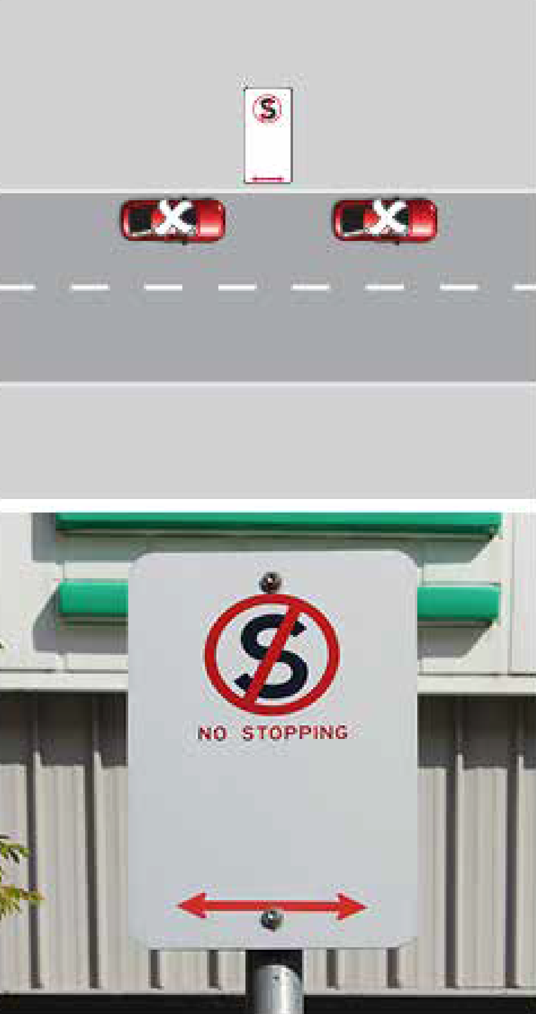
This is a serious offence and, as a result, there is no possibility of having a PIN for this offence withdrawn on the grounds of previous good driving record.
References
Liability for this offence is defined by the following provisions, which take precedence over the guidance provided above:
- Road Transport (Road Rules) Regulation 2017 Section 167
- Road Transport (Offences) Regulation 2005 Schedule 1 Part 1.12A Item 223
- Road Transport (General) Withdrawal of Infringement Notices Guidelines 2019 (No 1)

PINcode 302 | Disobeying a no parking sign

Stopping in a ‘No Parking’ zone is only permitted for picking up or dropping off passengers and/or goods. A motorist must not leave a vehicle unattended in a ‘No Parking’ zone and can remain there for a maximum of two minutes (unless otherwise indicated). Leaving a vehicle unattended means being three metres or more away from it.
Why do we have this rule?
No parking zones are established for a number of reasons. They can be put in place to maintain the safe flow of traffic, including at certain times of the day, provide high turnover ‘pick up, set down’ places for retail areas and prevent motorists from causing congestion on suburban streets, especially in areas surrounding town centres.

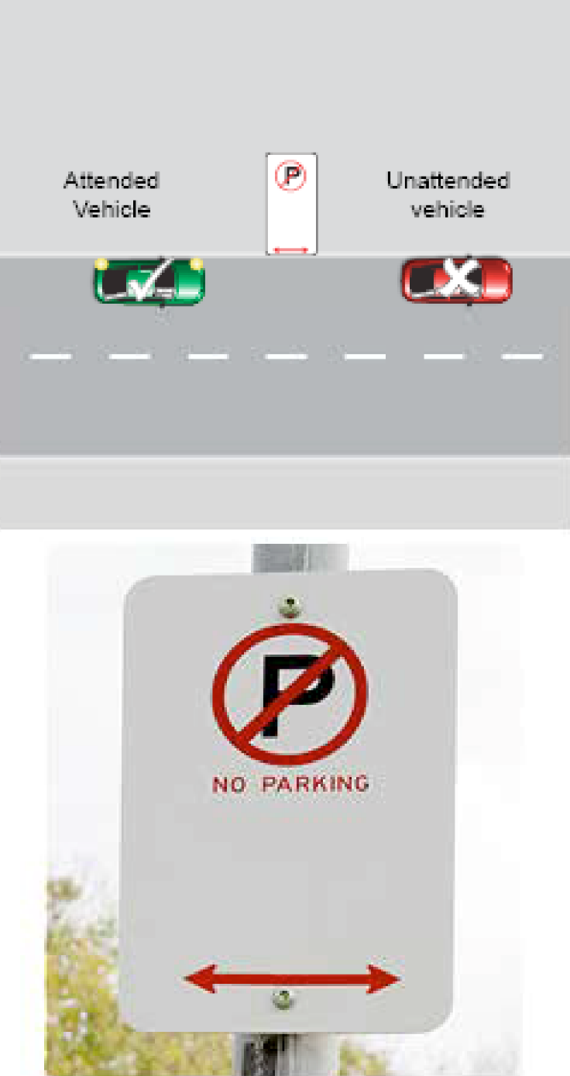
Specific exemptions
- The Road Transport (Road Rules) Regulation 2017 section 168(3)(c) allows a motorist displaying a mobility permit to stop for up to 5 minutes in a no parking zone if there is no indicated time restriction or if the time restriction is less than 5 minutes. Provided the driver stays within three meters of the vehicle.
References
Liability for this offence is defined by the following provisions, which take precedence over the guidance provided above:
- Road Transport (Road Rules) Regulation 2017 section 168
- Road Transport (Offences) Regulation 2005 Schedule 1 Part 1.12A Item 224

PINcodes 304, 305, 306 | Stopping on or near an intersection

A motorist must not stop in an intersection, or within a certain exclusionary zone, around the intersection unless he or she is acting in accordance with traffic control signs. The exclusionary zone around an intersection with traffic lights is 20 metres and around an intersection without traffic lights is 10 metres.
Why do we have this rule?
A high proportion of traffic accidents occur at intersections. If cars are parked on, or too close to an intersection, the risk of an accident occurring is heightened even further due to obstructions to line of sight and the creation of additional hazards.

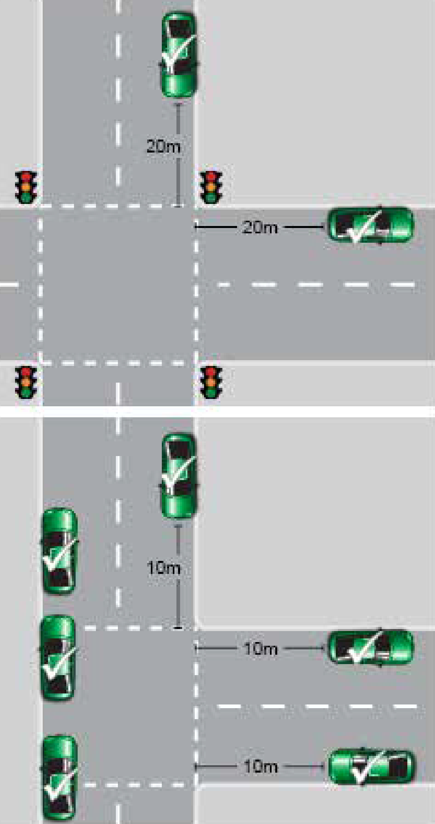
This is a serious offence and, as a result, there is no possibility of having a PIN for this offence withdrawn on the grounds of previous good driving record.
Specific exemptions
At a T-intersection, parking is permitted along the continuous side of the continuing road at the intersection (as shown)
References
Liability for this offence is defined by the following provisions, which take precedence over the guidance provided above:
- Road Transport (Road Rules) Regulation 2017 section 170
- Road Transport (Offences) Regulation 2005 Schedule 1 Part 1.12A Items 226, 227, 228
- Road Transport (General) Withdrawal of Infringement Notices Guidelines 2019 (No 1)

PINcode 307 | Stopping on/near a children’s crossing

A motorist must not stop on a children’s crossing, or on the road anywhere within 20 metres before the crossing and 10 metres after the crossing.
Why do we have this rule?
This rule is in place to protect the safety of children using a children’s crossing. Vehicles in breach of this rule can obstruct the line of sight of other motorists, increasing the probability that they will not see pedestrians entering the crossing. This significantly increases the risk of a serious, even fatal, collision.

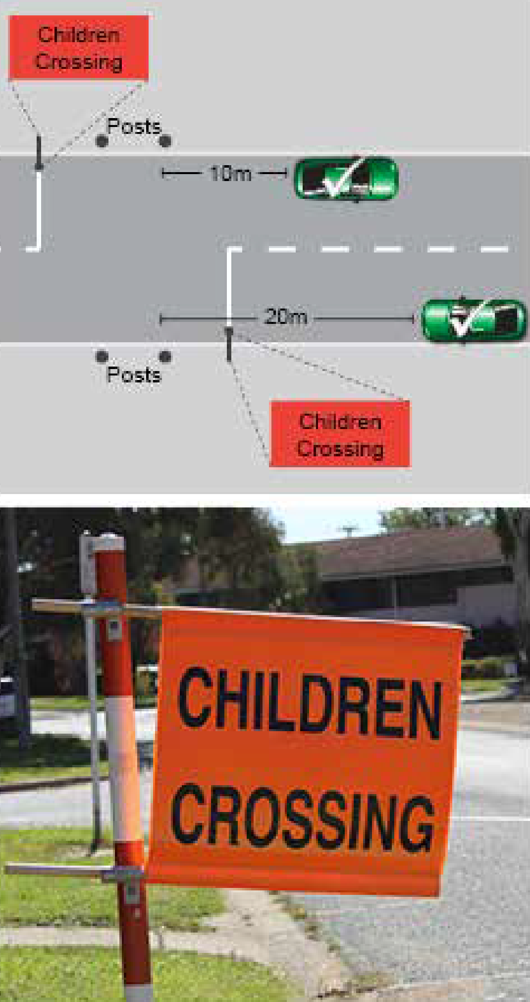
This is a serious offence and, as a result, there is no possibility of having a PIN for this offence withdrawn on the grounds of previous good driving record.
Specific exemptions
- When the crossing in not operational, such as during school holidays.
- If there are parking signs that indicate stopping or parking is allowed within the normal exclusion zone around the crossing.
References
Liability for this offence is defined by the following provisions, which take precedence over the guidance provided above:
- Road Transport (Road Rules) Regulation 2017 section 171
- Road Transport (Offences) Regulation 2005 Schedule 1 Part 1.12A Item 229
- Road Transport (General) Withdrawal of Infringement Notices Guidelines 2019 (No 1)

PINcode 308 | Stopping on/near a pedestrian crossing

A motorist must not stop on a pedestrian crossing, or anywhere on the road within 20 metres before the crossing and 10 metres after the crossing.
Why do we have this rule?
This rule is to protect the safety of pedestrians using a pedestrian crossing. Vehicles in breach of this rule can obstruct the line of sight of other motorists, increasing the probability that they will not see pedestrians entering the crossing and significantly increasing the risk of a serious, even fatal, collision.

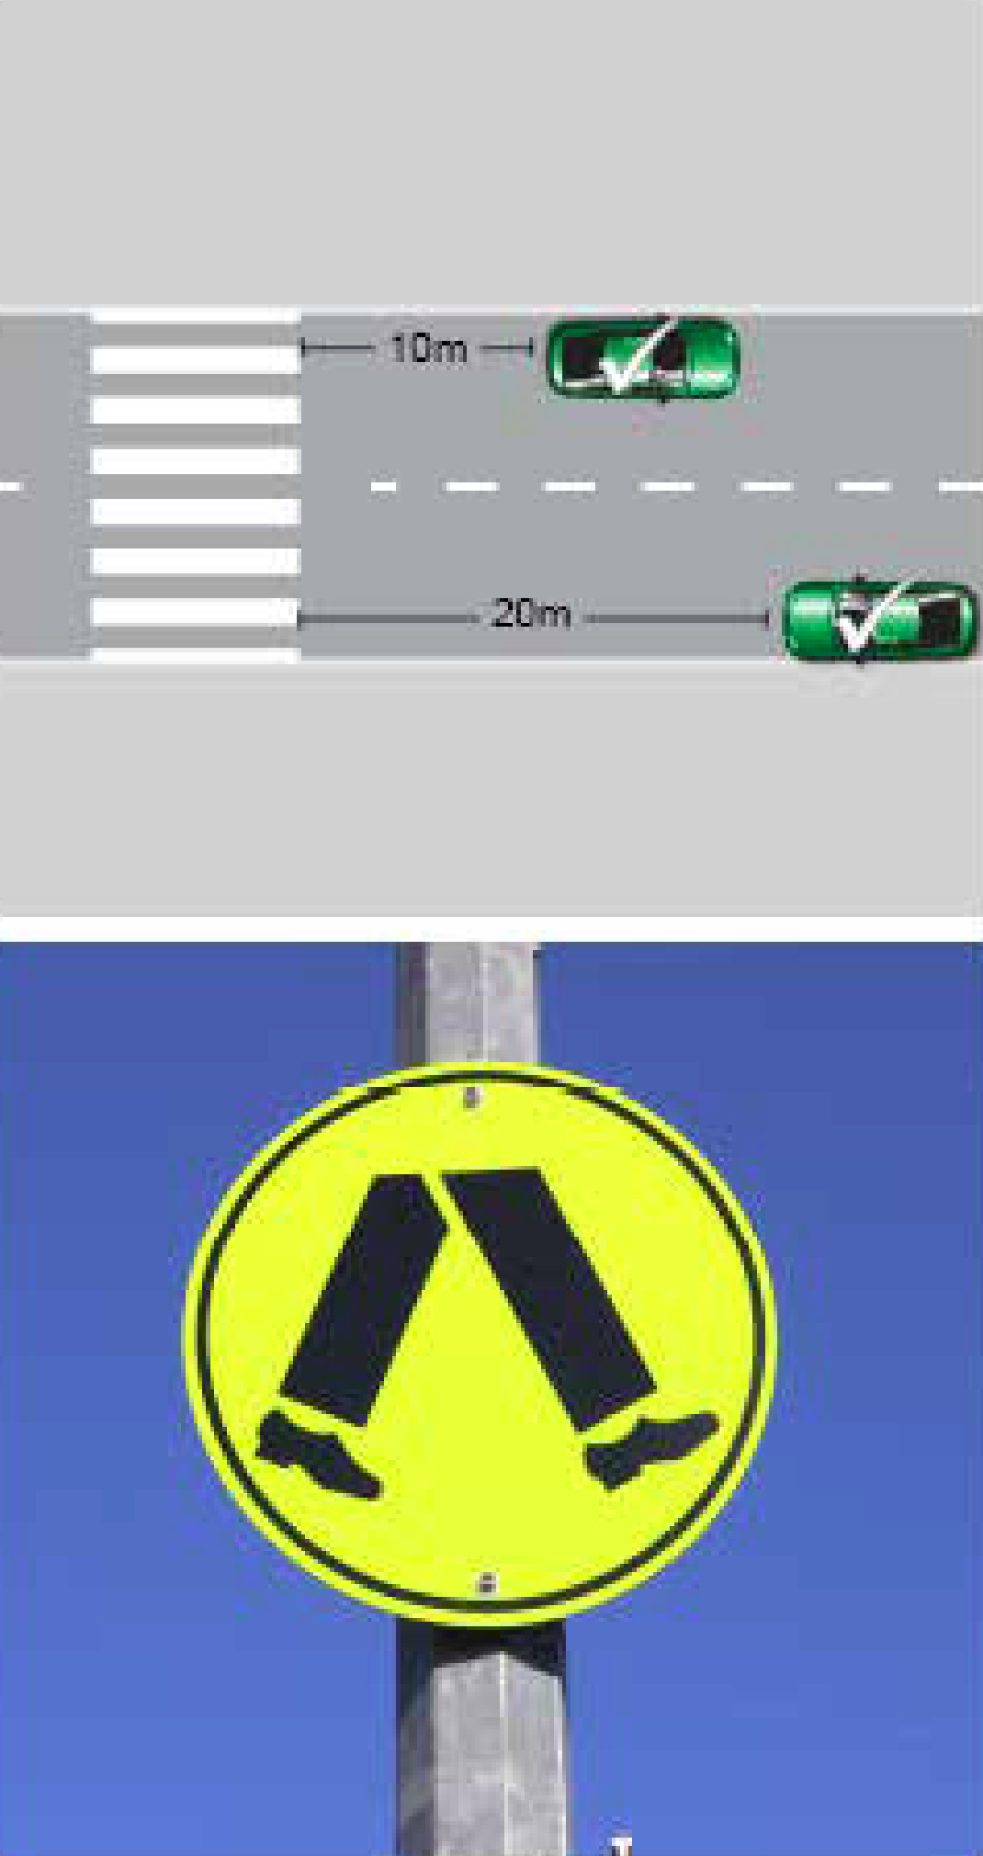
This is a serious offence and, as a result, there is no possibility of having a PIN for this offence withdrawn on the grounds of previous good driving record.
Specific exemptions
- If there are parking signs that indicate stopping or parking is allowed within the normal exclusion zone around the crossing.
References
Liability for this offence is defined by the following provisions, which take precedence over the guidance provided above:
- Road Transport (Road Rules) Regulation 2017 section 172
- Road Transport (Offences) Regulation 2005 Schedule 1 Part 1.12A Item 230
- Road Transport (General) Withdrawal of Infringement Notices Guidelines 2019 (No 1)

PINcodes 314, 315, 316, 398 | Loading zone offences

A motorist must not stop in a loading zone unless he or she is driving a vehicle that is primarily designed for carrying goods and is using the loading zone for the sole purpose of loading or unloading goods. Other vehicles can park in a loading zone only if they display a valid permit to do so. If there is a time limit for a loading zone indicated by signage, or by a loading zone permit, a motorist must not stay longer than the time limit. If no time limit is indicated the maximum time allowed is 30 minutes.
Note: a mobility permit does not entitle a motorist to park in a loading zone.
Why do we have this rule?
When unauthorised vehicles use loading zones, or authorised vehicles overstay their time limit, the ability of businesses to move their stock and conduct their business can be adversely affected.

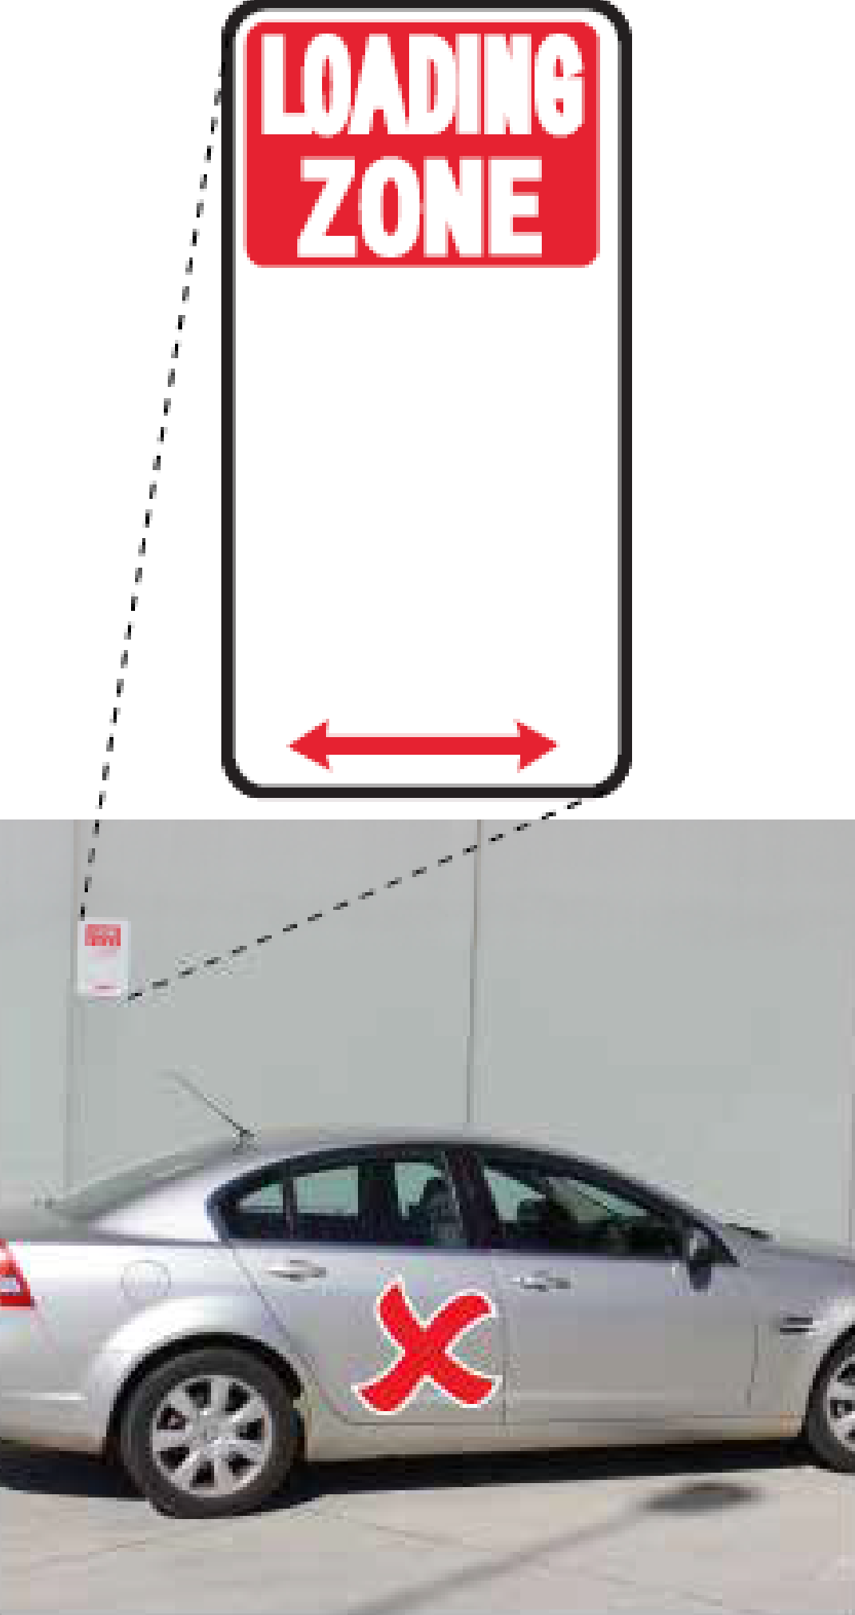
Specific exemptions
- Some loading zones have signs indicating that general parking is allowed between certain hours.
- Vehicles that are generally allowed to stop in a loading zone for the sole purpose of loading or unloading goods, would be a truck, commercial van or utility vehicle. Station wagons, 4WDs and people movers are not vehicles primarily designed for carrying goods.
- A bus or a taxi is able to stop and pick up or drop off passengers in a designated loading zone.
References
Liability for this offence is defined by the following provisions, which take precedence over the guidance provided above:
- Road Transport (Road Rules) Regulation 2017 section 179
- Road Transport (Offences) Regulation 2005 Schedule 1 Part 1.12A Item 237, 238, 239, 240

PINcode 319 | Stopping in a taxi zone

Taxi zones must only be used by taxis.
Why do we have this rule?
Taxi zones are established to ensure customers have access to this form of public transport. If a vehicle that is not a taxi is parked in a taxi zone, it can severely disrupt the operation of a taxi rank.

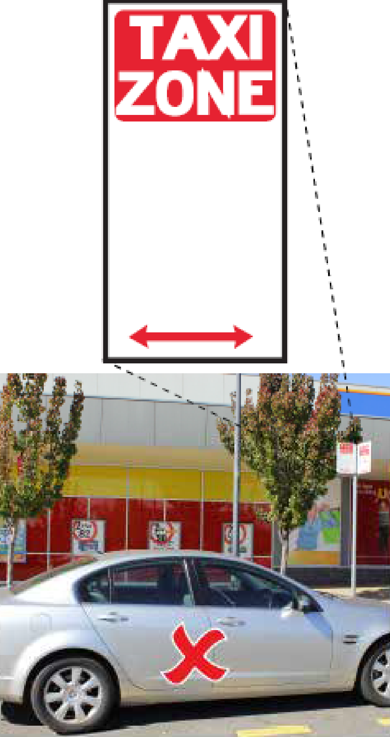
References
Liability for this offence is defined by the following provisions, which take precedence over the guidance provided above:
- Road Transport (Road Rules) Regulation 2017 section 182
- Road Transport (Offences) Regulation 2005 Schedule 1 Part 1.12A Item 243

PINcodes 320, 321, 335 | Bus zone offences

A motorist who is not operating a public bus must not stop in a bus zone.
Why do we have this rule?
Public buses need designated spaces for passengers to get on and off safely. A motorist who parks a private vehicle in a bus zone, can impede the safe flow of traffic where buses would otherwise leave the carriageway to drop off and pick up passengers. They can also make a bus stop completely inaccessible, causing bus services to be disrupted.

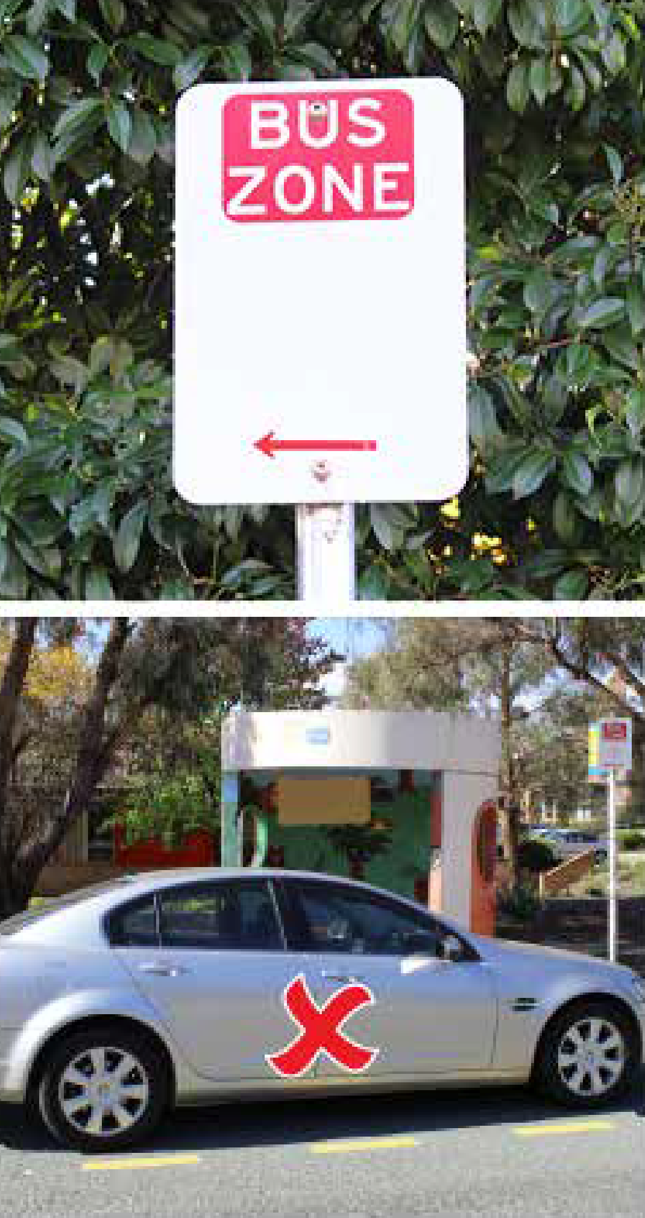
References
Liability for this offence is defined by the following provisions, which take precedence over the guidance provided above:
- Road Transport (Road Rules) Regulation 2017 sections 183 and 195
- Road Transport (Offences) Regulation 2005 Schedule 1 Part 1.12A Items 244 and 260

PINcode 329 | Double parking

Double parking is where a motorist stops or parks in a position that places any part of his or her vehicle between a vehicle that is parked on the road and the centre of the road.
Why do we have this rule?
Double parking can prevent a parked vehicle from being able to leave by blocking it in. It can also cause safety issues by blocking the line of sight of other vehicles, both parked and driving on the road.

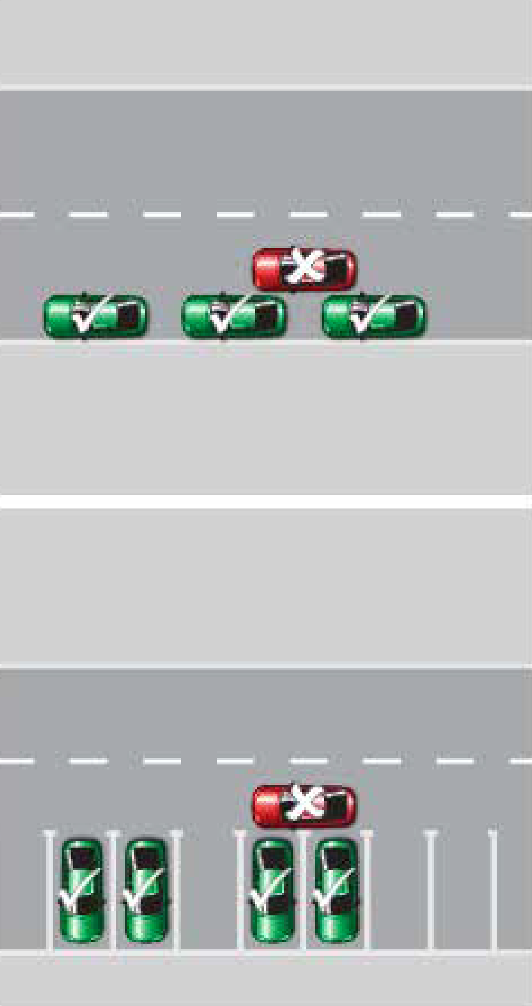
References
Liability for this offence is defined by the following provisions, which take precedence over the guidance provided above:
- Road Transport (Road Rules) Regulation 2017 section 189
- Road Transport (Offences) Regulation 2005 Schedule 1 Part 1.12A Item 253

PINcode 336 | Stopping on a path/strip in a built-up area

In any built-up area, a motorist must not stop on a bicycle path, footpath, shared path, dividing strip, or a nature strip. Within a residential area a nature strip is the area between a road and the resident’s boundary, excluding the footpath.
Why do we have this rule?
There are many reasons why this rule is in place. Vehicles parked on footpaths or nature strips can obstruct motorists’ line of sight of other vehicles on the road and pedestrians about to cross the road, which can severely heighten the risk of collisions. This risk is particularly high when vehicles are parked on paths or nature strips close to intersections.
Vehicles parked on footpaths, including footpaths located on a driveway, can prevent footpaths from being used by pedestrians. When this occurs, pedestrians can be forced to walk on the road, which is a serious safety risk particularly for children, the elderly, the vision impaired and wheelchair and pram users.

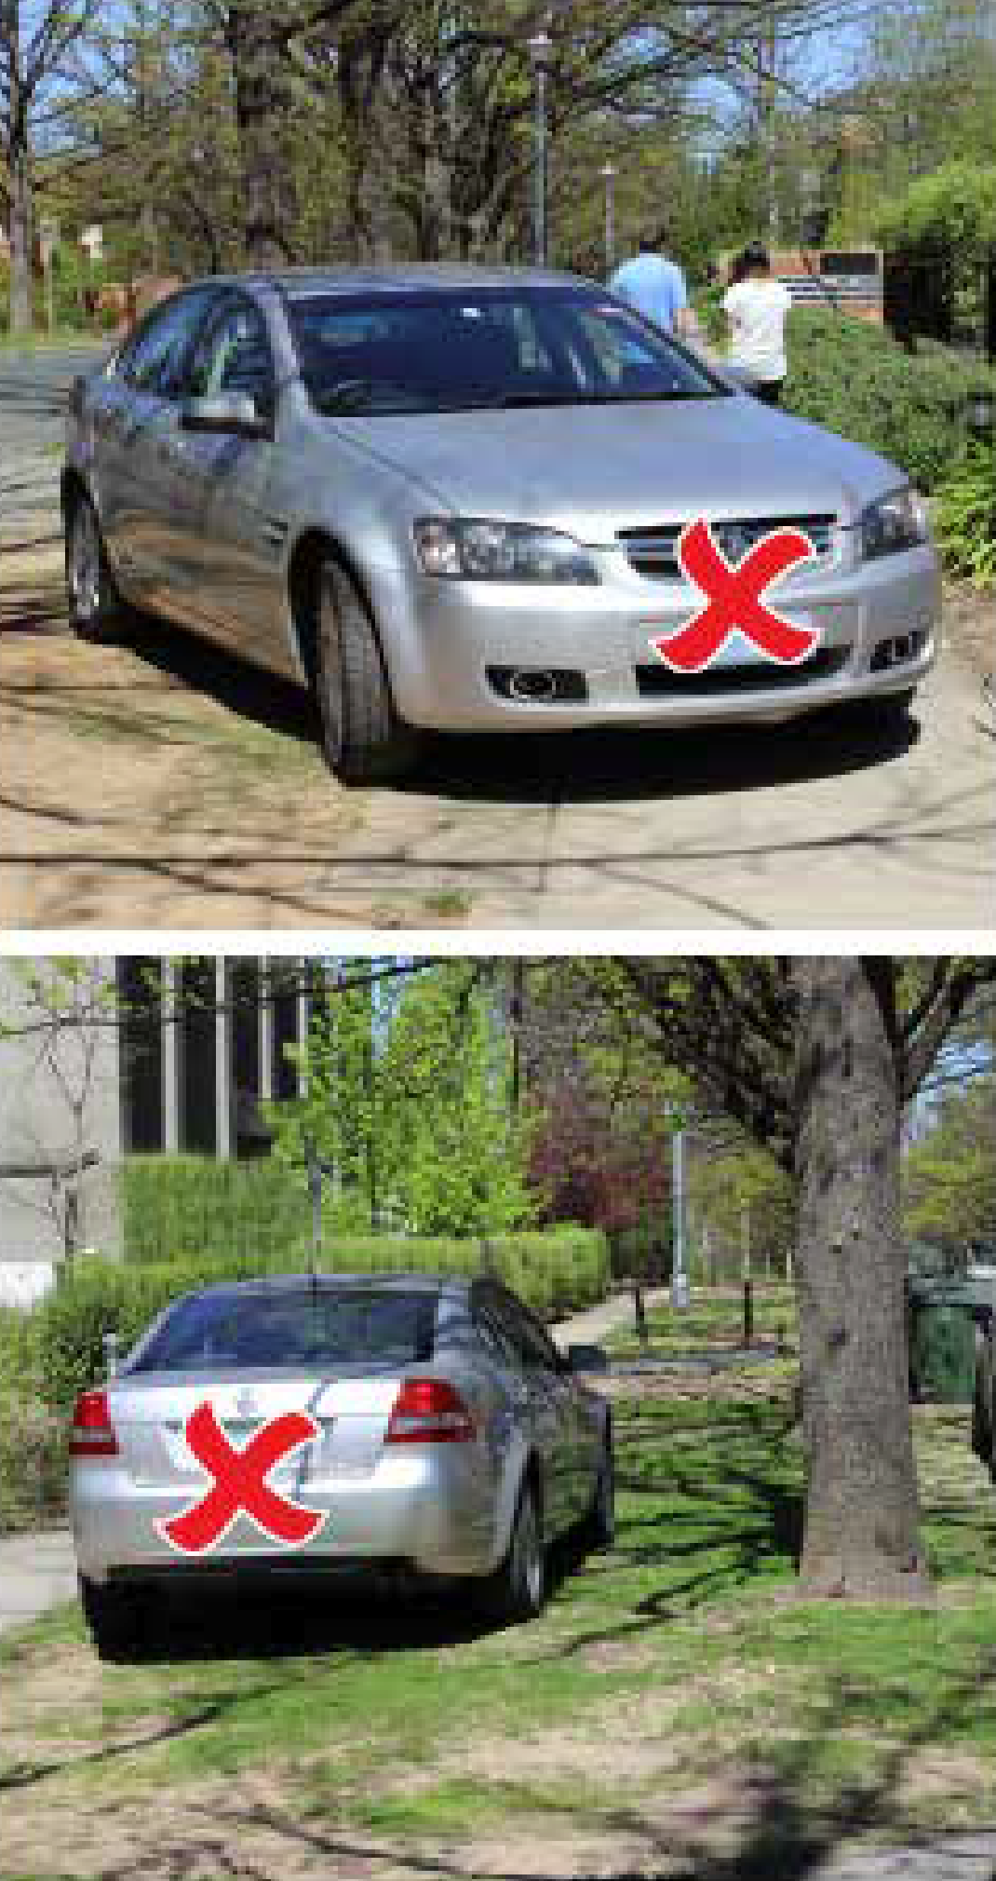
Parking on nature strips also erodes vegetation by putting excessive force on tree roots and grass shoots, which can make trees unstable and dangerous, particularly in high winds. It can also damage public infrastructure, both above and below the ground. Emergency services and other personnel may be prevented from accessing key infrastructure such as water, gas, telecommunications and drainage facilities.
Motorists should also note that driving onto footpaths or nature strips in order to park is a safety hazard as pedestrians do not expect vehicles to park here and are unlikely to be exercising the same precautions they usually do when crossing a road.
When this kind of illegal parking is reported, Parking Operations’ response is dependent upon the level of risk posed (i.e. whether it is a high, medium or low risk).
References
Liability for this offence is defined by the following provisions, which take precedence over the guidance provided above:
- Road Transport (Road Rules) Regulation 2017 section 197
- Road Transport (Offences) Regulation 2005 Schedule 1 Part 1.12A Item 263

PINcode 337 | Stopping on or across a driveway or other access to or from land

A motorist must not stop on, or across a driveway, or other way of access for vehicles travelling to or from adjacent land.
Why do we have this rule?
It is inappropriate for a motorist to restrict access to a driveway by parking across it. This can prevent people from leaving or returning to their homes. It can also cause line of sight obstructions for motorists entering or exiting a partially blocked driveway.

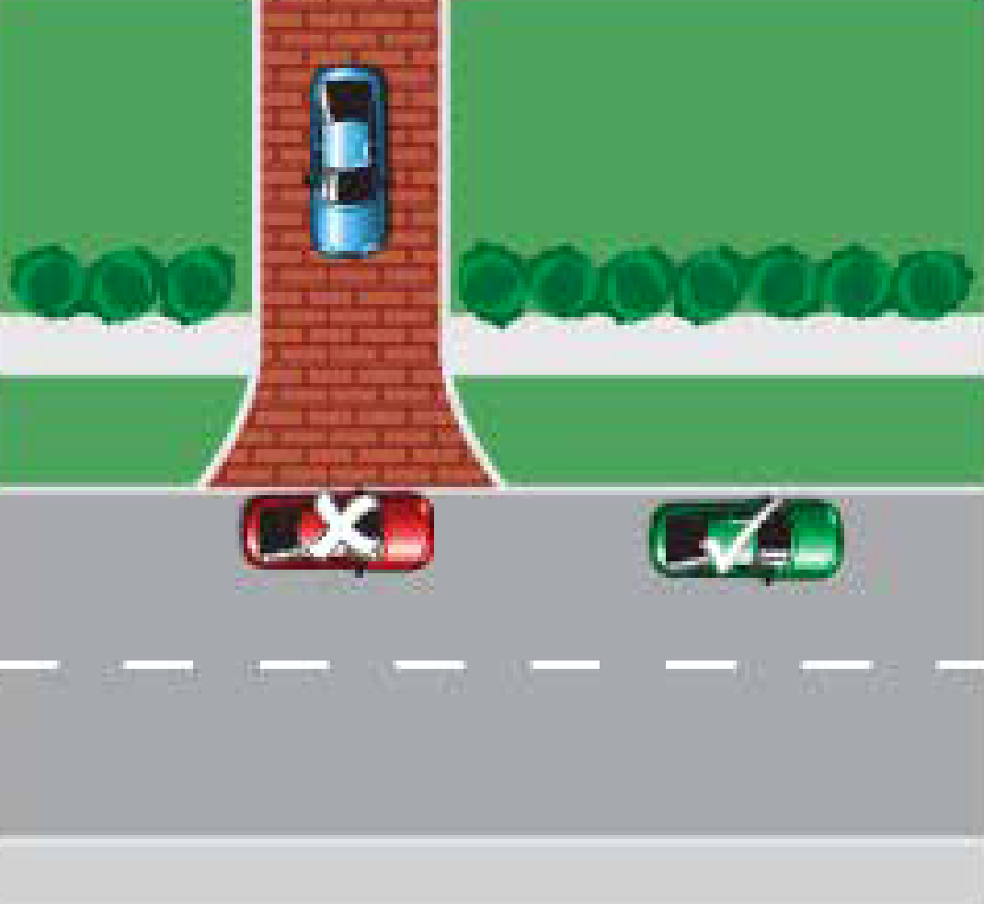
References
Liability for this offence is defined by the following provisions, which take precedence over the guidance provided above:
- Road Transport (Road Rules) Regulation 2017 section 198
- Road Transport (Offences) Regulation 2005 Schedule 1 Part 1.12A Item 267

PINcode 342 | Disobey motorbike parking sign

A driver of a vehicle other than a motorbike must not park in a ‘Motorbike Only’ zone.
Why do we have this rule?
Certain areas are provided for motorbike parking only. Motorbikes have separate parking facilities to ensure that sufficient parking is available for them. It also ensures that motorcycles park in an appropriately-sized parking bay and do not need to park in a regular-sized bay.

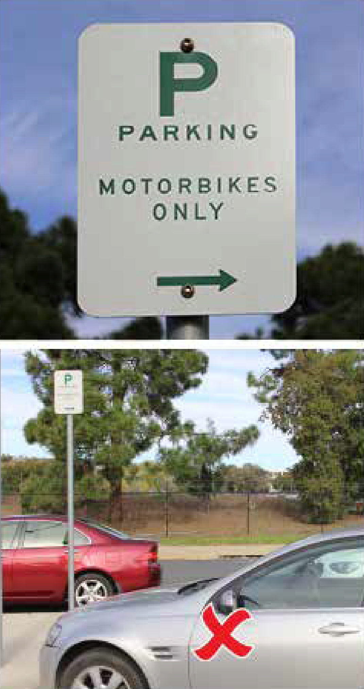
References
Liability for this offence is defined by the following provisions, which take precedence over the guidance provided above:
- Road Transport (Road Rules) Regulation 2017 section 202
- Road Transport (Offences) Regulation 2005 Schedule 1 Part 1.12A Item 272

PINcode 343 | Stopping in parking area for disabled

Anyone parking in a designated parking area for people with disabilities, must display a valid mobility parking scheme permit.
Note: many of these parking spaces have an area next to them, identified by yellow diagonal stripes, to allow easier entry and exit to and from vehicles. This extra area is intended to be used for this purpose and is not designed to be parked on.
Why do we have this rule?
These spaces are provided to allow people with disabilities and a valid mobility parking scheme permit, easy access to shops, places of work, and other amenities. These spaces are generally located close to entrances and have easy access to wheelchair ramps.

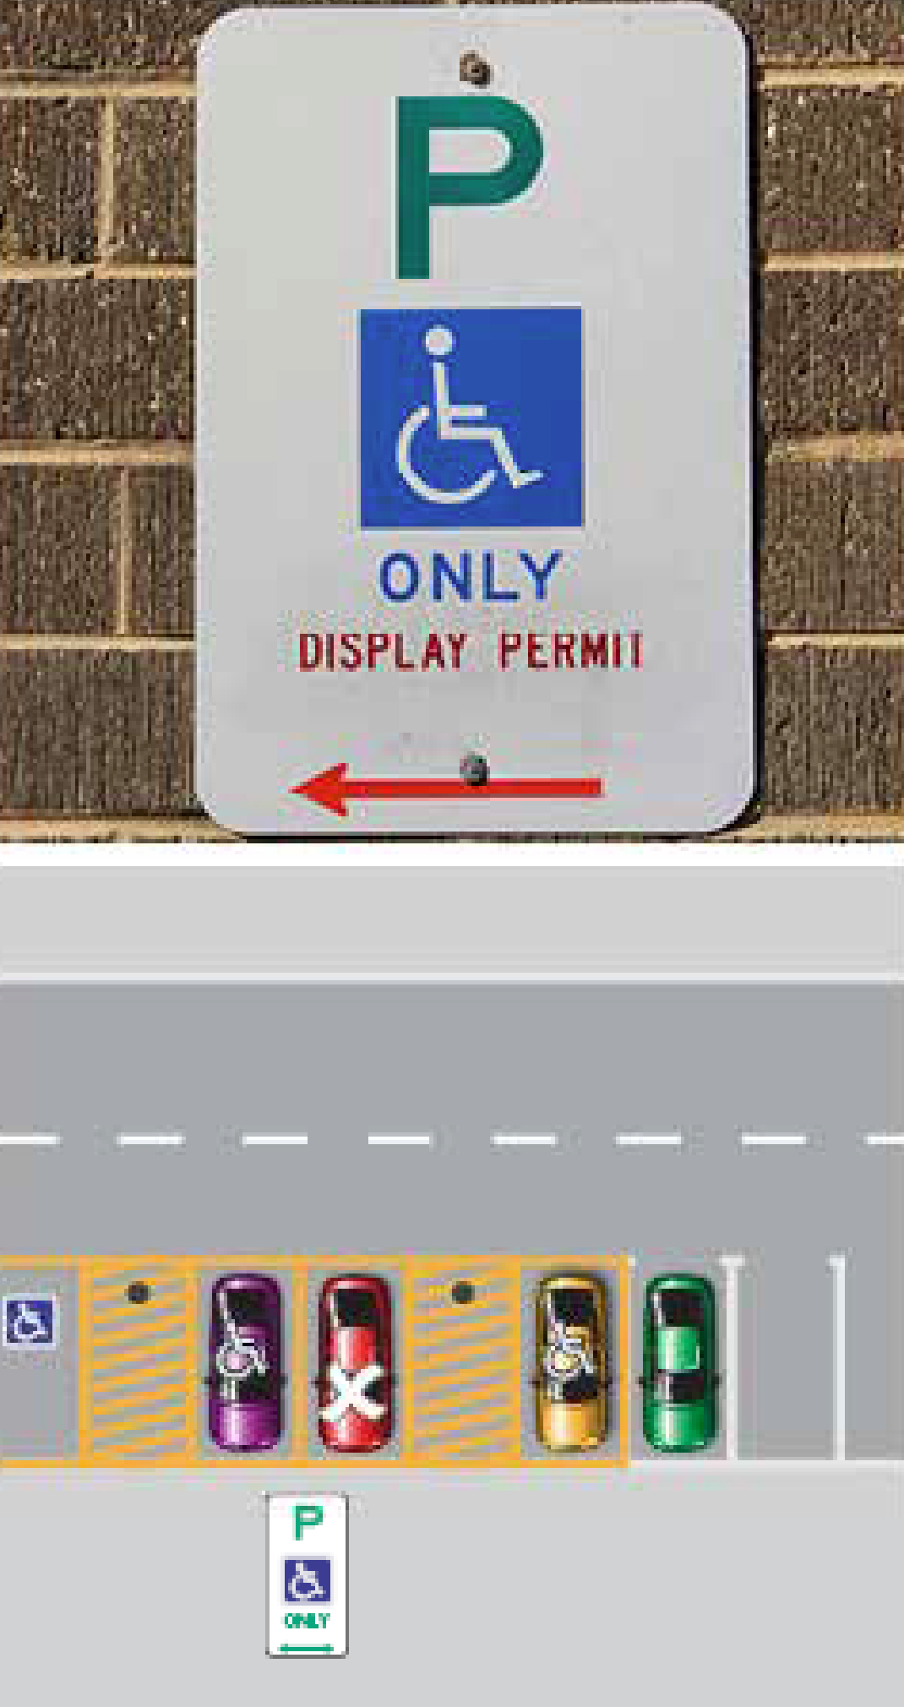
Anyone who parks in a parking area for people with disabilities, who does not have a valid mobility parking scheme permit, is likely to be preventing someone with a legitimate disability from using accessible parking.
This is a serious offence and, as a result, there is no possibility of having a PIN for this offence withdrawn on the grounds of previous good driving record.
References
Liability for this offence is defined by the following provisions, which take precedence over the guidance provided above:
- Road Transport (Road Rules) Regulation 2017 section 203
- Road Transport (Offences) Regulation 2005 Schedule 1 Part 1.12A Item 273
- Road Transport (General) Withdrawal of Infringement Notices Guidelines 2019 (No 1)

PINcode 344 | Parking continuously for longer than permitted

A motorist must not park continuously for longer than indicated by signage in a given area.
Why do we have this rule?
Some parking bays are time-limited to ensure motorists have equitable access to parking. In the vicinity of shops, for instance, time-limited parking ensures that parking spaces are used by customers of those shops rather than people wanting to park there all day and go elsewhere.

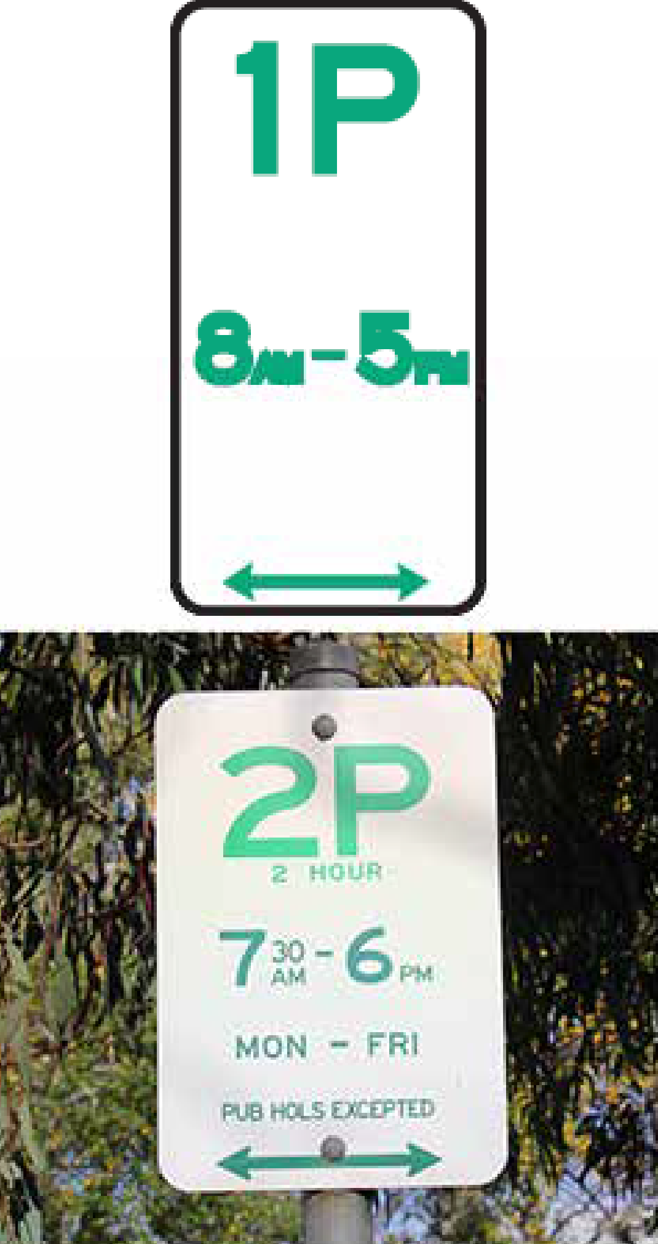
Parking Officers use chalk to mark a vehicle’s tyres to determine whether it has remained parked for the duration of the time it is monitored. It is illegal to remove or alter the chalk marks except by driving the vehicle.
Specific exemptions
- If the motorist displays a valid mobility parking scheme permit, he or she is entitled to additional time as follows:
- If the time limit is 30 minutes or less, the motorist may park for 2 hours
- If the time limit is greater than 30 minutes, the motorist may park for an unlimited amount of time
References
Liability for this offence is defined by the following provisions, which take precedence over the guidance provided above:
- Road Transport (Road Rules) Regulation 2017 section 205
- Road Transport (Offences) Regulation 2005 Schedule 1 Part 1.12A Item 275

PINcodes 345, 411 | Not parallel parking in the direction of travel

When parallel parking, a motorist must park a vehicle in the direction in which traffic could legally travel on the side of the road the vehicle is parked.
Why do we have this rule?
This rule seeks to prevent motorists from positioning their vehicles in dangerous places on the road. This applies to both the time when the motorist is parking a vehicle and when the motorist is leaving. When parking, it is potentially dangerous for a motorist to parallel park on the opposite side of the street as this can force them to drive on the wrong side of the road. When leaving, the motorist may also be forced to travel on the wrong side of the road.

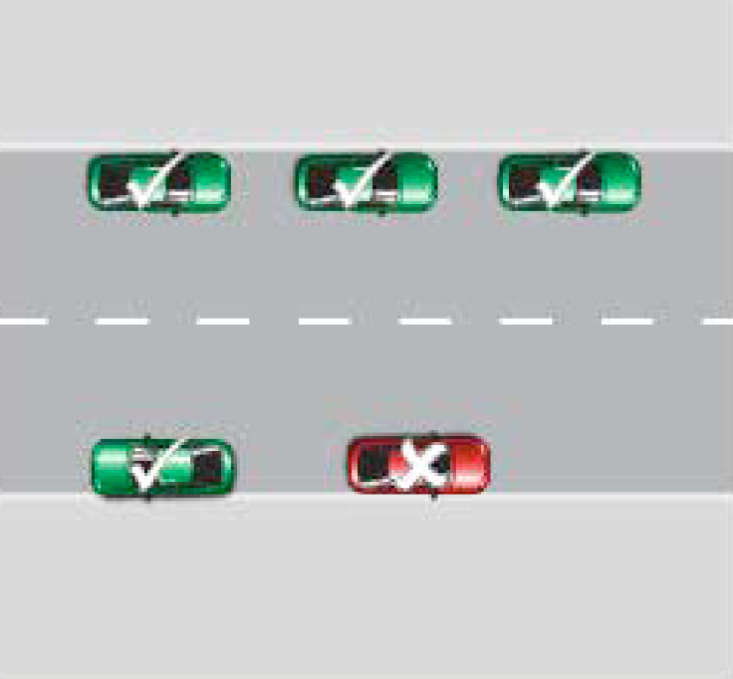
References
Liability for this offence is defined by the following provisions, which take precedence over the guidance provided above:
- Road Transport (Road Rules) Regulation 2017 section 208 and 208A
- Road Transport (Offences) Regulation 2005 Schedule 1 Part 1.12A Item 277.1, 278

PINcode 349 | Parallel parking close to dividing line/strip

If a road has a continuous dividing line or strip, a motorist must not park a vehicle within 3 metres of the line or strip unless there are signs or other traffic control devices indicating otherwise. If the road does not have a continuous dividing line or strip, there must be at least 3 metres of road alongside the vehicle that is clear for other vehicles to pass, unless information on a parking control sign indicates otherwise.
Why do we have this rule?
This rule seeks to ensure the safe flow of traffic. If a vehicle is parked too close to a dividing line or strip the vehicle can form a hazard and/or restrict the line of sight of motorists using the road and consequently increase the risk of an accident occurring.

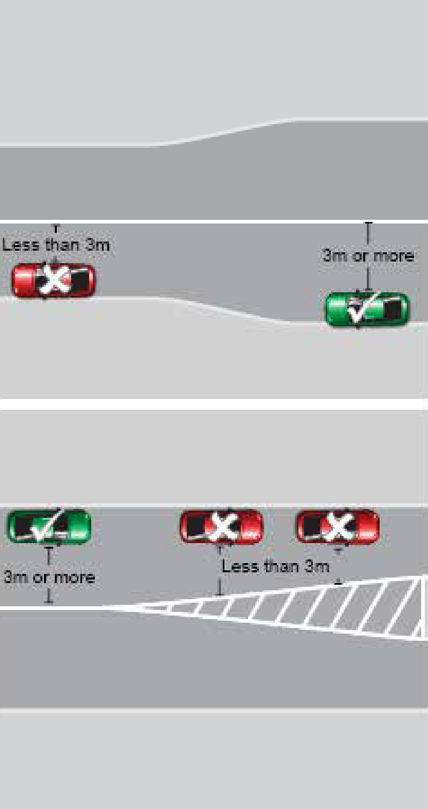
References
Liability for this offence is defined by the following provisions, which take precedence over the guidance provided above:
- Road Transport (Road Rules) Regulation 2017 section 208(6)
- Road Transport (Offences) Regulation 2005 Schedule 1 Part 1.12A Item 277.5

PINcode 351 | Parking so as to obstruct vehicles/pedestrians

A motorist must not position a vehicle such that it unreasonably obstructs the path of other vehicles or pedestrians.
Why do we have this rule?
Parking in a manner that obstructs other vehicles or pedestrians can cause significant risks to the safety of other motorists and pedestrians who may have to divert their paths to get around the vehicles causing the obstruction. Sometimes an obstructing vehicle can prevent another vehicle from moving altogether.

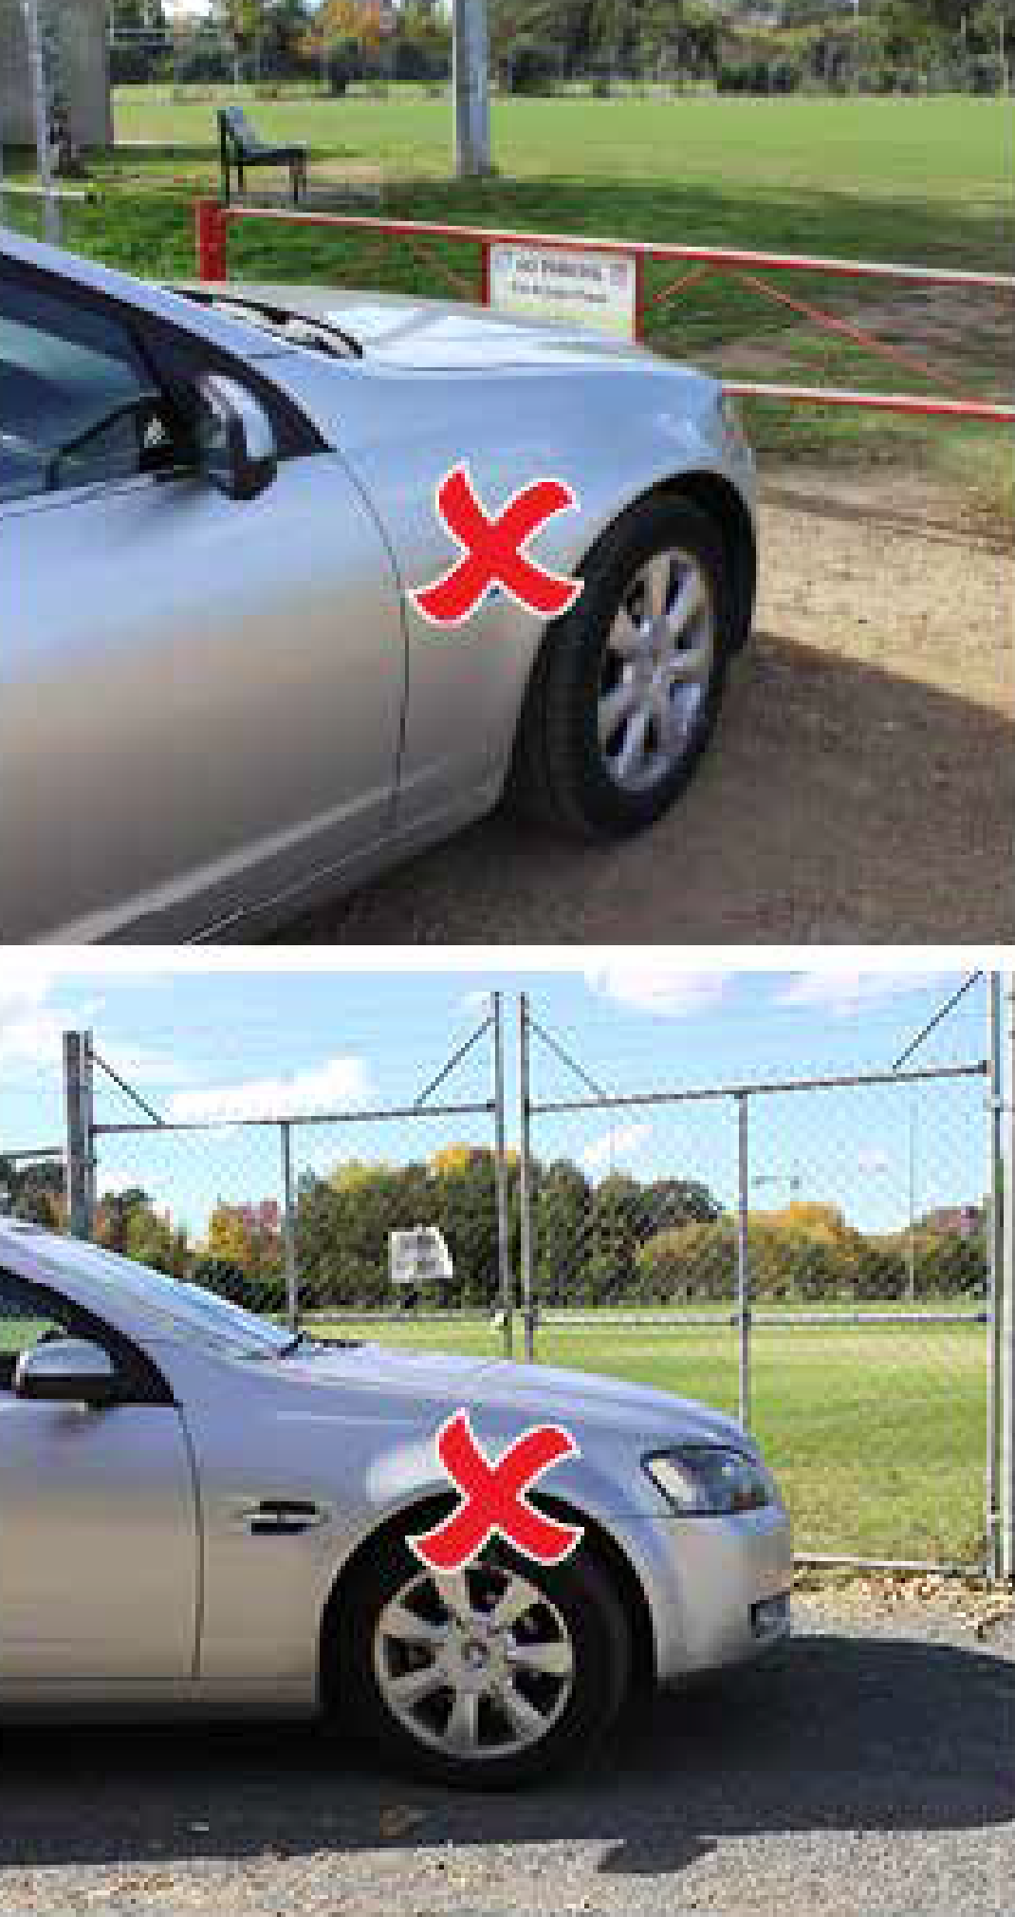
References
Liability for this offence is defined by the following provisions, which take precedence over the guidance provided above:
- Road Transport (Road Rules) Regulation 2017 section 208(8)
- Road Transport (Offences) Regulation 2005 Schedule 1 Part 1.12A Item 277.7

PINcodes 361, 362, 370 | Parking outside of marked parking bays

A motorist must park within marked parking bays where they are present. This applies whether or not a ‘Park in Bays Only’ sign is present.
Why do we have this rule?
Offences against this rule can affect either the safety or the amenity of other road users.
If a vehicle is parked across the marked boundary of a parking bay, it can restrict access to adjoining bays and prevent other motorists from parking there.
When vehicles are not parked fully within parking bays, they can often obstruct thoroughfares. This creates an unexpected hazard for vehicles using the thoroughfare and can lead to accidents.

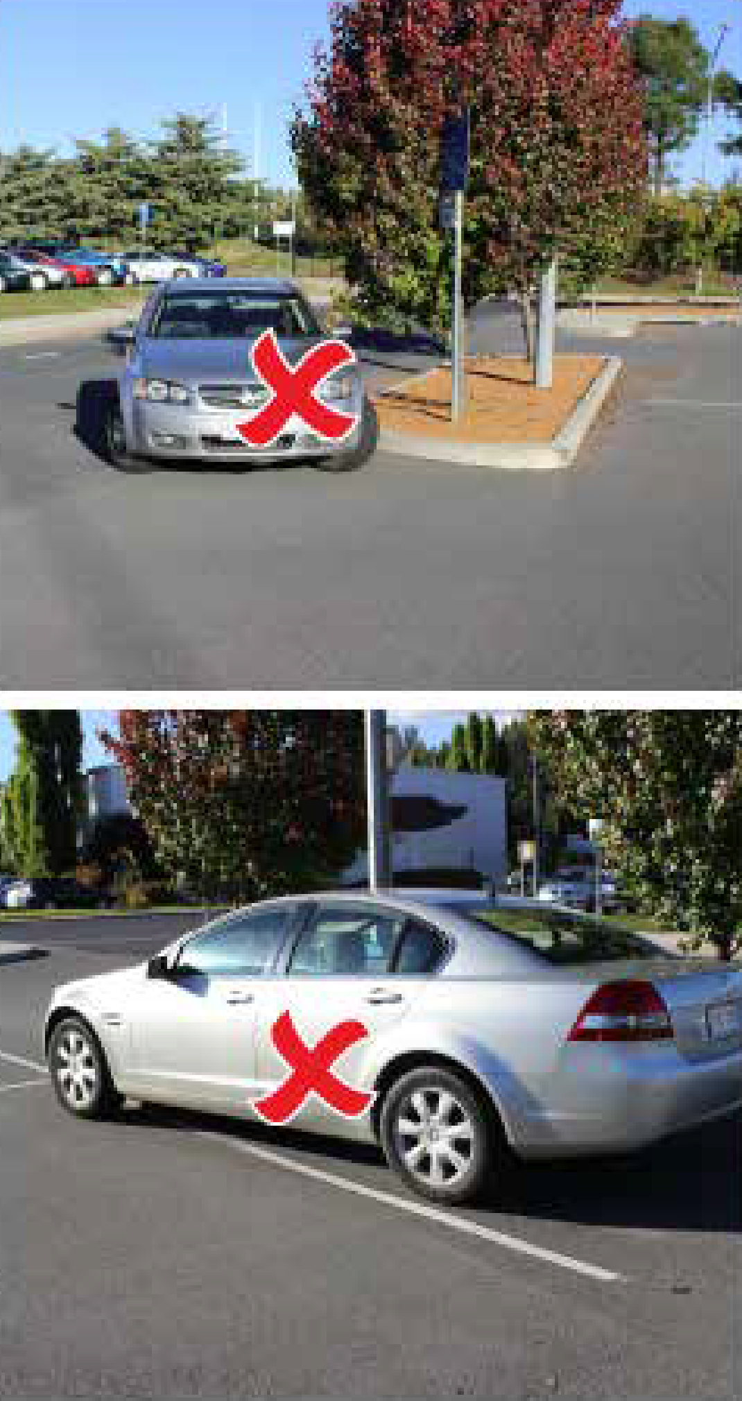
References
Liability for this offence is defined by the following provisions, which take precedence over the guidance provided above:
- Road Transport (Road Rules) Regulation 2017 section 211 and 213(I)
- Road Transport (Offences) Regulation 2005 Schedule 1 Part 1.12A Items 283, 284, 304

PINcode 371 | Parking without displaying a valid ticket

In certain areas, parking must be paid for by displaying a valid ticket on a vehicle’s dashboard or via a smartphone application.
Why do we have this rule?
Paid parking is in place to ensure equitable use of public car parking space. Paid parking helps to manage the demand for parking, particularly in town centres and other high demand areas.
By charging a fee for parking in certain areas, the ACT Government is also encouraging commuters to consider using more environmentally friendly forms of transport such as public buses or carpooling.

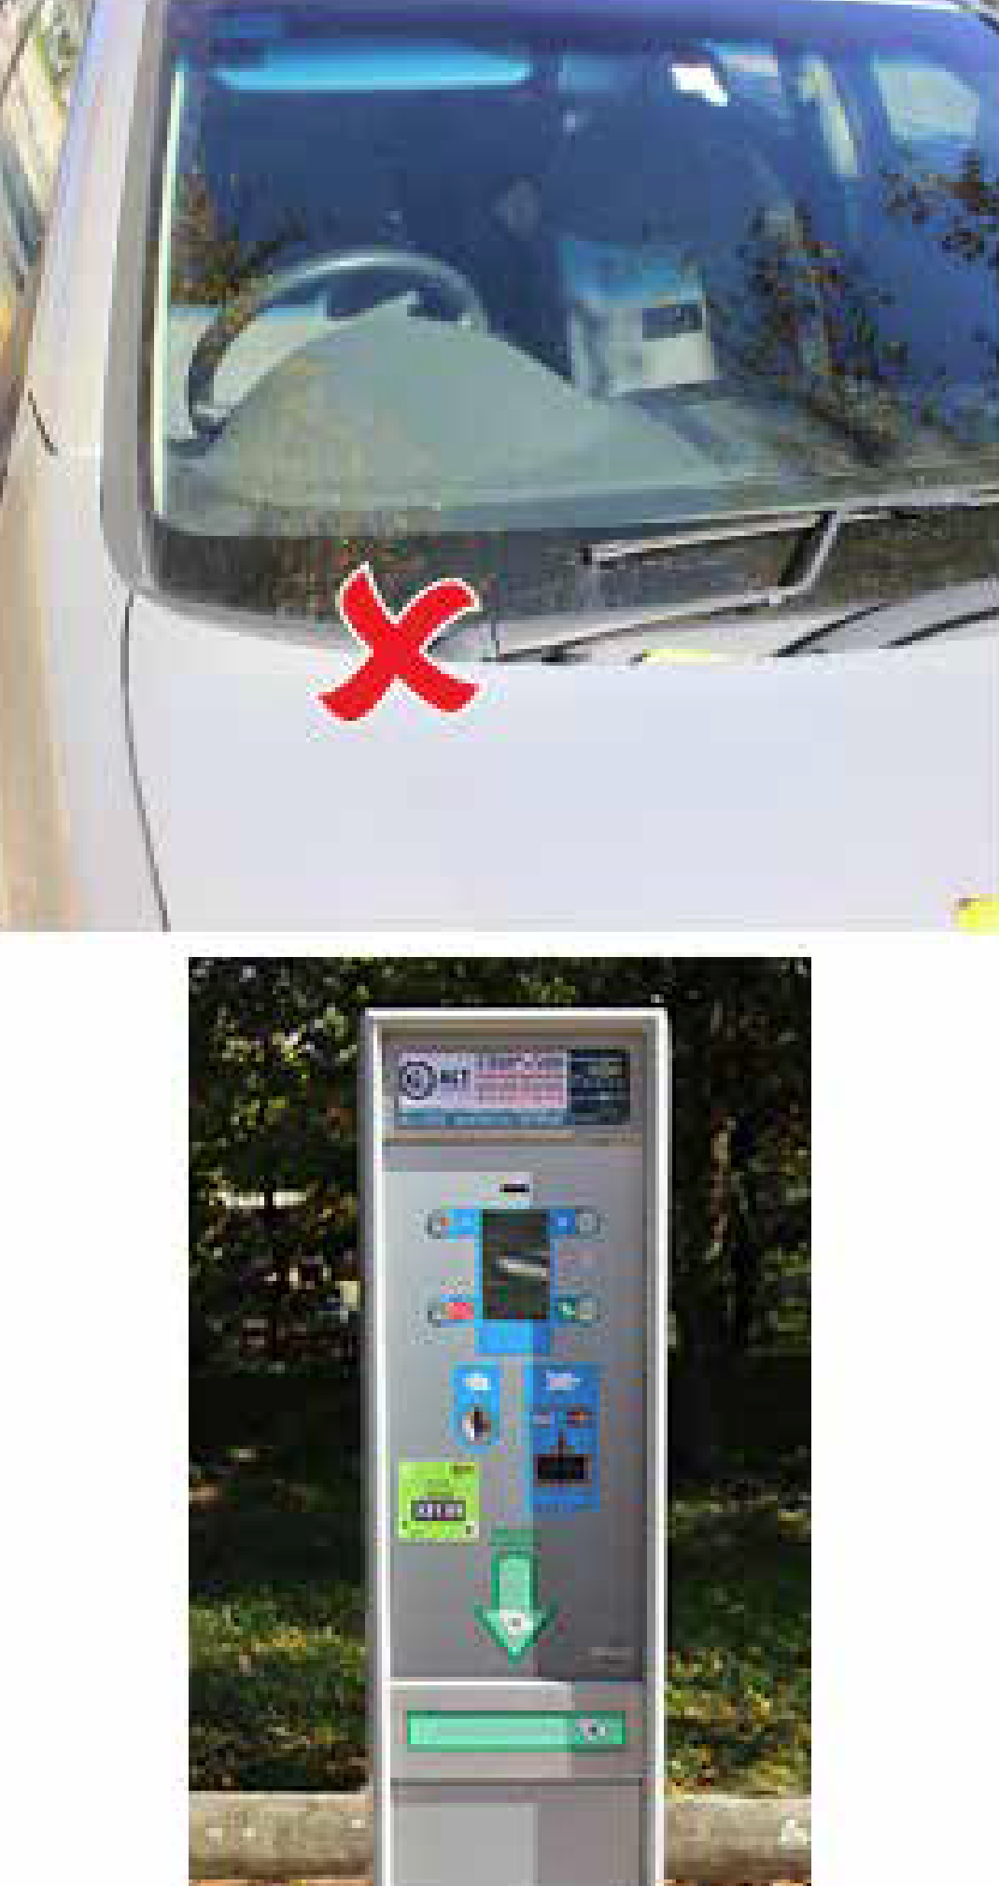
Specific exemptions
- If the motorist displays a valid mobility parking scheme permit, he or she is entitled to free parking as follows:
- If the time limit is 30 minutes or less, the motorist may park for free for 2 hours
- If the time limit is greater than 30 minutes, the motorist may park for free for an unlimited amount of time.
References
Liability for this offence is defined by the following provisions, which take precedence over the guidance provided above:
- Road Transport (Road Rules) Regulation 2017 section 213K(1)
- Road Transport (Offences) Regulation 2005 Schedule 1 Part 1.12A Item 309

PINcode 372 | Parking after a meter or ticket has expired

Where parking must be paid for, either by displaying a valid ticket or by a smartphone application, motorists must ensure that they have paid for the entire time they park.
Why do we have this rule?
Paid parking is in place to ensure equitable use of public car parking space. Having paid parking helps to manage the demand for parking, particularly in town centres and other high demand areas. By overstaying an area, you are not allowing equitable access to other motorists who may wish to park there.
By charging a fee for parking in certain areas, the ACT Government is also encouraging commuters to consider using more environmentally friendly forms of transport such as public transport or carpooling.

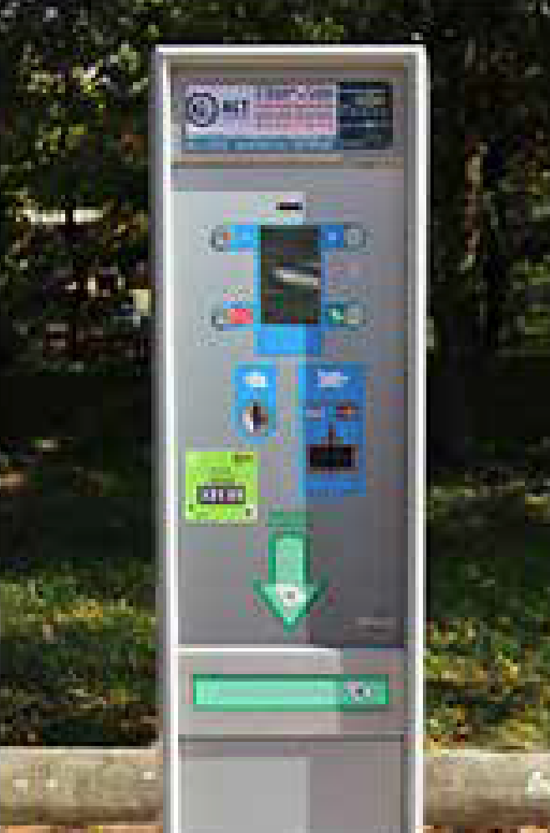
References
Liability for this offence is defined by the following provisions, which take precedence over the guidance provided above:
- Road Transport (Road Rules) Regulation 2017 section 213M(1)
- Road Transport (Offences) Regulation 2005 Schedule 1 Part 1.12A Item 20, 310

PINcodes 377, 378 | Displaying a false or altered ticket

A motorist parked in a paid parking area must not display anything falsely resembling a parking ticket or a parking ticket that has been changed, damaged or defaced in any way.
Why do we have this rule?
It is fraudulent for anyone to avoid paying for parking by using a false or altered ticket. Attempting to mislead a parking officer is a serious offence.

References
Liability for this offence is defined by the following provisions, which take precedence over the guidance provided above:
- Road Transport (Road Rules) Regulation 2017 section 213P(2)(a) and 213P(2)(b)
- Road Transport (Offences) Regulation 2005 Schedule 1 Part 1.12A Item 314, 315

PINcodes 387, 388, 389, 390, 391, 392, 393, 394, 395 | Stopping in a permit zone without a valid permit

There are certain permit zones other than those that have already been discussed, where motorists must not park without displaying a valid permit for that zone. These zones include:
- Diplomatic
- Government vehicle
- Member of Parliament
- Category L (Legislative Assembly)
- Community Nurse
- Medical Practitioner
- Park ‘n Ride
- Resident Parking
- Airport Permit

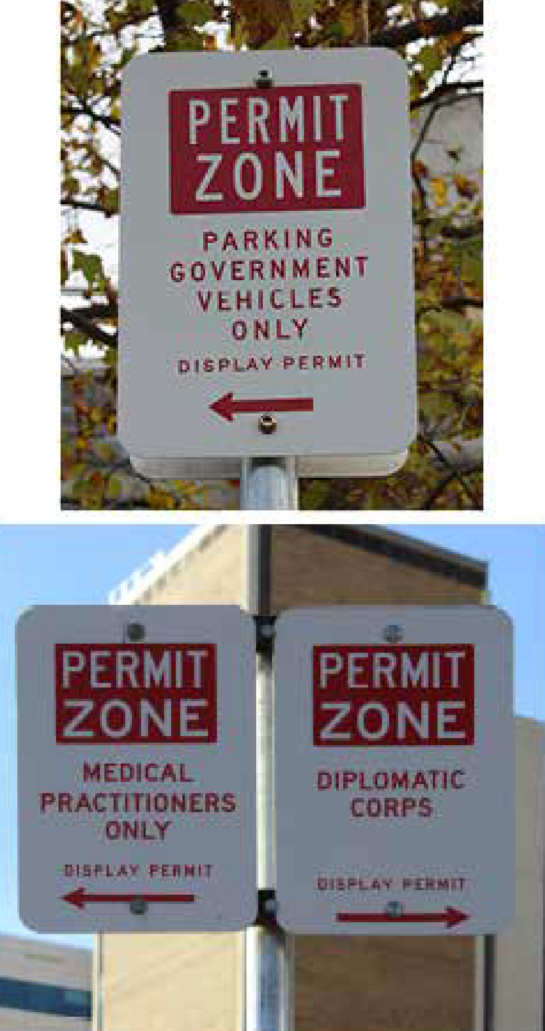
Why do we have this rule?
The purpose of this rule is to ensure that there is parking available for members of groups to which the permit refers.
References
Liability for this offence is defined by the following provisions, which take precedence over the guidance provided above:
- Road Transport (Road Rules) Regulation 2017 section 185
- Road Transport (Offences) Regulation 2005 Schedule 1 Part 1.12A Item 247
- Road Transport (Safety and Traffic Management) Regulation 2017 section 64

PINcode 410 | Stopping on a painted island

A motorist must not stop on a painted island, irrespective of whether it is on a road, in a car park or located next to a parking bay, including a parking area for people with disabilities bay.
Why do we have this rule?
On road surfaces, painted islands are generally intended to separate traffic to ensure the safety of motorists. Stopping on a painted island can obstruct the safe flow of traffic and line of sight to other vehicles.

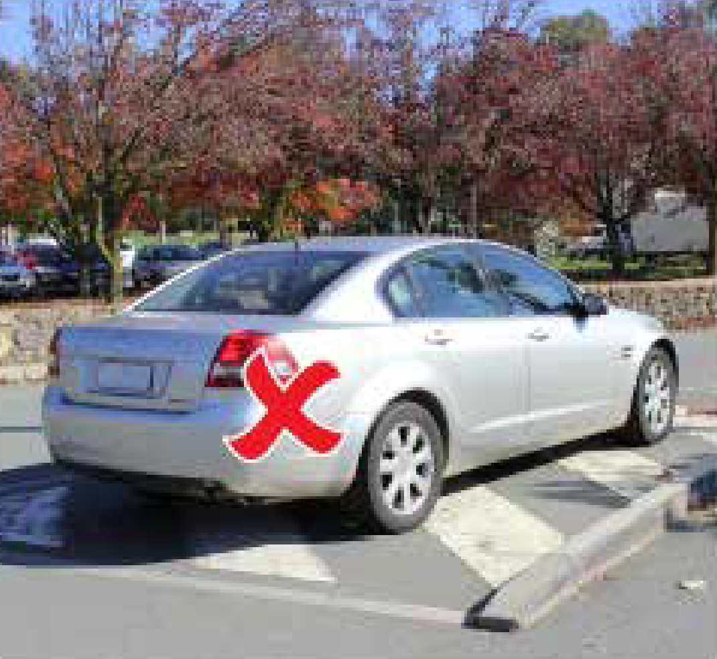
References
Liability for this offence is defined by the following provisions, which take precedence over the guidance provided above:
- Road Transport (Road Rules) Regulation 2017 section 197
- Road Transport (Offences) Regulation 2005 Schedule 1 Part 1.12A Item 264

PINcodes 427, 428 | Removing, interfering or copying a parking permit

A motorist must not remove, interfere, or copy a parking permit or mobility parking scheme permit in any way.
Why do we have this rule?
It is fraudulent for anyone to avoid complying with parking rules by using a false or altered parking permit or mobility parking scheme permit. Attempting to mislead a parking officer is a serious offence.

References
Liability for this offence is defined by the following provisions, which take precedence over the guidance provided above:
- Road Transport (Road Rules) Regulation 2017 section 213U
- Road Transport (Offences) Regulation 2005 Schedule 1 Part 1.12A Item 323, 324

Useful Contacts

Parking Operations
Parking Operations provides information and enforcement of parking conditions for public areas across the ACT.

Infringement Office
The Infringement Office is responsible for investigating and preparing responses to correspondence disputing parking infringement notices, the Infringement Office also prepares reports and recommendations on infringement matters and prepares legal documents for Court proceedings.

Parking Infringement Notices (PINs)
If you would like to request a review of a parking infringement, you must do so in writing and, it must be received within 28 days of the date of service of the infringement notice or, if a reminder notice has already been issued, within 28 days of the date of service of the reminder notice. To request a review of your Parking Infringement Notice (PIN), go to the Access Canberra website and complete the online form. www.act.gov.au/infringements

Other
Road Transport (General) Act 1999:
www.legislation.act.gov.au/a/1999-77/
Road Transport (Safety and Traffic Management) Regulation 2017:
www.legislation.act.gov.au/sl/2017-45/
Road Transport (General) Withdrawal of Infringement Notices Guidelines 2019 (No 1):
www.legislation.act.gov.au/di/2019-211/
Road Transport (Offences) Regulation 2005:
www.legislation.act.gov.au/sl/2005-11/default.asp
Road Transport (Road Rules) Regulation 2017:
www.legislation.act.gov.au/sl/2017-43/
ACT Road Rules Handbook:
www.accesscanberra.act.gov.au/s/article/act-road-rules-tab-overview

