

JANUARY 2019

The ACT Road Rules Handbook is written and compiled by the Chief Minister, Treasury and Economic
Development Directorate. The assistance of the following in bringing together this handbook is gratefully acknowledged:
- Infant Restraint Loan Service
- Australian Driver Trainers’ Association - ACT Branch
- NSW Transport Roads and Maritime Services.

Other available publications:
- ACT Heavy Vehicle Drivers’ Handbook
- ACT Older Drivers’ Handbook
While this handbook is predominantly a training tool for learner drivers, it is also intended to assist ACT or visiting drivers, however it is intended as a guideline only. Legislative provisions are contained in the Australian Road Rules 2012 and related Acts and Regulations.
For further information please see page 15 of this handbook.

ISBN 0 642 60329 4
© Australian Capital Territory, Canberra, 2019
This work is copyright. Apart from any use as permitted under the Copyright Act 1968, no part may be reproduced by any process without written permission from the Chief Minister, Treasury and Economic Development Directorate, ACT Government,
GPO Box 158, Canberra ACT 2601. Produced by Publishing Services.
Publication No. 18/1662 http://www.act.gov.au
Telephone: Access Canberra 13 22 81

Foreword

This ACT Road Rules Handbook contains practical information to help you master the road rules and obtain the other knowledge you will need to pass the Road Ready Course and the Road Rules Knowledge Test. Most importantly, the information in this publication could save your life.
The Handbook is essential reading for anyone learning to drive. It’s also a great resource for experienced drivers who want to keep up to date with changes to road rules and is a valuable source of information for interstate or overseas visitors who plan to drive in the ACT.
As a learner driver you will find the handbook will reinforce what you learn each time you get behind the wheel. And it will remain a valuable resource once you graduate to your Provisional licence and start driving solo—the period during which drivers are at most risk of being involved in a road accident.
It is very important that you get plenty of driving practice with an experienced driver sitting beside you, in these early days of your driving career. I urge all of you to consider signing up for a Road Ready Plus course, which will give you a chance to share your experiences with other young drivers as you earn the right to remove your P plates and increase your demerit points allowance.
Safe driving!

iii

ACCESSIBILITY
The ACT Government is committed to making its information as accessible as possible
If you require a translator or interpreter, contact us through the
Translating and Interpreter Service (TIS) on 13 14 50.
If you are deaf, or have a hearing impairement, contact us through the National Relay Service (NRS) on 13 36 77 and ask for 13 22 81.
Speak and Listen users can phone 1300 555 727 and ask for
13 22 81.
If you would like to receive this document in an alternative format such as large print, contact 13 22 81.

CONTENTS
PART A - General Information viii
Who this book is for 1
Licence Classes 2
Licence Classes Codes 3
Licence eligibility requirements 4
Medical Information 4
Public passenger vehicle 4
Obtaining an ACT learner
driver licence 5
Proof of identity and residency 6
Evidence of change of name 8
The Knowledge Test 9
Learner driving outside the ACT 9
The driving test 9
Competency Based Training and Assessment Scheme (CBT & A) 11
Licence classifications 12
Provisional licence 12
Full licence 12
Heavy vehicle licence 13
Probationary licence 13
Safe driving tips 13
Safe System and Vision Zero 14
Where to get further information 15
PART B - First steps to safe driving 16
Seat belts and child restraints 17
Seat belts 17
Child restraints 18
Child restraint rules 18
Carrying passengers 19
Technical advice 19
The risks associated with alcohol,
drugs and driving 20
Legal penalties 20
The legal limit 20
Mixing alcohol, drugs
and medication 21
Warning signs after
taking medication 21
Effects of alcohol on the body 21
Alcohol impairment varies 22
What is Alcohol Concentration
(BAC) 22
Random breath testing
and drug testing 23
Using a mobile telephone 23
Vehicle Security 24
Demerit points scheme 24
Fatigue 25
Distractions 27
PART C - Knowing the road rules 28
Traffic controls 29
Road markings 29
Merging 30
Form One Lane 30
Diagonal bars, painted islands 31
Arrows and other road turn
markings 31
Hold and turn lines 32
Coloured bicycle lanes 32
Traffic signals 33
Give way to the right 34
Traffic signs 35
Regulatory signs (mandatory) 35
Warning signs (advisory) 36
Information signs 36
Temporary signs 37
Bus priority traffic signals 37
Speed limits 38

v

ACT default speed limit 38
Speed zones 38
Safe speed 38
Speed restriction signs 39
Posted speed limits 39
Speed and red light cameras 39
What to do when the traffic
lights change to amber 40
What happens when a vehicle is photographed 40
Mobile speed cameras 40
Radar detectors 40
Intersections 41
Examples of giving way at intersections 42
Additional give way rules and examples as depicted in the
Australian Road Rules 44
Giving way at a give way sign at
a bridge or length of narrow road 44
Giving way at an intersection (except a T-intersection or
roundabout) 44
Giving way when entering a road from a road-related
area or adjacent land 47
Giving way when entering
a road-related area or adjacent
land from a road 47
Types of intersections 48
T-intersections 48
Cross roads 49
Roundabouts 50
Turning 53
Left-hand turns 53
Right-hand turns 56
Do Not Overtake Turning Vehicle 58
U-Turns and Three Point Turns 58
Three point turns 59
Crossings 60
Pedestrian crossings 60
Wombat crossings 60
School crossings 60
Pedestrian refuge zone 61
School Zones 61
Level crossings 62
Parking 63
Where not to park your vehicle: 63
How and where to park 64
Goods Vehicles 65
Heavy Vehicles 65
Short stay parking 66
Some examples of parking signs 67
Parking regulations 68
How to avoid Parking
Infringement Notices (PINS) 68
Parking – minimum distances from
other vehicles and dividing strip 68
Parking infringement 68
Miscellaneous 69
Throwing objects at vehicles 69
Failing to stop for police 69

PART D - Road craft 70
Preparing to drive 71
Mechanical checks 71
Pre-drive checks 72
Opening car doors 72
Getting under-way 72
Moving off 72
Keeping a lookout 72
Keeping your distance 73
Space in front 73
Space to the sides 75
Space behind 75
Steering 76

vi

Letting others know 76
Horn use 77
Lane positioning 77
Bus lanes 77
Keep clear markings 77
Keeping to the left on
a multi-lane road 78
Lane changing 79
Overtaking 79
Coasting, freewheeling
and clutch control 81
Braking and stopping 82
Reaction Time 83
ABS - Anti-lock Braking System 83
Reversing 83
Major ACT arterial roads 84
Driving under difficult conditions 86
Night driving 86
Fog lights 87
Winter and wet weather driving 87
Snowy and icy conditions 88
Steep hills 88
Towing 88
Unsealed roads 89
Emergencies and what to do 89
Skids 89
Possible head-on collision 91
Forced off the road onto gravel 91
Shattered windscreen 91
Tyre blow-out or rapid puncture 91
Brake failure 91
Car fire 92
Stuck accelerator 92
Breakdowns and accidents 92
Interfering with the driver’s
control of the vehicle 92
Towing and being towed 93
What to do after a crash 93

PART E - Vulnerable road users

and sharing the road 94
Vulnerable road users 95
Inattentional blindness 95
Share the road 95
Pedestrians, cyclists, motorcyclists
and horse traffic 96
Pedestrians and drivers 96
Pedestrians in Shared Zones 97
Cyclists and drivers 97
Overtaking a cyclist 97
Minimum overtaking distance 97
The rule in a snapshot 98
Parking and cyclists 99
Bicycle lanes 99
Road rules for cyclists 99
Motorcyclists and drivers 102
Motorcycle Lane Filtering 102
Carrying pillion passengers
on motorcycles 103
Head checks 103
Motorcycles in bicycle lanes 103
Sharing the road with motorcycles 103
Sharing the road with large vehicles . 104 Looking out for heavy vehicles 104
Oversize vehicles 104
Dangerous loads 105
Buses 105
Bus priority traffic signals 106
Giving way to buses 106
Transit lanes 107
Emergency vehicles 107
Index 108

vii

PART A - General Information

Who this book is for
    - Vehicle classifications
    - Licence eligibility requirements
    - Public vehicle endorsement
    - Safe driving tips
    - Knowledge test

  - Obtaining an ACT Learner driver licence
    - Proof of identity and residency
    - The knowledge test
    - Driving outside the ACT
    - The driving test
    - Requirements for driving test vehicles
    - During the driving test
    - Driver competencies
    - Competency Based Training and Assessment Scheme

  - Licence classifications
    - Provisional licence
    - Full licence
    - Heavy vehicle licence
    - Probationary licence

  - Safe driving tips
  - Safe System and Vision Zero
  - Where to get further information

viii

Who this book is for
PART A - General information
This book is for people who wish to obtain their ACT learner driver licence, and for experienced drivers with an interest in refreshing their knowledge of ACT road law and defensive driving skills.
People with an interstate licence must obtain an ACT licence within three months of taking up permanent residence in the ACT. Such people are required
to present their interstate licence at any Access Canberra Service Centre,
complete a licence application form, and successfully pass an eyesight test.
Almost everything in this book applies to drivers of cars and riders of motorcycles. This book uses the word “driver” to cover both of these groups. Most information applies to pedal cyclists as well and an additional section for cyclists is also included.
Possession of a licence indicates that the Road Transport Authority is satisfied that the holder is capable of driving safely
on public roads in company with other qualified drivers.

Remember: A driver licence is not a right but a privilege granted under the law.
The ACT Government issues a ten year driver licence to most ACT licence holders after they have completed their provisional licence period. The licence
class codes are endorsed on all ACT driver licences. The chart on page 3 identifies the vehicle licence class codes.

Licence Classes

Motorcycle licence (class R licence)   | Car licence (class C licence)  
Light rigid vehicle licence (class LR licence)


Medium rigid vehicle licence (class MR licence)


Heavy rigid vehicle licence (class HR licence)

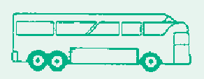


Heavy combination vehicle licence (class HC licence)


Multi-combination vehicle licence (class MC licence)

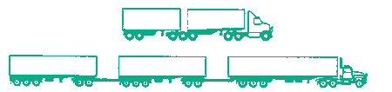

Licence Classes Codes

Codes | Licence Class | May Drive:
R | Motorcycle licence | - A motorbike or motor trike.  - A motorbike towing a single trailer designed to be towed by a motorbike.
C | Car licence | - A motor vehicle (other than a motorbike) with a Gross Vehicle Mass (GVM)  not over 4.5 tonnes and that is constructed or equipped to seat not more than 12 adults (including the driver).  - A tractor or implement.  - A motor vehicle mentioned in item 1 or 2 that is towing a single trailer with a GVM not over 9 tonnes.  - However, this class does not cover a motor vehicle that is towing:  - 2 or more trailers; or  - a single trailer with a GVM over 9t.
LR | Light rigid vehicle licence | - A motor vehicle with a GVM over 4.5 tonnes but not over 8 tonnes.  - A motor vehicle with a GVM not over 8 tonnes that is constructed or equipped to seat more than 12 adults (including the driver).  - A motor vehicle mentioned in item 1 or 2 that is towing a single trailer with a GVM not over 9 tonnes.  - However, this class does not cover a motor vehicle that is towing:  - 2 or more trailers; or  - a single trailer with a GVM over 9t.
MR | Medium rigid vehicle licence | - A motor vehicle with 2 axles and a GVM over 8 tonnes.  - A motor vehicle mentioned in item 1 that is towing a single trailer with a GVM not over 9 tonnes.  - However, this class does not cover a motor vehicle that is towing:  - 2 or more trailers; or  - a single trailer with a GVM over 9t.
HR | Heavy rigid  vehicle licence | - A rigid motor vehicle with 3 or more axles and a GVM over 8 tonnes.  - An articulated bus with 3 or more axles and a GVM over 8 tonnes.  - A motor vehicle mentioned in items 1 or 2 that is towing a single trailer with a GVM not over 9 tonnes.  - However, this class does not cover a motor vehicle that is towing:  - 2 or more trailers; or  - a single trailer with a GVM over 9t.
HC | Heavy combination vehicle licence | - A prime mover to which is attached a single semi-trailer plus any unladen converter dolly.  - A rigid motor vehicle to which is attached a trailer with a GVM over 9 tonnes plus any unladen converter dolly.
MC | Multi-combination vehicle licence | Any motor vehicle or combination of vehicles, other than a motor bike.

Licence eligibility requirements
Applicants are required to satisfy minimum age and driving experience requirements to be eligible for an ACT driver licence.
Applicants MUST learn to drive the respective vehicle types under the supervision of a fully licensed driver of the appropriate class.
Learner licences are not issued for classes LR, MR, HR, HC, MC or for T, H, W, M
or O conditions.
An applicant for an LR or MR licence must be a minimum of 18 years of age and must have held a licence to drive a C class vehicle for at least 12 months.
An applicant for a HR licence must be a minimum of 19 years of age and must have held a licence to drive a C class vehicle for at least 24 months.
An applicant for a HC licence must be a minimum of 19 years of age and must have held a licence to drive a MR or HR class vehicle for at least 12 months.
An applicant for a MC licence must be a minimum of 20 years of age and must have held a licence to drive a HC or HR class vehicle for at least 12 months.

Medical Information

Before applying for a driver licence of any type, licence applicants should check the medical declaration on the reverse side
of the drivers licence application form to ensure that they meet the medical requirements to obtain a driver licence. Any medical conditions that may effect your ability to drive must be reported to the ACT Road Transport Authority.

Public passenger vehicle

O (Public Bus)
T (Taxi)

W (Restricted Hire Car)
H (Hire Car) Condition or
M Hire Car (including restricted) for a motorbike
Q Condition issued to visa holders
Applicants who wish to drive a public passenger vehicle must obtain a public vehicle licence class code T, H, W, M or O condition for their licence.
Applicants must be at least 20 years of age and have held a current Australian full driver licence of the relevant class for at least one year. As well as being medically fit, applicants must meet suitable person requirements which includes their traffic and criminal records.
A Public Vehicle Driver Authority Card is issued to all public vehicle licence holders and must be displayed in the public vehicle at all times when the driver is driving the vehicle.
The purpose of the PVDAC is to provide a visual assurance for passengers of public vehicles that a driver is authorised to drive a public vehicle.
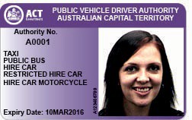

Obtaining an ACT learner driver licence
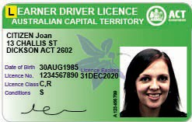
Any person aged 15 years and 9 months or more may apply for a learner driver licence to drive a motor car.
The learner car licence is valid for 24 months. An applicant for a provisional driver licence must have held their learner car licence for a minimum period of six months (regardless of age) and must
have attained the age of 17 years before a practical driving test can be attempted with a government licence examiner OR before a provisional licence can be issued under the Competency Based Training and Assessment (CBT&A) Scheme.
The learner motorcycle licence is valid for 12 months. To obtain a learner motorcycle licence an applicant must be at least 16 years and 9 months old.
Learner motorcycle applicants must complete the government approved Pre-Learner Licence Training Course
before being eligible to apply for a learner motorcycle licence.
A learner motorcycle licence must be held for a minimum of 3 months before a
Pre-provisional Training Course and practical riding test can be attempted.
To obtain a learner driver licence an applicant must:
- provide proof of identity, age and residency; (see page 6)
- complete and pass a ‘Road Ready Learner Licence Course’;
- pass a knowledge test on ACT road rules and safe driving practices;
- pass an eyesight test.
To drive a motor vehicle, holders of a Learner Driver Licence MUST be
accompanied by a person holding a FULL Australian licence of the same class.
Towing is restricted to small trailers not exceeding 750 kilograms GVM.
Holders of a learner driver licence for a motorcycle are NOT permitted to tow.
‘L’ plates MUST be displayed on the front and the rear of the vehicle while it is being driven by the learner. ‘L’ plates must NOT be placed in a position where they obstruct the vision of the learner driver, or the accompanying licensed driver.
They should be of the correct size and colour, and must not obscure the vehicle’s number plates.
Motorcyclists only need to display one ‘L’ plate, at the rear of the bike.

Note 1: ‘L’ plates are meant to be easily seen by other motorists, for your safety and theirs. The plates must be placed at the front and rear of the vehicle in a conspicuous position so they are clearly visible from in front of and behind the vehicle. ‘L’ plates are not clearly visible if they are placed, for example, behind wiper arms, behind rear louvres or inside tinted windows.

It is an offence to drive a vehicle with ‘L’ plates displayed if the driver is not a learner driver.
Note 2: The Road Ready Course and Knowledge Test certificates are valid for two years. If an applicant fails to
obtain their learner driver licence within 2 years of completing the Road Ready Course, they will be required to retake and successfully pass the Road Ready Course and Road Rules Knowledge Test before their original learner licence will be issued.
Where an applicant wishes to renew an expired learner licence, they will be
required to undertake and pass the Road Rules Knowledge Test again.

Proof of identity and residency
Before being permitted to attempt a knowledge test, or obtain a learner driver licence from an Access Canberra Service Centre, you must produce three original proof of identity documents and one proof of residency document:
  - One primary proof of identity (Category A) document;
  - One secondary proof of identity (Category B) document;
  - One POI document must display the applicant’s name in full and not as an initial.
  - One POI document must show a signature.
  - One POI document must show a date of birth.
  - Proof of Residency must be provided as a fourth document if not already satisfied by other POI documents.
- POI document must be current (not expired unless otherwise stated).
- Photocopies are not acceptable unless otherwise stated.
- Certified Photocopies are not acceptable.

Category A documents
(Primary Proof) consists of:
- Australian Photographic Driver Licence (current or expired up to 2 years).
- Australian Birth Certificate (not a Commemorative Certificate and not an extract). Note If the certificate
is not in the name currently used appropriate linking documentation will be required - see Evidence of change of name.
- Australian Passport (expired up to 2 years).
- Overseas Passport (expired by up to 2 years).
- Australian Citizenship Certificate or Naturalisation Certificate.
- Department of Immigration and Border Protection travel document (valid up to 5 years after issue).
- Department of Immigration and Border Protection Evidence of Immigration Status (EIS) ImmiCard (valid to date of expiry).
- Department of Immigration and Border Protection Permanent Resident Evidence (PRE) ImmiCard (valid to date of expiry).
- Department of Immigration and Border Protection Australian

Migration Status (AMS) ImmiCard (valid to date of expiry).
  - Police Officer Photo-identity card (from ACT only).
  - Australian Proof of Age Card (includes NSW Photo Card) with appropriate security features, showing date of issue by an Authority, that is current or expired up to 2 years.

Category B documents
(Secondary Proof) consists of:
  - ACT High Risk Work Licence.
  - Current Medicare Card.
  - Current Credit Card or Account Card, with signature and embossed name from a Bank, Building Society or Credit Union.
  - Current Student Identity Document (with photo and / or signature) issued by an Educational Institution.
  - Current Centrelink or Department of Veterans Affairs Concession Card.
  - Australian-issued Security Guard
/ Crowd Controller Licence (with photo).
  - Australian-issued Firearm Licence (with photo).
  - Current Consular photograph identity card issued by Department of Foreign Affairs and Trade.
  - Current State, Territory, or Federal Government employee photo-identity card.
  - Australian Defence Force Photo- identity card (excluding civilians).
  - ACT Services Access Card issued by the ACT Government (for Asylum seekers).
- Working with Vulnerable People card.

Proof of residency
Proof of residency, if not already established by a Category A or Category B document must be supplied by all interstate and overseas licence holders
transferring to an ACT driver licence, and all original licence applicants.
Provided the applicant’s residential address is listed on the document, the following are acceptable:
- Home Internet Account relating to the nominated physical address paid within the last 6 months.
- MyGov electronic correspondence displaying physical address received in the last 6 months.
- Contract of Purchase, Current Lease or Rental Document for relevant premises (a receipt only is not acceptable) prepared by a real estate agency or ACT Government.
Private rental agreements will not be accepted.
- ACT Revenue Office Rates Notice (current).
- Land Tax Valuation Notice (current).
- Australian Taxation Office Assessment (last or current financial year).
- Utility Accounts relating to the nominated physical address
(Electricity, Gas, Landline Telephone or Water) paid within the last 6 months.
- Pay Television account relating to the applicant’s nominated physical address paid within the last 6 months.

  - Department of Defence Minute Confirmation of address, supported by a Defence Identification Card.
  - Letter from Approved University Residences, accompanied by a Student Identity Card from that University.
  - Bank Statements with evidence of regular purchases in the ACT over the last 3 months.
  - Utility provider welcome letter or bundle advice relating to the
nominated physical address received in the last 3 months.
  - Current interstate registration renewal notice relating to the nominated physical address.
  - Documents from an Australian Government Department or ACT Government Directorate relating to the nominated physical address received within the last 6 months.

Proof of Identity and Residency is subject to change. Contact Access Canberra on 13 22 81 or visit www.act.gov.au/accessCBR
for current requirements.

Evidence of change of name
All documents must be original, not photocopied:
  - full evidence of identity of former name;
AND one of the following (where possible):
  - Marriage Certificate issued by Registrar of Births, Deaths & Marriages (commemorative certificates are not acceptable);
  - Change of Name Registration with Registrar of Births, Deaths
& Marriages Registry Deed Poll registered with relevant authority;
- Divorce Decree Nisi or Absolute (indicating the name being reverted to).

Interstate paper licence holders transferring to an ACT licence, must produce with their licence:
- one category A document; and
- one proof of residency document.

Overseas applicants/ licence holders applying for an ACT licence, must produce with their licence:
- one category A document;
- one category B document; and
- one additional category A or B document: and
- one proof of residency document.
Overseas applicants from an approved country, or recognised “experienced driver” country who are 25 years of age or older, must undergo an eyesight test.
Overseas applicants from non-approved countries must sit and pass the knowledge test, undergo an eyesight test and complete a practical driving test. If the test is assessed as a fail, applicants are required to obtain a learner driver licence and to comply with the conditions that apply, eg. display ‘L’ plates and have a fully licensed driver seated beside them when driving.
An applicant’s overseas licence becomes invalid upon the applicant failing to pass a driving assessment.
If the test is assessed as a pass, the applicant’s licence will be converted, based on years of driving experience and age, to the class of licence they would have been

on had they commenced driving in that Australian jurisdiction.
Overseas applicants may gain their licence through the Competency Based Training and Assessment Scheme (CBT&A) if they wish, however, applicants who choose this option are required to obtain a learner driver licence and abide by the regulations pertaining to that learner driver licence.
After passing a practical driving test, overseas licence holders will be issued a full driver licence.

The Knowledge Test
There are 35 multiple choice questions in the knowledge test. Some questions are mandatory knowledge and must be answered correctly. The remainder are general knowledge questions and four incorrect answers are allowed.
After successfully passing the knowledge test you will be issued with a photographic learner driver licence which is green in colour.

Note: While the information needed to pass the knowledge test can be found in this handbook, many of the questions asked in the test require common sense answers. The test has been designed
to make applicants think through the questions carefully before selecting an answer.
To assist in passing the knowledge test, applicants can practice the test on the Road Ready website at: www.roadready.act.gov.au

Learner driving outside the ACT
ACT learner driver licences are acceptable in all States and Territories of Australia.
Learners should be aware that when driving as a learner in another State or Territory, they MUST comply with the conditions and road laws of that State or Territory and any specific conditions relating to learner drivers. For further information, see Posted Speed Limits, page 39.

The driving test
Prior to making an appointment for a driving test, it is recommended that learner drivers complete a minimum of 50 hours driving practice before
attempting a practical driver assessment.

Making an appointment
Bookings can be made in person at an Access Canberra Service Centre. For Service Centre locations, opening hours and acceptable payment methods visit www.act.gov.au/accessCBR. If you are the holder of an existing ACT learner licence bookings may also be made phoning Access Canberra on 13 22 81.
Do NOT arrange a driving test booking for a date prior to your 17th birthday or if you have NOT held your learner driver
licence for the required 6 month minimum period. You will forfeit your booking
fee and be required to arrange another booking at further cost.
If you are unable to keep your driving test appointment you may change your appointment time, but you must do so at least 48 hours in advance of the time. There is a fee for this service.
Ensure that you are aware of the location for your assessment. If you arrive at the wrong location for your test, you will forfeit your booking fee.

Vehicle requirements
When you attend for your driving test, your vehicle should:
  - be mechanically sound and registered, roadworthy, clean and fitted with
lap sash type seat belts for both front outer seating positions;
  - have a floor mounted handbrake between the front seats, if the test is for a class C, or C with A (Automatic condition); and
  - tyres MUST have at least 1.5mm of tread depth for the full tread width that comes into contact with the road surface.
The Licence Examiner will check your test vehicle to ensure that it complies with these conditions. If it does not, the test will not proceed and you will be required to pay another booking fee to obtain another test time.

During the driving test
Try to arrive for your test about 10 minutes early.
The Licence Examiner will then accompany you while you undertake your test, and will decide if it is safe to let you drive unaccompanied on ACT and interstate roads.
During the practical test, which starts when you enter the test vehicle, the Licence Examiner will expect you to:
  - coordinate the various vehicle controls;
  - maintain direction and speed on the road, while observing all rules and signs;
  - respect the rights and safety of other road users;
- demonstrate a safe defensive attitude;
- do head checks to cover your blind spots on all lane changes, when diverging left or right, or when moving off from the kerb;
- display no undesirable habits such as steering one handed or holding the gear lever when not required;
- not depress the clutch too early when stopping or have it depressed when cornering;
- not rely too much on good brakes eg. late braking;
- obey all relevant speed limits, signposting and road markings;
- have a basic knowledge of English in order to understand the Licence Examiner’s directions; and
- stop at stop signs, and not roll through them.
Applicants should be aware that the Licence Examiner may be accompanied by a Trainee Examiner or Auditor during the practical driving test.

Driver competencies
Your driving ability will be assessed against 22 driver competencies. These competencies have been arranged in a logical order. They are:
- Vehicle controls
- Cabin drill
- Starting up procedure
- Moving off procedure
- Gear changing
- Steering control
- Turns, left and right

- Speed control
- Slowing procedure
- Stopping procedure
- Hill starts
- Give way rules, intersections, traffic lights, roundabouts, traffic signs, road markings, pedestrian crossings, school crossings
- Reversing
- Right angle parking (front in)
- Reverse parallel parking
- U Turns - three types
- Turning around in the road, eg three point turns
- Lane changing, merging, entering freeways
- Overtaking
- Observation skills, visual searching and scanning, hazard recognition
- Compliance with the System of Vehicle Control
- Vulnerable Road Users
- Final drive on Busy Roads and Unfamiliar Roads
Further details about the 23 driver competencies can be found in the Learner Driver Handbook Towards Your “Ps” in the ACT and Logbook.
ACT licence holders renewing their licence must produce:
- A completed licence renewal form;
- An existing ACT photographic licence (or satisfactory proof of identity);
- They must pass an eyesight test (if required); and
- Be photographed for their licence, and pay the required fee.

Competency Based Training and Assessment Scheme (CBT & A)
Learner drivers now have the option of obtaining their provisional driver licence through a Competency Based Training and Assessment (Logbook) Scheme, as an alternative to the one-off practical driving test by a Government Licence Examiner.
Under this scheme, learner drivers are assessed by an Accredited Driving Instructor against the 23 driver
competencies. After successful completion of the competencies, the Accredited Driving Instructor can certify the learner driver as having the necessary competence to be issued a Provisional Driver Licence without the need for a formal Government practical driving assessment.
Further details on this scheme can be found in the Learner Driver Handbook Towards Your “Ps” in the ACT and Logbook.

Note: It is a legal requirement to carry your driver licence with you at all times when driving. You may be issued with an infringement notice if the police stop you and you are not carrying your driver licence.

Licence classifications

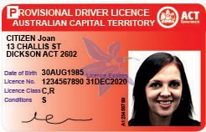
Provisional licence

After you have passed your practical test, or the CBT&A Scheme, you will be issued with a photographic provisional driver licence (red) for a three year period.
It should be noted that if you pass your practical test, or the CBT&A Scheme, in an automatic vehicle, your driver licence will be endorsed with an ‘A’ condition which will allow you to drive automatic vehicles only. You will be required to display ‘P’ plates on your vehicle for three years. You will lose your licence if you accumulate four or more demerit points. However, you can reduce the length of time that you must display your ‘P’ plates to six months and increase your demerit points limit to eight points if you complete an optional Road Ready Plus course.
This course may not be undertaken until six months after gaining your provisional driver licence. Provisional licence holders aged 26 years or older will have their demerit points limit increased to eight points and will be able to remove their ‘P’ plates after six months without having to undertake the course. All Provisional licence holders must attend an Access Canberra Service Centre to
get their Provisional Licence endorsed. Provisional licence holders are restricted to towing trailers up to 750 kilograms GVM for the first 12 months.

Note: ‘P’ plates are meant to be easily seen by other motorists, for your safety and theirs. The plates must be placed at the front and rear of the vehicle in a conspicuous position so they are clearly visible from in front of and behind the vehicle. ‘P’ plates are not clearly visible if they are placed, for example, behind wiper arms, behind rear louvres or inside tinted windows.
Motorcyclists only need to display one ‘P’ plate, at the rear of the motorcycle.
Note: It is an offence to drive a vehicle with ‘P’ plates displayed, if you are NOT the holder of a provisional licence.

Full licence
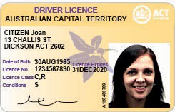
After a three-year provisional period has been completed, you will be eligible to obtain a full driver licence (gold).

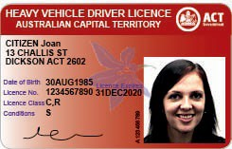
Heavy vehicle licence

Applicants for a heavy vehicle licence class will be issued with a heavy vehicle driver licence (magenta) after successfully passing a knowledge test and a practical assessment.

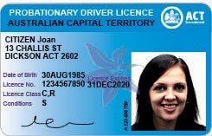
Probationary licence
Drivers/riders returning to driving/riding after a court imposed cancellation or disqualification will be required to hold a probationary driver licence for 12 months before progressing to the previous
licence held.

Note: Drivers are required to carry their driver licence at all times when driving a vehicle. Failure to produce your driver licence when asked to do so by police could result in a substantial fine.
Safe driving tips

- Always obey the speed limit and adjust your speed to suit the road, weather and traffic conditions;
- When changing lanes or pulling out from the kerb always perform a head check to check the blind spots;
- Always use your indicators to give other drivers sufficient warning when required. For example, changing lanes, moving out from the kerb, turning left or right,
diverging to the left or right;
- Never drive when you are tired;
- Always keep a three second safe following distance between you and the vehicle in front;
- Always stop completely at stop signs;
- Consider other drivers and drive knowing you share the road with other road users and respect their right to travel safely; and
- Practice safe and courteous driving behaviour.

ti
r
ce
r

Safe System and Vision Zero

The ACT Government has adopted the “Vision Zero” philosophy, and consistent with this, our policies must prioritise human life and health. Vision Zero is a philosophy – not a
target. It recognises the physical limits of the human body and that people will always make mistakes. It means that we must design, construct and manage the road transport system in such a way that people will not be killed or seriously injured in a crash.
The Safe System approach provides the technical methodology to move towards the Vision Zero goal. The Safe System approach relies on – safe speeds, safe roads and roadsides, safe vehicles, as well as safe people and safe behaviours.

In a Safe System, vehicles are designed to protect the people in them as well as other road users like pedestrians and cyclists in an accident. The Australian New Car Assessment Program (ANCAP) website indicates the level of safety that a vehicle provides in the event of an accident. This information can be found at: http://www.ancap.com.au/home Choose the safest car you can afford and keep it well maintained!
SAFE ROADS
r
SAFE SPEEDS
HUMAN TOLERANCE OF CRASH IMPACTS
SAFE VEHICLES
SAFE PEOPLE
Note: Safe System diagram adapted from Safer Roads, Safer Queensland: Queensland’s Road Safety Strategy 2015 - 21

Where to get further information
Test your knowledge of the ACT Road Rules on the following website:

www.roadready.act.gov.au

Road Ready is designed to help young people in the ACT to become safer and more competent drivers. Visit the Road Ready website for more information:

www.roadready.act.gov.au

You can access the Australian Road Rules on the ACT Legislation Register at

www.legislation.act.gov.au
by selecting Popular Legislation and Australian Road Rules.
For information on speeding and traffic enforcement, visit the ACT Policing website at:

www.police.act.gov.au
or phone 6256 7777.

For further information about driver licensing, vehicle registration and inspection, parking, paying infringements and changing your address on-line, visit the Australian Capital Territory Road Transport Authority website:

www.act.gov.au/accessCBR
or telephone Access Canberra 13 22 81.

For First Aid information, visit the St John Ambulance website:

www.stjohn.org.au
or telephone (02) 6282 2399 (Canberra)
or 1300 360 455 (Australia-wide).

PART B - First steps to safe driving

Seat Belts and Child Restraints
    - Seat belts
    - Child restraints
    - Carrying passengers
    - Technical advice

  - Alcohol and Other Drugs
    - Legal penalties
    - The legal limit
    - Mixing alcohol, drugs and medication
    - Warning signs after taking medication
    - Alcohol
    - Standard drinks
    - Effects of alcohol on the body
    - Effects of alcohol from person to person
    - Random breath testing (RBT)
    - Failing a breath test

  - Using a mobile telephone
  - Vehicle security
  - Points Demerit Scheme
    - ACT points demerit schedule

  - Fatigue
    - What is driver fatigue
    - Facts about fatigue
    - Signs of driver fatigue
    - Tips on avoiding fatigue
    - Community driver reviver
    - Road side rest areas

  - Distractions
16

Seat belts and child restraints
PART B - First steps to safe driving

Seat belts
Seat belts have two purposes:
- Seat belts prevent the occupant hitting the dashboard/ windscreen or from being thrown from the vehicle in the event of a collision (injuries to the head and chest are the most lethal in car collisions).
- Seat belts spread the shock of a crash over larger and stronger body areas, reducing the shock to safer levels.
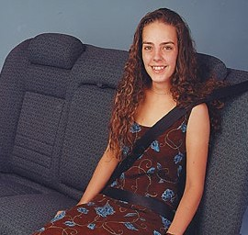
Most front seat belts have “inertia locking” devices. Under normal driving conditions belted occupants can move easily but in an emergency, such as a panic stop or collision, the belt automatically locks to hold the occupant in position.
Photograph courtesy of Safe-n-Sound

Wearing your seat belt correctly
Some of the earlier seat belt designs need to be adjusted to suit the user to provide adequate protection.

Make sure that:
- the belt is done up tightly so that both the lap and sash sections hold you firmly;
- the sash sits over your shoulder (not under your arm) to the opposite hip;
- the lap section of the belt is across your hips, not across your abdomen;
- the belt is flat and without twists; and
- the buckle is at your side, not across your body.
Seat belts and other restraints must be used whenever they are available. If a seat belt is not fitted to a seat occupied by a passenger but one is available alongside, then the passenger is required to move to that position and use the seat belt.
Unrestrained animals within the vehicle and loose objects such as groceries can be dangerous during a collision. Animals should be securely restrained and loose objects should be placed in the boot.

You may not have to use a seat belt in the following circumstances:
- If you have a medical or physical condition, which stops you wearing a seat belt and have a certificate from a medical practitioner.
- If you are doing delivery work that does not entail travelling at more than 25 km/h between stops.

Seat belt use by pregnant women
The medical profession supports the use of seat belts by pregnant women since the most frequent cause of death in vehicle accidents for an unborn child is the death of the mother.

Child restraints
The driver of a vehicle is legally responsible to ensure that any child travelling in that vehicle is restrained in an approved child restraint or seatbelt.
Children are especially vulnerable if they are not protected by the use of a seat belt or an approved child restraint. During a crash or even sudden braking, unrestrained children may be hurled around the interior of the vehicle.
The Australian Road Rules legislation requires all children under 7 years old to be restrained in a suitable approved child restraint that is properly fastened and adjusted.
All passengers who are at least 7 years old or older, but under 16 years old, must be restrained in a suitable approved child restraint which is properly fastened and adjusted, or occupy a seating position that is fitted with a suitable seat belt and wear the seat belt properly fastened and adjusted.

Child restraint standards
Child restraints must meet Australian Standards and must display an AS/NZS 1754 symbol.

Child restraint rules
A child less than 6 months old must be restrained in a suitable approved rearward facing child restraint or capsule.
A child who is at least 6 months old but less than 4 years old must be restrained in either a suitable approved rearward facing or forward facing child restraint with an inbuilt harness.
A child who is at least 4 years old but less than 7 years old must be restrained in either a suitable approved forward facing child restraint with an inbuilt harness,
or a suitable approved booster seat and seatbelt.
A child who is less than 4 years old must not be placed in the front row of seats of a vehicle with two or more rows of seats.
A child who is at least 4 years old but less than 7 years old must not be placed in the front row of seats of a vehicle with two or more rows of seats unless all other seating positions are occupied by a passenger who is also less than 7 years old.
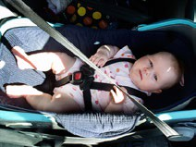
Baby capsule
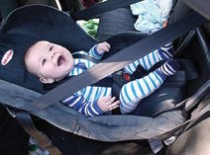
Rear facing child restraint


Forward facing child restraint.
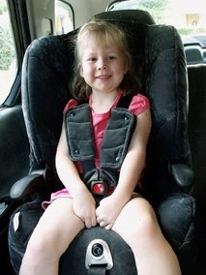
Convertible booster seat

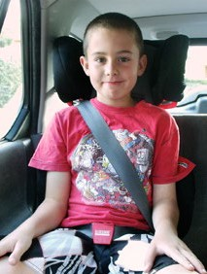
Booster seat with lap/sash seat belt

Carrying passengers
The carrying of unrestrained passengers of any age in the load area (eg station wagons) is prohibited.
The carrying of additional unrestrained passengers of any age after all seating positions with a seat belt are occupied is prohibited.
Drivers are responsible for making sure all passengers are using a seat belt or child restraint.

Technical advice
If you need advice on fitting restraints to your vehicle, you may contact Vehicle Safety Standards of the Road Transport Authority, or the Infant Restraint Loan Service.
Vehicle Inspection and Technical Unit VITU Ph: 62077236
KIDSAFE Infant Restraint Loan Service Ph: 6290 2244
Remember:
  - ALWAYS use a restraint, even for short trips.
  - NEVER put a child into a seat belt with an adult. In a crash the weight of an adult’s body will crush the child.
  - NEVER put two children into one seat belt.

The risks associated with alcohol, drugs and driving

Alcohol, drugs and driving do NOT mix. Any driver who combines alcohol, drugs and driving runs the risk of:
- injury and even death, of themselves and/or others
- damage to his/her vehicle and other property;
- loss of income (and perhaps his/her job); and
- loss of insurance cover since most insurance companies have a disclaimer clause - if you are involved in an accident and convicted of driving under the influence of alcohol or drugs, the insurance company may not pay for any damage or injury.

Legal penalties
Legal penalties for driving over the prescribed alcohol concentration (BAC) limit and/or for taking drugs include:
- possible fine or imprisonment; and
- immediate licence suspension even for a first time offender.
In summary, drivers who drink or take drugs are liable to Court imposed
penalties, and also run the risk of personal financial ruin, injury and even death.
SO – DO NOT DRINK AND DRIVE DO NOT TAKE DRUGS AND DRIVE

The legal limit
A zero alcohol concentration (BAC) applies to a person who holds a
- learner driver licence;
- provisional driver licence;
- probationary driver licence;
- restricted driver licence; or
- foreign driver licence that is not recognised as corresponding to an ACT driver licence.

Or a driver of a:
- public passenger vehicle including a taxi, bus, hire car and restricted hire car;
- dangerous goods vehicle;
- heavy motor vehicle, that has a GVM or GCM of more than 15 tonnes.

Or a person:
- who is learning to drive a heavy vehicle over 4.5 tonnes GVM;
- who is a driving instructor providing driving instruction or assessment to the driver of a vehicle;
- who is a heavy vehicle driver assessor providing driver assessment to the driver of a vehicle over 4.5 tonnes GVM;
- who is a driving supervisor of a learner driver.
In any other case, the legal limit is UNDER 0.05.
The higher the BAC level, the greater the likelihood of being involved in a crash, and of that crash resulting in serious injury or death.

Mixing alcohol, drugs and medication

Driving under the influence of drugs is dangerous, and is an offence.
Tranquillisers and sedatives, antihistamines, marijuana, amphetamines, heroin and LSD can all affect driving skills for considerable periods (drugs can stay in your system long after you take them, so you could test postive hours or even days after consumption). Keep in mind that drugs such as marijuana, heroin and LSD are illegal.
The effect of drugs is multiplied when combined with alcohol and the potential for being involved in a crash is sharply increased. The effect of marijuana on the nervous system has much in common with alcohol. For example, research clearly shows that marijuana affects both the distance you can see, and your ability to react quickly.
In the case of legal drugs, you should check the label on the medication container to see if the medication is likely to cause drowsiness, OR ask your doctor or pharmacist about your medication before drinking alcohol or driving.

Warning signs after taking medication
You should not be driving if you are taking a medication and you feel:
  - drowsy;
  - dizzy, light headed, faint or shaky;
  - aggressive;
  - nauseous; or
  - have blurred or double vision.

Effects of alcohol on the body
Alcohol in the body is not easily removed.
It takes the body about one hour to get rid of the alcohol in one standard drink and this rate of elimination cannot be sped up.
This means that once a person has reached the legal limit (under 0.05) it only requires one standard drink per hour thereafter to stay at that level.
Once alcohol is in the bloodstream its effect on the brain cannot be prevented or controlled.
Black coffee, sleep, cold showers and exercise may alter the way you feel but cannot change your BAC.
The safest BAC for driving is zero regardless of what licence class you hold. As a Learner and Provisional driver, you must not drive after you have consumed any alcoholic drinks or foods containing alcohol.
Drinking any alcohol before driving will affect your reaction, judgement, and ability to drive. Getting back to zero takes time.
Remember, after a heavy night of drinking, you can still be booked for drink driving the next day.

Standard Drinks
Standard drinks all contain about the same amount of alcohol. Be aware that ‘low alcohol’ and ‘boutique beers’ vary in alcoholic content. Most low alcohol beers and wines are about 2/3 the strength of ordinary beers and wines.
Drinking any alcohol in a 24 hour period can put you over the legal BAC limit.

Examples of Standard Drinks
(containing 10 grams of alcohol)

- one middy of full strength beer (285ml)
- approx one port glass of fortified wine (60ml)
- approx one nip of spirits (30ml)
- one can of low alcohol beer (375ml)
- Approx one small glass of table wine (100ml)
- Approx one schooner of low alcohol beer (425ml)
Alcohol can impair driving and riding skills even when the blood alcohol content is less than the legal limit.
Alcohol affects skills in the following ways:
- a false sense of security develops;
- the driver/rider remains unaware of the level of driving/riding impairment;
- concentration deteriorates;
- speed is underestimated;
- reactions become slower;
- distances become harder to judge;
- range and breadth of vision are reduced;
- coping with bright lights becomes increasingly difficult; and
- steering errors are corrected more slowly, and less competently.

Alcohol impairment varies
The level of impairment from person to person depends on:
- the metabolism and size of the individual;
- the rate of consumption and type of alcoholic drink consumed;
- whether food has been eaten before or during the period of alcohol consumption;
- tiredness, mood, health;
- ingestion of other drugs; and
- many other factors.

What is Alcohol Concentration (BAC)
Alcohol concentration (BAC) is a measurement of the amount of alcohol in a person’s blood or breath. It is measured in grams of alcohol per 100mL of blood if the analysis is based on a sample of blood or grams of alcohol in 210L of breath if the analysis is based on a sample of breath measured by a breath analysis instrument.
ACT Learner and Provisional drivers must ensure that they comply with the BAC restrictions applicable in the state or territory in which they are driving.
Drinking alcohol while driving or riding a vehicle is an offence. Drinking whilst supervising a learner driver is also an
offence. Both offences carry a maximum of 20 penalty points.

Random breath testing and drug testing
Random breath testing and drug testing are used in the ACT to help reduce deaths and injuries on our roads by discouraging people from drinking and/or taking drugs and driving.
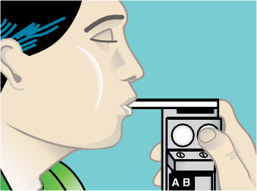

Random breath testing
Police randomly screen test drivers for both alcohol and drugs at the roadside. If you fail a screening test, you will be taken into custody by a Police Officer for a test on a breath or drug analysis instrument. Undertaking a police breath test requires you to provide a sample of your breath by blowing into a breath analysis instrument. A drug test requires you to provide a sample of your saliva for testing using a drug analysis instrument. Unlike alcohol which has a legal limit, any trace of cannabis, methamphetamine or ecstacy in your system while driving is an offence. If you fail a drug or alcohol test, or refuse to take a test, you will be prosecuted for
a drink or drug driving offence and must complete an alcohol and drug awareness course.
If you have been drinking or taking drugs
- DO NOT DRIVE.
- Get a lift with a driver who has not been drinking or taking drugs
- Catch a taxi or bus
- stay the night
If you consumed a large amount of alcohol the night before, you will probably still be over the legal limit to drive the following morning.
Using a mobile telephone

It is an offence to use a mobile phone which is held in the hand while driving a vehicle. This includes sending or reading text messages, video messages and emails. You can only use a mobile phone to make or receive phone calls if your phone has
a hands free connection or is secured in a commercially designed cradle. If your phone is not fitted with a hands free connection or secured in a cradle, you must stop and park the vehicle before
answering or making a phone call. Drivers can also use their mobile phones for GPS purposes and vehicle system functions, provided the mobile phone is securely mounted to the vehicle.

The “do’s” and “don’ts” of using mobile phones while driving

What you can do with a mobile phone, when driving:
- Mobile phones can be used as a driver’s aid for navigational and intelligent highway functions, such as through Google Maps, TomTom App, Garmin App and others, provided the phone is securely mounted to the vehicle.

  - Mobile phones can be used to stream, play or listen to music or audio files
if the phone is not being held by the driver and the use of the phone does not require the driver at any time to touch the phone in any manner.
  - Mobile phones can be used to make or receive a phone call provided the phone is mounted to the vehicle. Drivers and riders are legally allowed to touch the phone if it is securely mounted.
  - If the phone is not mounted, it can still be used to make or receive a phone call, but the driver or rider must not touch or hold any part of the phone at any time, this can be done via Bluetooth or voice activation.

Important road safety information:
  - Use of mobile phones when driving is distracting. Drivers and riders must have full control of the vehicle and
pay attention to road conditions at all times.
  - Motorists using mobile phones for GPS navigation are encouraged to rely on the GPS’ spoken directions to avoid the need to look at the phone when driving.

What you cannot do when driving:
  - It is illegal for drivers and riders to use mobile phones for anything other than for making or receiving a call and for navigational purposes. The following activities are not permitted (even if the phone is securely mounted):
  - texting and audio texting,video messaging,emailing,using social media,using mobile phone applications other than for navigational purposes, and taking photos.

Vehicle Security

Before leaving a vehicle, you must turn off the engine, apply the parking brake and leave it in gear or in the ‘park’ position.
Unless the vehicle is occupied by a person 16 years or older, you must remove the key from the ignition. This rule applies regardless of whether you are leaving
the vehicle for a few moments or for an extended period of time.
Demerit points scheme
Drivers within the ACT who are guilty of a traffic offence will incur a traffic fine and possible demerit points.
With the introduction of a National Points Demerit Exchange Scheme, points incurred interstate will accumulate against your licence in your home State or Territory.
- The holder of a learner driver licence, who incurs 12 or more demerit points within a three year period, will have his or her learner driver licence suspended for three months.
- The holder of a provisional driver licence, who incurs four or more demerit points within a three year period, will have his or her provisional driver licence suspended for three months.
- A provisional licence holder, who has held their licence for at least six months and who has completed the Road Ready Plus (P-Off) Course will have their provisional driver licence suspended for three months if they incur eight or more demerit points.
- The holder of a full or heavy vehicle driver licence, who incurs 12 to
15 demerit points within a three

year period, will attract a three months suspension. Incurring 16 to 19 demerit points results in a four months suspension, and 20 or more demerit points results in a five months suspension. The licensee may elect
for a good behaviour period of 12 months instead. A driver who incurs two or more demerit points during a good behaviour period is suspended for twice the period of the original suspension.
- The holder of a probationary driver licence, who incurs two or more demerit points, will attract
cancellation of that licence and will be disqualified from holding a licence for six months.
- The holder of a restricted driver licence who incurs two or more demerit points, will attract cancellation of that licence.

Remember, your licence is a privilege – not a right.
ACT Points Demerit Schedule
OFFENCE PENALTY POINTS
Exceeding the speed limit by 45 km/h or more 6 Points
Exceeding the speed limit by more than 30 km/h but not more than 45 km/h 4 Points
Exceeding the speed limit by more than 15 km/h but not more than 30 km/h 3 Points
Exceeding the speed limit by 15 km/h or less 1 Point
Using a handheld mobile phone while driving 3 Points
Disobeying a traffic signal 3 Points
Disobeying major regulatory traffic control sign or Police directing traffic 3 Points
Failing to give way 3 Points
Failing to stop and/or give way at pedestrian, school or level crossing 3 Points
Drive with passenger including children and infants not in adjusted/fastened restraint/seatbelt 3 Points
Driving on wrong side of double lines or divided
highway 3 Points
Seatbelt not adjusted/fastened (driver) 3 Points
Motorcyclists not wearing a helmet 3 Points
Careless/negligent driving 3 Points
Improper overtaking and passing 2 Points
Turning or stopping without signalling 2 Points
Turning improperly 2 Points
Failing to keep left 2 Points
Failure to dip headlamps 1 Point
Following too closely 1 Point
Driving at night without headlamps on 1 Point

Fatigue

What is driver fatigue?
Fatigue is a term used to describe the feeling of being ‘sleepy’, ‘tired’ or
‘exhausted’. It affects everyone no matter how experienced a driver you are.
This is your body’s way of telling you that you need to stop and rest or sleep. The best way to avoid driver fatigue is to make sure you have plenty of sleep before you set off. The only way to treat driver fatigue once you have already started driving is to stop and rest until you are refreshed.

Facts about fatigue
Fatigue is associated with the hours when you would normally be asleep. The risk of having a fatal fatigue crash is four times greater between the hours of 10pm and 6am because this is when your body is programmed to sleep.
Your circadian rhythms (natural sleep pattern) cause this type of fatigue and there is nothing you can do to stop it. So if you drive at night or early in the morning your risk of driver fatigue is increased.
The average person needs about eight hours of sleep each night to function normally, while teenagers need even more.
Fatigue is caused by the length of time you have been awake. After being awake for 17 hours the risk of driver fatigue is greatly increased.
The risk of driver fatigue increases with the amount of time you have spent driving. To reduce fatigue you should aim to stop for 15 minutes every two hours. But remember, the only cure for fatigue is a good night’s sleep.

Signs of driver fatigue
Driver fatigue severely impairs your concentration and judgement; it slows your reaction time. In fact, some of the effects of fatigue are as dangerous as the effects of alcohol on your driving. Twenty four hours without sleep has the same effect on your driving ability as having a BAC of .1 which is twice the legal limit for a fully licensed driver.
As you drive, watch for the early warning signs of driver fatigue:
- Yawning
- Eyes feeling sore or heavy
- Poor concentration
- Vision starting to blur
- Restlessness
- Drowsiness
- Starting to ‘see things’
- Slow reactions
- Boredom
- Feeling irritable
- Making fewer and larger steering corrections
- Failing to see road signs
- Feeling stiff or cramped
- Cannot maintain constant speed
- Having difficulty staying within the lane.
If you feel tired and you notice these signs it is time to STOP. REVIVE. SURVIVE.
Regular breaks every two hours will help avoid fatigue.
Some of the ‘signs’ of driver fatigue are very dangerous and you should stop before you are unable to avoid wandering over lane lines or seeing things. The only cure is a good night’s sleep.
Being part of the Safe System means only driving when you are in full control of your vehicle. Sometimes it is not easy to choose not to drive. You might not have a passenger to take over, your passenger may be just as tired, it might not feel like a safe place to stop, you might have important

commitments to meet. In short, you may feel like you have no choice but to drive.
The best thing you can do is allow time in your schedule for a good night’s sleep and plenty of rest breaks on long drives. If you find that you have developed a pattern of driving while fatigued, think
about how you could improve your routine or whether you have alternative ways of travelling to where you are going.

Tips on avoiding driver fatigue
  - Get plenty of sleep before starting off.
  - Avoid starting a long drive at the end of the day.
  - Avoid driving between 10 pm and 6 am or when you would normally be asleep.
  - Share the driving if you can.
  - Aim to stop for 15 minutes every two hours.
  - Pull over and stop when you notice the warning signs of fatigue.
  - Have light snacks rather than fatty foods.
  - Avoid too much coffee or sweet soft drinks.
  - Drink plenty of water – dehydration can cause fatigue.
  - Stay away from alcohol at all costs.
  - Stop before you’re tired.

Microsleep
A microsleep is a brief and unintended loss of consciousness.
It is characterised by head snapping, nodding or closing your eyes for more than a couple of seconds. Microsleeps
occur when you try to stay awake to perform a monotonous task such as driving and can last from a few seconds to a few minutes. During a four second microsleep a car travelling at 100 km/h will travel more than 110 metres while completely out of the driver’s control.
Community Driver Reviver
During peak holiday travel periods, such as Christmas, Easter and holiday long weekends, Community Driver Reviver sites operate in other states.
These are places where drivers should take a break during a long journey.

Roadside rest areas
Rest areas are places where you can park safely and refresh yourself before continuing your journey. They are available 24 hours a day, all year round
and are clearly signposted. Service centres, petrol stations, parks and country towns are other places you can stop and take a break from driving.

Distractions

Distractions which can result in road crashes and trauma include playing loud music, adjusting the radio, inserting CDs in the player or talking on the phone (Refer Page 23).
Other distractions which are high risk behaviour are failing to concentrate on the driving task, failing to watch the road and even talking to passengers.
Driving is a complex task and requires a driver’s full concentration. All drivers
need to be aware of the limitations of their driving experience and the consequences of being distracted while they are driving a motor vehicle.

PART C - Knowing the road rules

Traffic Controls Road markings
  - Lane lines
  - Merging
  - Form one lane
  - Diagonal bars
  - Painted islands
  - Arrows and other road turn markings

- Traffic Signals
- Traffic Signs
  - Regulatory (Mandatory)
  - Warning (Advisory)
  - Information signs
  - Temporary signs
  - Bus priority traffic signals

- Speed Limits
  - ACT speed limit
  - Posted speed limits
  - Speed and red light cameras
  - Radar Detectors

- Intersections
  - Giving way at intersections
  - Types of Intersections
  - T-Junctions
  - Cross roads
  - Roundabouts
- Turning
  - Left-hand turns
  - Slip lanes
- Right-hand turns
- U-turns
- 3-point turns

- Crossings
  - Pedestrian
  - Wombat
  - School
  - School zones
  - Railway
- Parking
  - Where not to park
  - How and where to park
  - Parallel parking
  - Centre of road parking
  - Angle parking
  - Goods vehicles
  - Heavy vehicles
  - Short stay parking
  - Parking meters
  - Ticket machines
  - Park ‘n’ ride
  - 3 for free parking
  - Mobility parking
  - Parking regulations
  - How to avoid infringements (PINs)
  - Parking Infringement Rules
- Miscellaneous
  - Throwing objects at vehicles
  - Failing to stop for police

28

Traffic controls
PART C - Knowing the road rules

Road markings
Many of the road markings you will see, and the rules you must follow, are set out below.

Lane lines
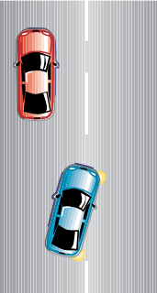
You should keep to the left of these lines. You can cross them to overtake if it is safe to do so, but otherwise you must drive as close to the left hand side of the road as practical.
Broken line in centre of the road
Keep left and never cross these except to enter or leave a driveway.

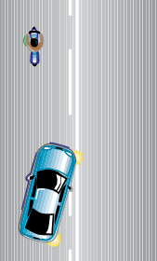
Double lines with an UNBROKEN line closer to you

You may cross these lines to overtake
or do a U-turn, or to enter or leave a driveway, if the road ahead is clear.

Double lines with a BROKEN line closer to you

NEVER cross any single unbroken line at an intersection.

Double unbroken lines
You may only cross these lines to allow the required minimum distance to pass a cyclist only when it is safe to do so.

Keep left and only cross these to enter or leave a driveway, or to allow the required minimum distance to pass a cyclist only when it is safe to do so.

Merging
Lane changing procedures are required when one lane ends and you are required to merge into another lane. This includes using your mirrors, indicators and doing a head check. If you have to cross a lane line, or merge line, you MUST give way to any vehicles in the lane that you wish to enter. You must not cross unless it is safe to do so.

Form One Lane

Merging with continuous lane separation. A must give way to B.
A and B must both be prepared to give way or both may be charged following a collision.
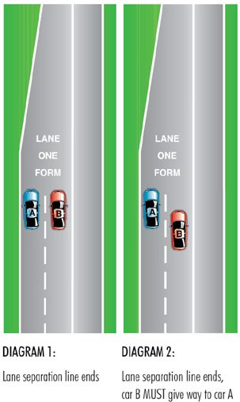
DIAGRAM 1
Be prepared to use lane changing procedures in this situation, ie using your mirrors, indicators and doing a head check.
Sometimes the lane separation line will end and both lanes of traffic are required to merge into one lane. When merging in such cases, the vehicle that is ahead has

the right of way over the trailing vehicle.
DIAGRAM 2
You should use care, commonsense and courtesy when merging.


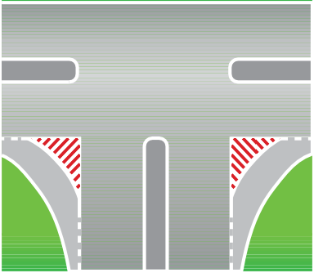
Diagonal bars, painted islands

Do not enter a painted island at a slip lane, as indicated in red in the diagram, or other painted traffic islands, except in an emergency.

Arrows and other road turn markings
When approaching intersections and exit ramps you may find white directional arrows with (or without) the word ‘ONLY’ painted on the road surface. Traffic in lanes with markings MUST proceed as indicated by the marking. It is illegal to ignore the word or the arrows.
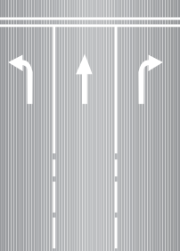
Traffic in left lane MUST turn left. Traffic in centre lane MUST proceed straight ahead. Traffic in right lane MUST turn right.

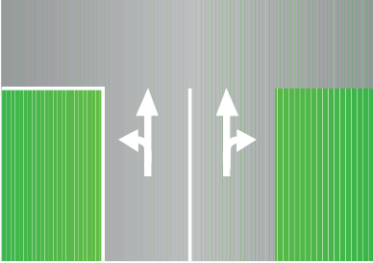
Traffic in the left lane MUST either turn left or proceed straight ahead. Traffic in the right lane MUST either turn right or proceed straight ahead.
The word ‘ONLY’ is used to reinforce the meaning of the arrow.

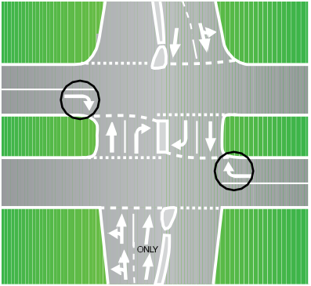
Right turn arrows
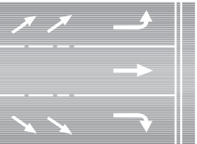
‘Oblique’ arrows are used to warn traffic that vehicles in a particular lane must turn further ahead. If you do not want to turn, you should change into another lane when it is safe to do so well before the intersection.

Hold and turn lines

Stop hold lines
The hold line at a STOP sign shows you where you should stop.
The front of the vehicle should not be past this line.
The road markings at stop and give way signs are gradually being altered to
conform to the new Australian Standard.
Give way hold line
The hold line at a GIVE WAY sign shows you where you must stop, if you are required to give way.

Hold and turn lines
The hold line (A) and turn line (B) are for your guidance when turning at
an intersection. Stay to the left of the turn line.

Coloured bicycle lanes
Coloured bicycle lanes at intersections are to remind motorists that this section of the roadway is a travel lane for bicycle riders. The marking highlights the existence of the ‘bicycle lane’ to motorists and the ‘right of way’ legally provided to the cyclist by a ‘bicycle lane’. Therefore, where you see a bicycle lane and particularly a green coloured area at an intersection, be on the lookout for cyclists. If a cyclist is in the bicycle lane, motorists must give way.
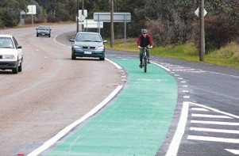
Green bicycle lane for cyclists

Traffic signals

Green circle light alone means you may proceed directly ahead or make a turn in either direction providing it is safe to do so. All turning vehicles give way to pedestrians at traffic lights.
Right turning vehicles MUST give way to oncoming or left turning vehicles not using a slip lane.

Note: Accidents commonly occur at traffic lights when a right turning
vehicle fails to give way to an oncoming vehicle. This usually occurs when there is no right turning traffic light arrow.

Yellow circle light warns that the red signal is about to come on. You must stop at the stop line and not enter the intersection or junction. You may enter the inter- section if you are so close to the stop line that a sudden stop might cause an accident.

Red circle means STOP. Wait at the stop line marked on the road until the signal changes to green.
Green arrow light means you may turn in the direction shown by the arrow.



Yellow arrow light warns that the red signal is about to come on. You must stop at the stop line. Do NOT enter the inter-section or junction if you intend
to go in the direction of the arrow. You may enter the intersection if you are so close to the stop line that a sudden stop might cause an accident.


Red arrow light means you MUST NOT travel in the direction of the arrow. You MUST STOP at the stop line marked on the road at the approach to the signals.
The ARROW signals may be shown with any of the CIRCLE signals. Remember the ARROW signal MUST be obeyed if
you intend to travel in the direction of the arrow.


When only the CIRCLE signal is displayed (for example, after the RED ARROW has switched off) the CIRCLE signal MUST be obeyed.
Pedestrians using pedestrian crossings at traffic lights must obey the signals. The signal may show ‘walk’, ‘don’t walk’ or a person symbol.
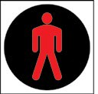
(NOT FLASHING)

Pedestrians must not cross

Flashing yellow traffic signals mean either the traffic signals are malfunctioning or there is a dangerous situation at the intersection or junction. If you see flashing yellow signals slow down and be prepared to
stop or give way, in accordance with the T junction rule or the give way rule.

Give way to the right
When signals are flashing or are ‘out’ the give way to the right rule applies at
intersections, ie give way to all vehicles on your right.
For a T junction, traffic on the terminating street gives way to all traffic on the continuing street when signals are malfunctioning.
Give way to the right also applies at any uncontrolled intersection, or when exiting a slip lane while turning left.
Stop and Give Way signs also require drivers to give way to the right, and also give way to all other approaching traffic.

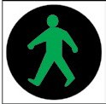
Pedestrians may start to cross

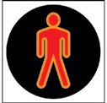 (FLASHING)
Pedestrians must not start to cross but may complete their crossing quickly.
This sign is to remind drivers that they are required to give way to pedestrians when turning at an intersection

Note: Drivers at intersections who are turning left or right must give way to all pedestrians who are crossing.

Traffic signs

Australian road traffic signs may be classified into four basic types:
    - Regulatory signs (mandatory);
    - Warning signs (advisory);
    - Information signs; and
    - Temporary signs.

Regulatory signs (mandatory)
These signs are usually red or black on white background. Drivers are required by law to obey regulatory signs.
At a stop sign, you must bring your vehicle to a complete stop, with no part of the vehicle over the unbroken (hold) line on the road surface. You must then give way to all vehicles approaching from the left
or right.
At a give way sign, the rules are the same as those for a stop sign, except that you are not required to stop if the road is clear and you can continue with safety. If you need to stop to give way, no part of your vehicle can be over the give way (broken/hold) line. Only proceed when it is safe to do so.
Where two oncoming vehicles each face a stop sign or give way sign, a vehicle turning right must give way to the oncoming vehicle ie. the vehicle moving straight ahead.
Where one vehicle faces a stop sign and an oncoming vehicle does not face any sign, the vehicle facing the stop sign must give way to the oncoming vehicle if the oncoming vehicle intends to turn right. Only proceed when it is safe to do so.



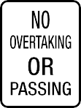

Examples of regulatory signs

Warning signs (advisory)
These signs usually indicate a hazard ahead.

Information signs
These signs usually give directions to local features.

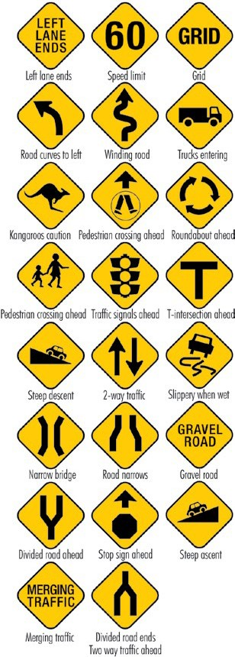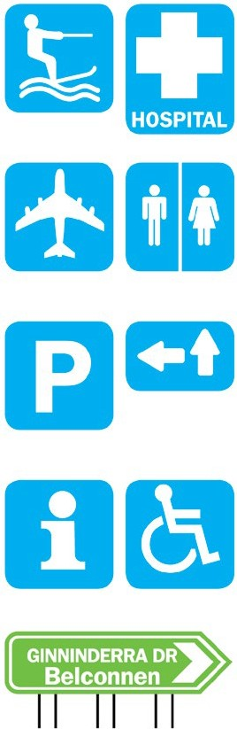

Temporary signs
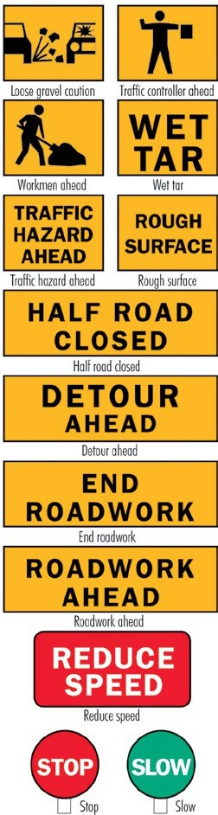
Used usually when a road is under repair.

Bus priority traffic signals
Bus priority traffic signals allow for buses that are in a bus lane, to move off when a white ‘B’ signal is showing, while all other traffic is still held by a red traffic signal.
The ‘B’ signal is activated only when a bus is in the bus only lane at traffic signal intersections.
The white ‘B’ goes off when the red light turns to green, allowing all traffic to proceed.

Bus priority signals give buses a ‘head start’ at lights, in order to make changing lanes and merging in heavy traffic easier and safer.
It should be noted that only Buses, Taxis, Hire Cars, and Motorcycles are permitted to use a bus lane in the ACT. Vehicles other than those mentioned above must not drive in bus lanes.

Speed limits

ACT default speed limit
The default speed limit in a built up area is 50 km/h for the ACT, unless a sign shows a higher or lower speed limit on a length of road.
Houses and streetlights, with the absence of speed signs, denote a built-up area where the default speed limit is 50 km/h. The default speed limit in a rural area in the ACT is 100 km/h.

Speed zones
These are for example; school zones, road worksite zones, shared zones, residential area zones etc, and are signed for the length of the zone. You MUST obey
the speed limit shown on the signs, as applicable, and pay close attention to cyclists and pedestrian traffic.

Safe speed
You will often need to reduce your speed owing to road surface and alignment, low sight distance, intersections, driveways, weather, traffic density, pedestrians, cyclists, wildlife, and on occasion, farm stock. Always drive at a legal speed comfortable for you, your car and your passengers, but at a speed that will not obstruct other road users.
Speed is the most important factor that you can control in the severity of a crash, even if you are not the driver ‘at fault’. It might not feel like you are going very fast, but:
- If you have a side-impact crash with a solid tree, pole or other vehicle
at more than 50 km/h, you or your passengers are extremely likely to be seriously injured or killed.
- If you have a head-on crash with another vehicle at 70 km/h or more you are almost certain to be seriously injured or killed.
- Pedestrians and cyclists don’t have the protection of a vehicle to cushion them in a crash. They rely on you to drive carefully around them. In a Safe System, high - pedestrian use areas have a low speed limit.
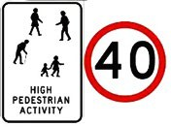
- If a pedestrian or cyclist is hit at over 30 km/h they will be seriously injured and may die.

Be very careful around children
- They don’t understand the road rules.
- They aren’t very good at choosing a safe time to cross the road.
- They can be impulsive.

  - You might be in control of your vehicle, but you can’t control what they do. The best you can do is reduce your speed and be very alert, particularly in school zones, at crossings and around parked cars.

Speed restriction signs
For roads with a speed limit other than the default speed limit of 50 km/h,
a speed restriction sign is the legal maximum speed you may drive at on the length of road, to which the sign is posted. Take into account factors outlined under ‘safe speed’.

Posted speed limits
ACT learner and provisional licence holders are permitted to drive to the posted speed limit in the ACT. ACT learner and provisional drivers / riders travelling in other States and Territories should check with the jurisdiction where they intend to drive for local speed regulations that apply.
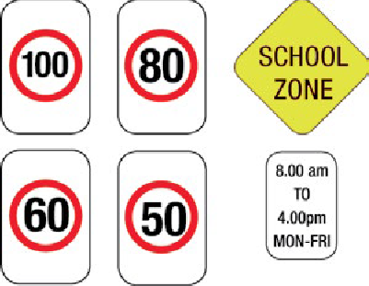
Speed and red light cameras
Fixed speed and red light cameras have been placed at various locations within the ACT to address the dangerous practices of speeding and running red lights.
Sensors embedded in the road detect the presence of vehicles at the red light
cameras. If a vehicle drives through a red light, a signal is sent to the camera, which then takes a series of photographs of the vehicle as well as a close-up of the number plate.
The same sensors also calculate the speed of vehicles and activate the camera if
the pre-set speed limit is exceeded. This occurs regardless of whether the traffic lights are green, red or amber.
Vehicles that are speeding and running red lights at the same time can incur infringement notices for both offences.
The images and infringement details, including the time and location, are digitally recorded and downloaded to the Traffic Camera Office.
A number of fixed speed only cameras have been placed on high volume higher speed roads using sensors in the road or radar detectors.
Point-to-point cameras measure the average speed of a vehicle over a stretch of road and discourage drivers from the practice of speeding up and slowing down to avoid detection by conventional fixed safety cameras. The ACT’s first point-to- point installation on Hindmarsh Drive commenced operation in February 2012.

What to do when the traffic lights change to amber
The amber light is a warning that the traffic signal is about to turn red and you must stop unless you are too close to the intersection to pull up safely. There is
no need for panic braking, which could result in someone running into the back of your vehicle, or for accelerating over the speed limit. However, if you continue through the intersection after the traffic light has turned red, you will receive an infringement notice.
Drivers are reminded that they are required to maintain a sufficient distance from the vehicle ahead to enable
them to avoid a collision should it stop unexpectedly. Road safety experts recommend you keep a gap of at least
three seconds between your vehicle and the one in front.

What happens when a vehicle is photographed
If you are identified as the registered operator of a vehicle detected by a camera for running a red light or exceeding
the speed limit, you will receive an infringement notice in the mail, usually within five working days of the offence.
As with other traffic infringement notices, you have 28 days to either pay the fine or take some other action.
Anyone issued with an infringement notice for a camera detected offence can examine the image produced by the camera, and obtain a copy if required.

Mobile speed cameras
Mobile speed cameras are also in use within the ACT, on an “anywhere, anytime” basis - including in school zones.
Mobile cameras may be operated from inside the vehicles provided for this purpose or mounted outside the vehicle on a tripod. Cameras can operate in both directions (monitor traffic in both directions). Generally vans are used for speed camera operations. Other vehicles
may be used during periods when vans are being maintained.
At night one or more flash units may be deployed to enhance the image taken of motorists committing an offence. These flash units can be deployed from the speed camera vehicle and triggered by infrared light emission.

Radar detectors

It is an offence in the ACT to use, sell or offer for sale or purchase a traffic offence evasion article such as a radar detecting device or radar jamming device.
It is also an offence to drive or park a motor vehicle in the ACT fitted with such a device, and an owner found guilty of an offence is liable for a substantial fine.
The Police may demand that any device fitted to a motor vehicle be surrendered to them, or surrendered within a specified time or manner to any ACT Police Station. Failure to comply may lead to a substantial fine.

Intersections

Giving Way
There are three types of intersections:
  - T-junctions;
  - cross roads; and
  - roundabouts.
Drivers must take action to avoid a crash. Sometimes this may mean giving way at intersections when the law would otherwise not require you to. In other words drive defensively so as to reduce your chance of a crash.
The law says you must give way to:
  - a vehicle on a continuing street if you are on a terminating street at a T- junction (diagrams 5, 6, 7, 8);
  - a vehicle on your right at an uncontrolled intersection (diagram 9);
  - vehicles on your left and right if you face a GIVE WAY sign or a STOP sign (diagram 1);
  - vehicles already circulating on a roundabout (diagram 11);
  - all traffic and pedestrians when entering or leaving a car park or private driveway;
  - all traffic before pulling out from the kerb;
  - vehicles on your right if you face a “Turn Left At Any Time With Care” sign (diagram 12);
  - oncoming or left turning traffic when turning right (diagram 2, 3, 4);
  - all traffic before doing a U-turn or a three-point turn;
- emergency vehicles sounding their sirens and/or flashing their emergency lights;
- pedestrians at traffic signals when you are turning left or right;
- pedestrians crossing the road the driver is entering if you face a GIVE WAYsign or STOP sign or where there are no signs;
- pedestrians on pedestrian crossings;
- pedestrians approaching or on any part of a school crossing;
- all other vehicles when exiting a slip lane (diagram 10).
If in doubt, be prepared to give way to all other vehicles.

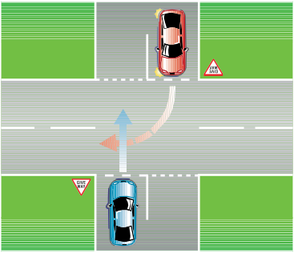
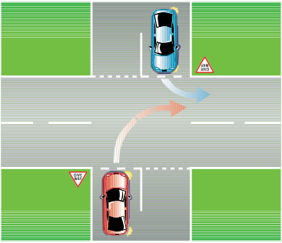
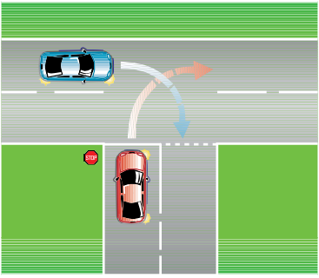
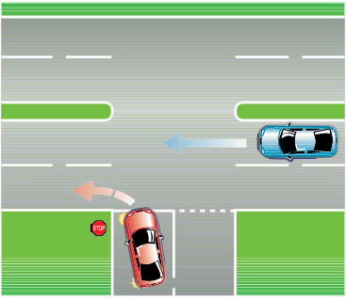
Examples of giving way at intersections
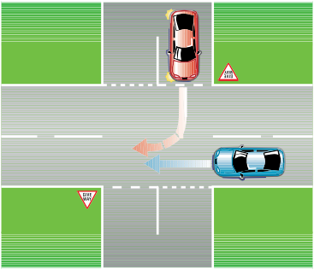
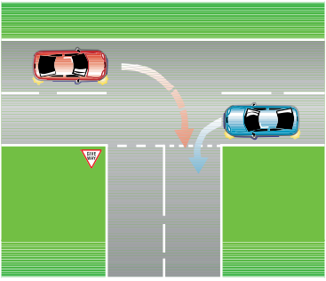
In each of the following diagrams the red car must give way.

1
4

2
5

3
6

Examples of giving way at intersections (continued)
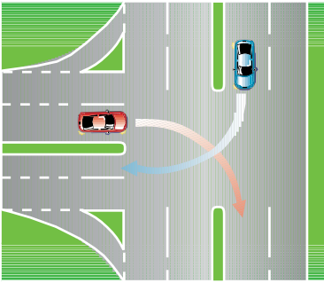
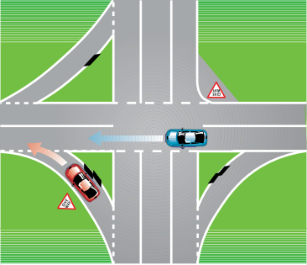
In each of the following diagrams the red car must give way.

7 10

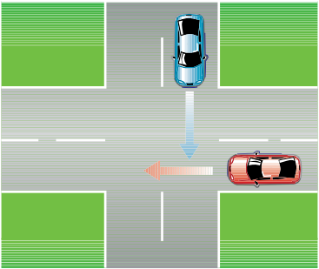
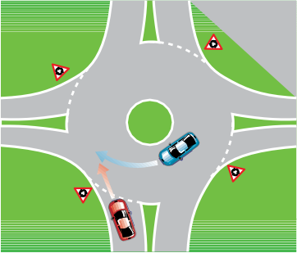
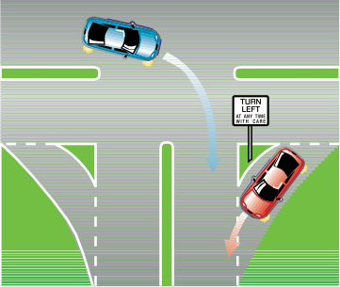
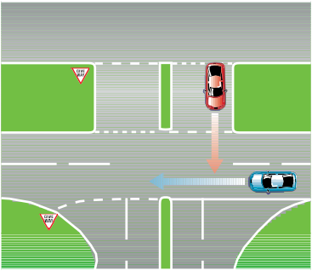 11
8

12
9

Additional give way rules and examples as depicted in the Australian Road Rules

Giving way at a give way sign at a bridge or length of narrow road
A driver approaching a bridge or length of narrow road with a give way sign must give way to any oncoming vehicle that is on the bridge or length of road when the driver reaches the sign.

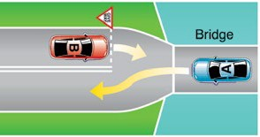
Example 1 - Giving way at a bridge.

Giving way at an intersection (except a T-intersection or roundabout)
If the driver is going straight ahead, the driver must give way to any vehicle approaching from the right, unless a stop sign, stop line, give way sign or
give way line applies to the driver of the approaching vehicle.
A driver at an intersection (except a
T-intersection or roundabout) without traffic lights or a stop sign, stop line, give way sign or give way line, must give way in accordance with this rule.

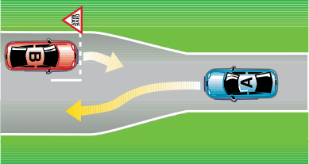
Example 2 - Giving way at a length of narrow road.

In each example, vehicle B must give way to vehicle A.

Example 1 - Driver going straight ahead giving way to a vehicle on the right that is going straight ahead

Example 2 - Driver going straight ahead giving way to a vehicle on the right that is turning right
In each example, vehicle B must give way to vehicle A.

If the driver is turning left (except if the driver is using a slip lane), the driver must give way to:
- any vehicle approaching from the right, unless a stop sign, stop line, give way sign or give way line applies to the driver of the approaching vehicle; and
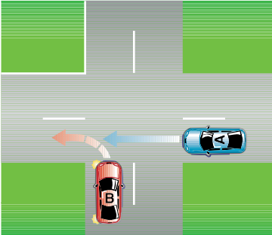
- any pedestrian at or near the intersection who is crossing the road the driver is entering.
Example 3 - Driver turning left giving way to a vehicle on the right that is going straight ahead
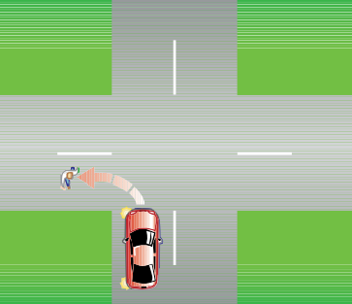
In example 3, vehicle B must give way to vehicle A.
Example 4 - Driver turning left giving way
to a pedestrian crossing the road the driver is entering.
In example 4, the vehicle must give way to the pedestrian.
If the driver is turning left using a slip lane, the driver must give way to:
- any vehicle approaching from the right or turning right at the intersection into the road the driver is entering (except a vehicle making a U-turn at the intersection); and
- any pedestrian on the slip lane.

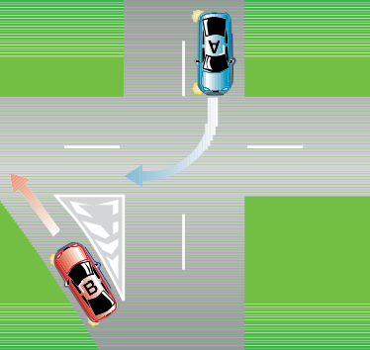

Example 5 - Driver turning left using a slip lane giving way to vehicle that is turning right into the road the driver is entering.
If the driver is turning right, the driver must give way to:
- any vehicle approaching from the right, unless a stop sign, stop line, give way sign or give way line applies to the driver of the approaching vehicle; and
- any oncoming vehicle that is going straight ahead or turning left at the intersection, unless:
  - a stop sign, stop line, give way sign or give way line applies to the driver of the oncoming vehicle; or
  - the oncoming vehicle is turning left using a slip lane; and
- any pedestrian at or near the intersection crossing the road the driver is entering.

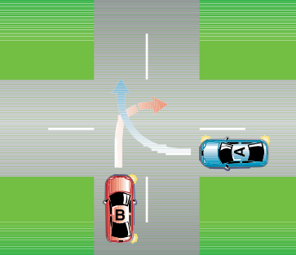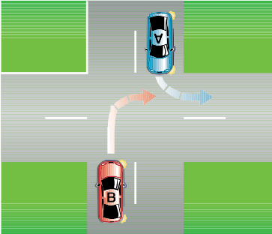

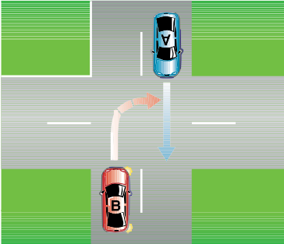
Example 6 - Driver turning right giving way to a vehicle on the right that is turning right into the road the driver is leaving.

Example 7 - Driver turning right giving way to an oncoming vehicle that is going straight ahead on the road the driver is leaving.
In examples 6 and 7, vehicle B must give way to vehicle A.

Example 8 - Driver turning right giving way to an oncoming vehicle that is turning left into the road the driver is entering.
In example 8, vehicle B must give way to vehicle A.
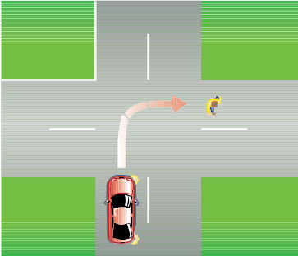
Example 9 - Driver turning right giving way
to a pedestrian crossing the road the driver is entering.
In example 9, the vehicle must give way to the pedestrian.

Giving way when entering a road from a road-related area or adjacent land
A driver entering a road from a road- related area, or adjacent land, without traffic lights or a stop sign, stop line, give way sign or give way line must give way to:
- any vehicle travelling on the road or turning into the road (except a vehicle turning right into the road from a
road-related area or adjacent land);
- any pedestrian on the road;
- any vehicle or pedestrian on any road- related area that the driver crosses to enter the road; and
- for a driver entering the road from a road-related area — any pedestrian on the road-related area and any other vehicle ahead of the driver’s vehicle or approaching from the left or right.
Adjacent land or a road-related area can include a driveway, service station or shopping centre.

Giving way when entering a road- related area or adjacent land from a road
A driver entering a road-related area or adjacent land from a place on a road without traffic lights or a stop sign, stop
line, give way sign or give way line must give way to:
- any pedestrian on the road;
- any vehicle or pedestrian on any road- related area that the driver crosses or enters;
- if the driver is turning right from the road any oncoming vehicle on the road that is going straight ahead or turning left; and
- if the road the driver is leaving ends at a T-intersection opposite the road- related area or adjacent land and the driver is crossing the continuing road any vehicle on the continuing road.
A road related area is any of the following:
An area that divides a road; a footpath or nature strip adjacent to a road; an area that is not a road and that is open to the public and designated for use by cyclists or animals; an area that is not a road and that is open to or used by the public for driving, riding or parking vehicles (eg, a car park).

Driver entering a road from a road-related area giving way to a pedestrian on the footpath and a vehicle on the road.
In this example, vehicle B must give way to the pedestrian on the footpath and to vehicle A.

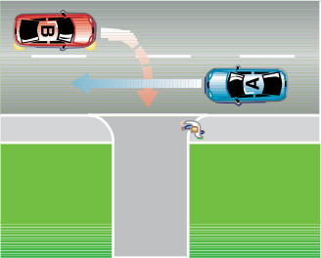

Example 1 - Driver turning right from a road into a road- related area giving way to an oncoming vehicle that is going straight ahead and to a pedestrian on the footpath.

Types of intersections

T- intersections
A T -intersection is formed where a road meets another and does not continue.


Two types of T- intersections
When two vehicles approach a
T- intersection from different roads and there is reasonable possibility of a
collision, the driver of the vehicle on the terminating road must give way to the vehicle in the continuing road.

Giving Way at T- Intersections

Example 2 - Driver crossing a continuing road at a T– intersection to enter a road-related area giving way to a vehicle on the continuing road.
In each example, vehicle B must give way to vehicle A. In example 1, vehicle B must also give way to the pedestrian on the footpath.

In this example, the driver of the red car must give way to the driver of the blue car.

Cross roads

A cross road is formed where two continuing streets intersect.
Before crossing or turning at an intersection, only proceed when you are sure it is safe and that you will not block the road by having to stop within the intersection.

Divided roads (dual carriageways)
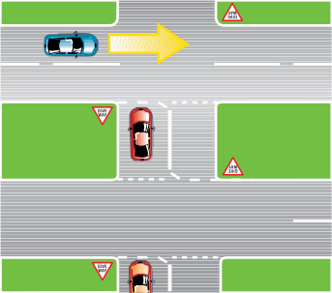


The red vehicle gives way in each case
At unusual intersections, eg
Y- intersections where it is not clear who is on the terminating road, there will generally be GIVE WAY or STOP sign erected to advise drivers which vehicle must give way.
Drivers turning at a T intersection must give way to any pedestrian crossing the road the driver is entering whether they are turning from the continuing road or the terminating road.
Note: If in doubt be prepared to give way to all other vehicles.
Divided road intersection
Road rules and traffic movement at divided road intersections are the same as those at single road intersections.
When a two-way road is divided by a median strip, a GIVE WAY or STOP sign applies to the WHOLE of the intersection.
A vehicle which has stopped adjacent to the median strip in the middle of the
intersection is still controlled by the STOP or GIVE WAY signs.
A wide central median strip may allow a vehicle to proceed to the position shown on the diagram. However, if there is a narrow central strip, a driver should
not enter the intersection unless the intersection can be negotiated without stopping.
The median strip or nature strip within a dual carriageway must not be driven on.

Roundabouts
The following roundabout rules are quoted from the Australian Road Rules and are recognised nationally.

What is a roundabout?
A roundabout is an intersection with:
one or more marked lanes, or lines of traffic, all of which are for the use of vehicles travelling in the same direction around a central traffic island; and a roundabout sign at each entrance.

Roundabout sign

Entering a roundabout from a multi-lane road or a road with two or more lines of traffic travelling in the same direction
A driver entering a roundabout from a multi-lane road, or a road with two or more lines of traffic travelling in the same direction as the driver, must enter the roundabout in accordance with these rules:

Leaving a roundabout less than halfway around it
If the driver is to leave the roundabout less than halfway around it, the driver must enter the roundabout from the left marked lane or left line of traffic.

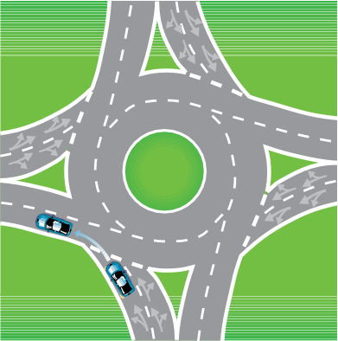
Example 1 - Leaving a roundabout less than halfway around it.
In simple terms: When approaching a multi-lane roundabout with the intention of turning left; approach in the left hand lane, operate the left hand indicator before entering the roundabout and continue to indicate throughout the turn (Example 1 refers).

Leaving a roundabout halfway around it
A driver leaves a roundabout halfway around the roundabout, if the driver leaves the roundabout on a road that is straight ahead, or substantially straight ahead, from the road on which the driver enters the roundabout.
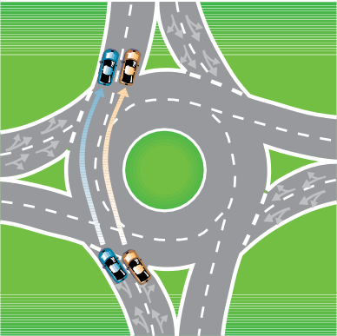
Example 2 - Leaving a roundabout halfway around it.
In simple terms: When approaching a multi-lane roundabout with the intention of continuing straight ahead, approach in either the left or right hand lane (Example 2 refers) and operate the left hand indicator when leaving the roundabout.

Entering a roundabout
It is not a requirement to indicate before ENTERING a roundabout if you are proceeding straight ahead and intend leaving the roundabout half way around it.

Leaving a roundabout more than halfway around it
If the driver is to leave the roundabout more than halfway around it, the driver must enter the roundabout from the right marked lane or right line of traffic.
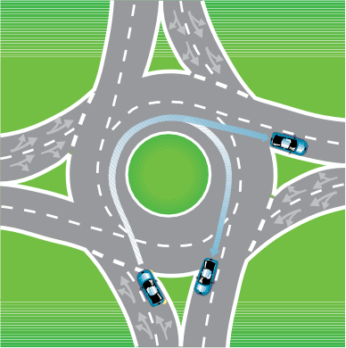

Example 3 - Leaving a roundabout more than halfway around it
In simple terms: When approaching a multi-lane roundabout with the intention of turning to the right, approach in the right hand lane and operate the right hand indicator before entering the roundabout (Example 3 refers), continue to operate the indicator until approaching the exit lane and then indicate left.

Continuing all the way around a roundabout
If the driver is to drive all the way around the roundabout, or more than three quarters of the way around it, the driver must enter the roundabout from the right marked lane or right line of traffic.
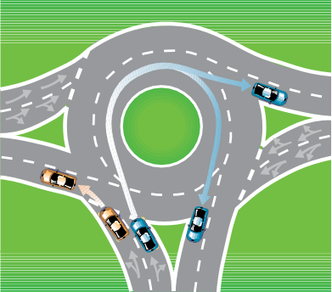
Example 4 - Roundabout with 3 entry points
In simple terms: When approaching a multi-lane roundabout with the intention of continuing all the way around the roundabout (U-turn), approach in the right hand lane, operate the right hand indicator before entering the roundabout and continue to operate the indicator until exiting the roundabout in the right hand lane. (Example 4 refers)

Giving way when entering a roundabout
A driver entering a roundabout must give way to any vehicle in the roundabout.

Driving in a roundabout to the left of the central traffic island
A driver driving in a roundabout must drive to the left of the central traffic island in the roundabout.

Obeying traffic lane arrows when driving in or leaving a roundabout
If a driver is driving in a marked lane in a roundabout and there are traffic lane arrows applying to the lane, the driver must:
- if the arrows indicate a single direction, drive in or leave the roundabout in that direction; or
- if the arrows indicate 2 or more directions, drive in or leave the roundabout in one of those directions.

Giving a change of direction signal when changing marked lanes or lines of traffic in a roundabout
A driver driving in a roundabout must:
- give a left change of direction signal before the driver changes marked lanes to the left, or enters a line of traffic to the left, in the roundabout;
- give a right change of direction signal before the driver changes marked lanes to the right, or enters a line of traffic to the right, in the roundabout.

Giving a left change of direction signal when leaving a roundabout
If practicable, a driver driving in a roundabout must give a left change of direction signal when leaving the roundabout.
The driver must stop giving the change of direction signal as soon as the driver has left the roundabout.
This rule does not apply to a driver if the driver’s vehicle is not fitted with direction indicator lights.

Giving way by the rider of a bicycle or animal to a vehicle leaving a roundabout
The rider of a bicycle or animal who is riding in the far left marked lane of a roundabout with two or more marked lanes, or the far left line of traffic in a roundabout with two or more lines of traffic, must give way to any vehicle leaving the roundabout.

Turning

Left-hand turns
Plan turns well in advance.
use your mirror, look over your shoulder and signal your intention before moving over.
If lanes are marked, use the left lane and, if practicable, turn into the left lane.
You may make left turns from lanes which have a left-turn arrow painted on the road. Remember, you must keep in the equivalent lane as you make your turn.
When turning left from a road that is not a multi-lane road, or from a one way street, you must approach and enter the intersection to the left of any vehicle travelling in the same direction, and as near as practicable to the left edge of the road you are leaving.

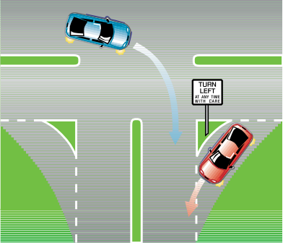Left turn slip lane
12

Left turns must be made from the extreme left of the road.
Move to the left in good time before reaching the intersection. Do not forget to
Left -hand turns using slip lanes.
A driver turning left through a slip lane with or without a Turn Left With Care sign MUST give way to any vehicle on the road the driver is entering or any vehicle turning right at the intersection into the road the driver is entering, or any pedestrian on the slip lane.
All drivers need to exercise caution when entering and exiting slip lanes. In particular, watch out for pedestrians and cyclists at such intersections.

What is a Slip Lane?
A slip lane is a branch of a road for the use of vehicles turning left at an intersection or T-intersection.
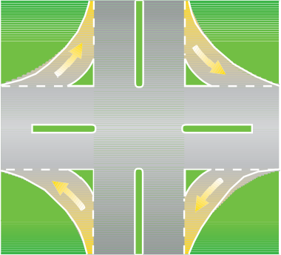
Figures 1 & 2. Shaded areas in diagrams are slip lanes and traffic flow direction is indicated by the arrows.
Fig.1. Slip lanes at an intersection
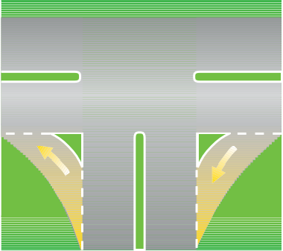
Fig. 2 – Slip lane at a T-intersection

Painted Islands and Concrete Islands
Traffic islands used to shape a slip lane may take the form of a raised construction, generally of concrete, or painted lines (chevrons) on the road surface.

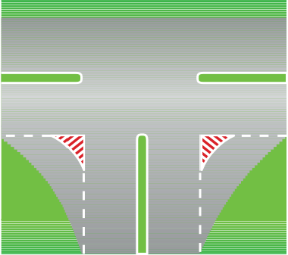
Fig. 3 – Traffic islands
Slip lanes should be regarded as terminating roads.
In the ACT, a slip lane should be regarded in the same way as the terminating road of a T-intersection, ie a driver in a slip lane or on a terminating road of a T-intersection MUST give way.
A driver MUST give way to all traffic when exiting a slip lane whether or not there are signs such as “Turn Left At Any Time With Care”, “Give Way”, or traffic lights.
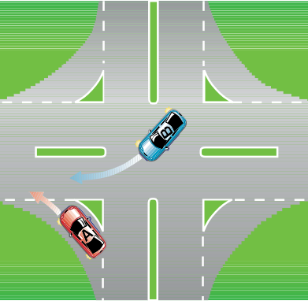
Fig. 4 – Vehicle A (red) gives way to vehicle B

Fig. 5 – Vehicle A gives way to vehicle B

EXCEPTION TO THE RULE:
Slip lane with its own traffic lane
The give way rule does not apply when a slip lane leads into its own traffic lane.
DO NOT cross ANY unbroken line (or lines) when exiting the slip lane to enter the new street, or to merge with other vehicles. Cross only the broken lines.

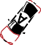Note: When turning left ALWAYS use your indicators.

Left Turn on Red Light
At selected intersections that are controlled by traffic lights, you may be also faced by a sign saying:

Left Turn On Red Permitted After Stopping sign

Fig. 6 – Vehicle A does not have to give way to vehicle B
Many drivers run into the rear of the vehicle ahead while driving through a slip lane. This happens when the driver in front slows or stops to check for vehicles approaching from the right.

REMEMBER:
In the ACT, motorists exiting a slip lane MUST give way to ALL other traffic including PEDESTRIANS on the slip lane.
This sign permits you to turn left even if the traffic light facing you is red.
But remember:
- you MUST first stop your vehicle completely;
- you MUST give way to all other traffic;
- you MUST give way to pedestrians;
- it MUST be safe to then proceed; and
- you CAN only do so where a sign is displayed.

Penalties
A driver failing to stop before turning, or stopping and then turning in an unsafe manner, is liable to a fine and Demerit Points.

Right-hand turns

Unmarked lanes

Laned roads

If lanes are not marked, make your turn from as close as possible to the centre line.
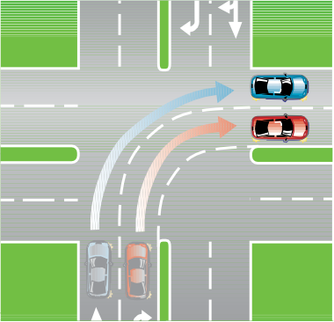
Sometimes special lanes are marked for the use of right-turning traffic.
56

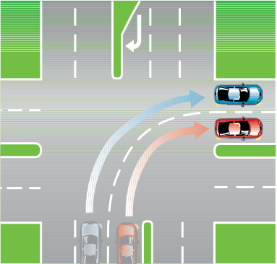
Right turns from more than one lane.
Directional arrows on the road may show that right turns may also be made from other lanes.
When right turns are allowed from more than one lane, you must keep in the equivalent lane as you turn from one road into another.
When turning from a road that is not a multi-lane road, you must approach and enter the intersection from as near as practicable to, but to the left of, the
middle of the road. When turning right from a one way road, you must approach and enter the intersection from as near as practicable to the right edge of the road that you are leaving.

Note: When turning right ALWAYS use your indicators.

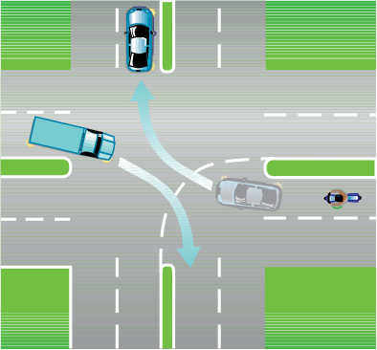
Right turns with opposing vehicles

Opposing vehicles at intersections should turn with the other vehicle passing/ turning on their left.

Do Not Overtake Turning Vehicle

Do Not Overtake Turning Vehicle sign
Motorists should remember that trucks and other long vehicles (more than 7.5 metres in length) which show this sign may have to use more than one lane when turning. Be prepared to give long vehicles such as trucks and buses room to turn.

Motorcycles and bicycles
Take care not to squeeze these smaller vehicles into the kerb.

U-Turns and Three Point Turns
These are the basic methods of turning a vehicle to face in the opposite direction. When making a U-Turn or three point turn you must give way to all other traffic.

U–turns
The following U-turn rules and examples have been taken directly from the Australian Road Rules and are recognised nationally.

Beginning a U–turn
A driver must not begin a U–turn unless:
  - the driver has a clear view of any approaching traffic; and
  - the driver can safely make the U–turn without unreasonably obstructing the free movement of traffic.

Giving way when making a U–turn
A driver making a U–turn must give way to all vehicles and pedestrians.

Making a U–turn contrary to a no U– turn sign
A driver must not make a U–turn at a break in a dividing strip on a road if there is a no U–turn sign at the break in the dividing strip.
A driver must not make a U–turn on a length of road to which a no U–turn sign applies.
A no U–turn sign on a road (except a no U–turn sign at an intersection or at a break in a dividing strip) applies to the length of road beginning at the sign and ending at the nearer of the following:
    - the next intersection on the road;
    - if the road ends at a T– intersection or dead end — the end of the road.

No U–turn signs

No U–turn sign No U–turn sign
Standard sign Variable illuminated message sign

Making a U–turn at an intersection with traffic lights
A driver must not make a U–turn at an intersection with traffic lights unless there is a U–turn permitted sign at the intersection.

U–turn permitted sign

Making a U–turn at an intersection without traffic lights
A driver must not make a U–turn at an intersection without traffic lights, if there is a no U–turn sign at the intersection.

Starting a U–turn at an intersection
A driver making a U–turn at an intersection must start the U-turn:
- if the road where the driver is turning has a dividing line or median strip — from the marked lane nearest, or as near as practicable, to the dividing line or median strip; or
- in any other case — from the left of the centre of the road.

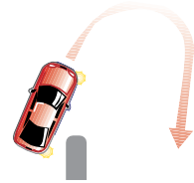Three point turns
Three point turns are completed in three movements using forward and reverse gear.

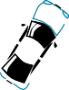Starting a U–turn on a road with a median strip

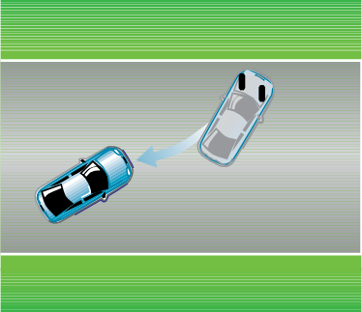
First move

Second move
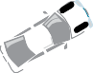
Third move

Crossings

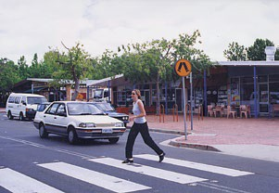
Pedestrian crossings
Pedestrian crossings are marked by white stripes on the roadway and special signs.
Motorists must give way to pedestrians and cyclists on a marked pedestrian crossing.

Note: It should be noted that some crossings in the ACT have now been made more distinguishable by the implementation of flashing amber lights. These crossings have the same regulations as crossings without lights and should be negotiated in the same way.
DO NOT overtake a stationary vehicle at a pedestrian crossing.

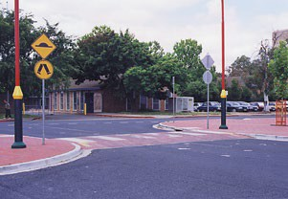
Wombat crossings
Wombat crossings are used where there is a need to slow the speed of vehicles to
make the crossing safer for use by children or the elderly and slow pedestrians.
These crossings are marked across a raised speed hump type section of street, and
are clearly signposted. Motorists MUST give way to pedestrians and cyclists on a marked wombat pedestrian crossing.

DO NOT overtake a stationary vehicle at a wombat pedestrian crossing.

School crossings

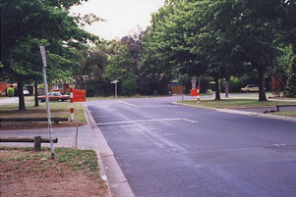
School crossings are marked by white lines on the roadway, and by red and white striped posts on each kerb.
School crossings are operative only when a traffic sign or flag with the words ‘School Crossing’ or ‘Children Crossing’ is placed on or near the crossing.
Vehicles MUST stop at the white hold lines and remain stationary until the crossing is clear of all pedestrians.

DO NOT overtake a stationary vehicle at a school pedestrian crossing.

Pedestrian refuge zone

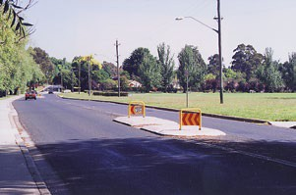

Pedestrian refuge zones are designed to provide a safe area for pedestrians when crossing busy streets.
Pedestrian refuge zones are yellow and red with “Keep Left” printed on them.
They are located on refuge islands on school crossings within school zones, at shopping centres and in high traffic areas.
They are located in most suburbs, and additional pedestrian refuge zones will be installed throughout the ACT as the need is assessed.
When you see a yellow and red refuge zone, slow down and watch for children and other pedestrians crossing the road.

School Zones
Areas around schools have been designated school zones. School zone signs erected near schools in the ACT
are designed to be ‘closed’ or ‘open’. When the sign is ‘closed’ a normal default 50km/h speed limit applies unless signposted otherwise.
When the sign is ‘open’ a special speed limit of 40km/h applies at the times and days indicated on the sign.
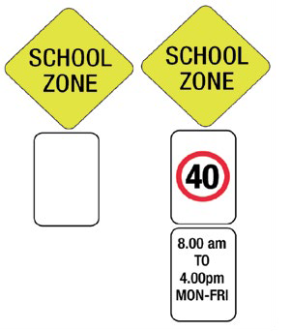
‘Closed’ ‘Open’
Lower part of sign swings up/down to open/close the zone.

Level crossings
While there are few tramway and railway crossings in the ACT, it is important to be aware of the rules and regulations for these level crossings in the ACT.
A level crossing is an area where a road and a railway meet at substantially the same level, whether or not there is a level crossing sign on the road at all or any of the entrances to the area.
You must obey “Stop” and “Give Way” or any other warning sign at tram or railway level crossings.



ONLY
You must not enter a level crossing if
- traffic lights, warning lights (for example, ‘T’ signal traffic light, twin red lights or rotating red lights); or
- a gate, boom or barrier at the crossing is closed or is opening or closing; or
- a tram or train is on or entering the crossing; or
- a tram or train approaching the crossing can be seen from the crossing, or is sounding a warning, and there would be a danger of a collision with the tram or train if you entered the crossing; or
- you cannot drive through the crossing because the crossing, or a road beyond the crossing, is blocked.
- if your vehicle or vehicle load is at risk of coming close to the overhead wires on the tramway while crossing the intersection.
You must leave the level crossing as soon as you can do so safely.



Level crossing signs

Parking

Where not to park your vehicle:
  - on the right hand side of the road with your vehicle facing the oncoming traffic;
  - in a “No Stopping” zone. “No Stopping” means a vehicle may NOT stop or park on the street for any purpose;
  - in a “No Parking” zone, stopping is permitted. Where signs indicate “No Parking”, a vehicle may stop to pick up or set down passengers or goods only and must drive on within two minutes of stopping. The driver MUST remain with the vehicle
at all times. A vehicle is declared unattended if a person is more than three metres away from the closest point of the vehicle;
  - on a dividing strip, nature strip, painted island, footpath, bicycle path or shared path within a built up area;
  - in a “Loading Zone”, unless you are loading/ or unloading goods to or from a vehicle specifically permitted to do so;
  - across or within a passage, thoroughfare, entrance driveway or foot-crossing;
  - double parked;
  - in a “Taxi Zone”;
  - upon a bridge, or 20 metres before or 10 metres after a pedestrian crossing or school crossing, and 10 metres before and 3 metres after a marked foot crossing;
- Within 20 metres of the nearest point of an intersection controlled by traffic lights, and 10 metres from an intersection without traffic lights;

Intersection
- parking is permitted within a
T-intersection along the continuous side of the continuing road at the intersection as shown below, unless a parking sign indicates otherwise;
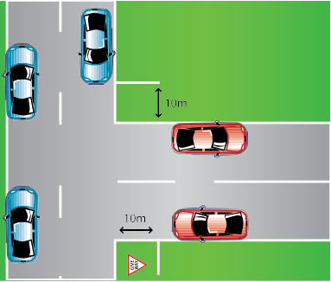
T Intersection
- at a bus stop, or on the road, within 20 metres before a sign on the road that indicates the bus stop, and
10 metres after the sign, unless you stop at a place on a length of road, or in an area, to which a parking control sign applies and you are permitted to stop at that place under the Australian Road Rules;

- so that any part of the vehicle overhangs any line marking or marked parking bay;
- anywhere other than a marked bay, if in a car-park with marked parking bays;
- on a crest or curve outside a built-up area unless:
your vehicle is visible for 100 metres to drivers approaching the vehicle and travelling in the direction of travel of traffic on the same side of the road as the vehicle; or
you stop at a place on a length of road, or in an area, to which a parking control sign applies and you are permitted to stop at that place under the Australian Road Rules.
- within 1 metre of a fire hydrant.
You must not stop or park on a road in a position that obstructs access by vehicles or pedestrians to or from a footpath ramp or a similar way of access to a footpath, or a bicycle path or passageway unless:
- you are dropping off or picking up, passengers; or
- you stop in a parking bay and you are permitted to stop in the parking bay under the Australian Road Rules.
You must not stop on, or across, a driveway or other way of access for vehicles travelling to or from adjacent land unless:
- you are dropping off, or picking up, passengers; or
- you stop in a parking bay and you are permitted to stop in the parking bay under the Australian Road Rules.


Blocking a driveway
In the example, the vehicle marked with an ‘X’ is stopped in contravention of the rule above.
You must not stop on a road within three metres of a public post-box, unless you:
- are dropping off, or picking up, passengers; or
- stop at a place on a length of road, or in an area, to which a parking control sign applies and you are permitted to stop at that place under the Australian Road Rules.
- You must not double park your vehicle
  - that is stand it on the road alongside a parked car.

How and where to park
The rules relating to parking are set out in the Australian Road Rules.
Vehicles should always be parked parallel and close to the left-hand side of the street facing in the direction the vehicle would travel except when otherwise indicated
by a traffic sign or road marking (ie angle parking, centre of the road parking).

Parallel parking
You MUST park:
    - in-line with, and as close as practicable to, the kerb;
    - entirely within any marked bays;
    - at least one metre from any vehicle in front and behind.
The recommended distance from the kerb is 30 cms.

Centre of road parking
Where parking is allowed along the centre of the road, marked bays are usually set out at right angles to the traffic.
You must drive out forwards, do NOT reverse.

Angle parking
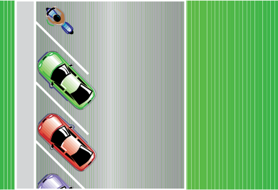
You must angle park at the kerb if signs or marked bays indicate angle parking. You must always park at a 45 degree angle, unless a sign or line marking indicates otherwise.

Goods Vehicles
Goods vehicles primarily designed to carry goods may park in loading zones for no longer than 30 minutes unless signposted otherwise, for the purpose of loading or unloading ONLY.

Note: Other vehicles may park in loading zones for the purpose of loading and unloading goods only if they have the appropriate parking permit affixed to the windscreen of the vehicle.
Vehicles not loading or unloading goods may be issued with a parking infringement notice.

Heavy Vehicles
Vehicles used for commercial purposes with a GVM of more than 3.75 tonnes, longer than 6 metres or more than
2.6 metres high, are not permitted to park on residential land containing a multi-unit development.
There are additional restrictions on the parking of heavy vehicles in excess of
4.5 tonnes GVM in residential areas.

For further information, including information about parking heavy vehicles on residential leases, please contact Parking Operations on 6207 7200.

Short stay parking
Four types of short stay parking are available in Canberra. These are pay and display ticket machines, ticket, boom-gate and time limited parking.

Pay and display ticket machine
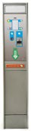
You MUST immediately upon standing or parking in a designated parking area, insert the specified coins or use a debit or credit card if available at the nearest pay and display ticket machine. Payment can also be made through the Parkmobile app.

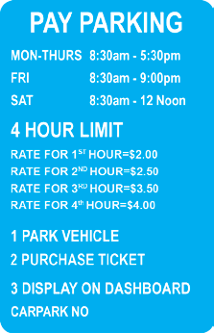
Ticket machines
You must purchase a ticket immediately AFTER parking your vehicle and display the ticket face up on the dashboard of your vehicle.

Park ‘n’ ride

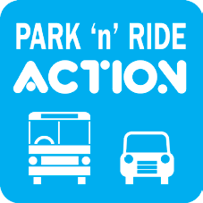

Park‘n’ride allows you to park your vehicle for free in a Park‘n’ride zone provided that you display a Park‘n’ride permit in those areas that require a permit.
Park‘n’ride permits are available at ACTION My Way offices. These permits are valid for one calendar month only.
To obtain further information in relation to Park‘n’ride permits and locations, visit www.transport.act.gov.au

3-for-FREE parking

Free parking in Belconnen, Woden and Tuggeranong for cars carrying at least three people, arriving between 7.30am and 9.00am (10am in Tuggeranong), Monday to Friday.
For more information please telephone 6207 7200.

Disability parking sign

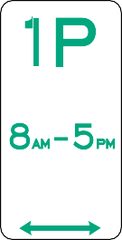
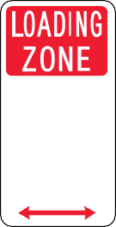
Throughout Canberra, parking spaces are reserved for people with a mobility disability who display a Disability Parking
Permit on their windscreens. These spaces are conveniently located at all major and suburban shopping centres, hospitals, health and community centres, business areas and places of interest.
Considerable penalties apply for improper use of permit required zones in the ACT.
For further information about Parking Permits, telephone 13 22 81 or write to:
Manager
Transport Licensing PO Box 582
DICKSON ACT 2602, or
www.act.gov.au/accessCBR

Some examples of parking signs

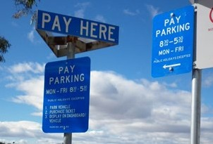
Parking regulations
Under the ACT Road Transport legislation, the registered operator of a motor vehicle is responsible for parking offences incurred by that motor vehicle.
However, if the registered operator is not the actual offender, he or she will not be held liable if:
- the registered operator supplies a declaration stating the name and address of the person driving at the time of the offence; or

- the registered operator supplies documented proof that at the time of the alleged offence, the vehicle was stolen or illegally taken or used.

Note: If you sell a vehicle you must provide a notice of disposal to the RTA which includes the name and address of the new operator. If you fail to do this you remain liable for any outstanding parking infringements.
Failure to pay a parking infringement penalty within the prescribed period will result in suspension of your ACT licence and/or registration, or right to drive in the ACT.

How to avoid Parking Infringement Notices (PINS)
ALWAYS read parking sign carefully and make sure you understand the sign.
Parking signs apply 24 hours a day and 7 days a week, unless restricted hours are stated on the sign.
Look for the signs on upright poles or on walls adjacent to the parking surface.

Parking – minimum distances from other vehicles and dividing strip

more than
1m

more than 3m less than 3m less than 3m

If a road has a continuous dividing line or dividing strip you must position the
vehicle at least 3 metres from any dividing line or dividing strip, unless information
on a parking control sign indicates otherwise.
If the road does not have a continuous dividing line or dividing strip, you must position the vehicle so there is at least 3 metres of road alongside the vehicle that is clear for other vehicles to pass, unless information on a parking control sign indicates otherwise.

Parking infringement

The Rules
If you don’t pay your parking fines on time, you will lose your right to drive.
You have just 28 days to pay your parking fine from the day the ticket was issued.
If you don’t pay within 28 days you have 28 more days, but have to pay an
administration charge, as well as your fine.
If you still don’t pay, your licence or registration will be suspended. You will have to pay your fine and the administration charge, before you can drive, or before the vehicle may be used again.

How to keep on the right side of the law
Best of all, park according to the rules and don’t get an Infringement Notice.
If you do get an Infringement Notice, pay it within 28 days to avoid the extra administration charge.
If you are paying by mail, please allow enough time for the payment to be received by the due date. Late payments will attract the extra administration charge.
If you do have to pay the extra administration charge, pay it (and the fine too if that isn’t already paid) within 28 days.

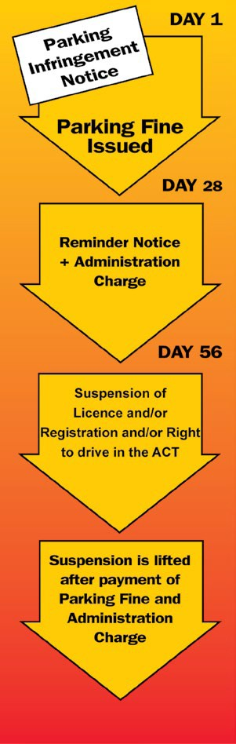
WARNING: You risk serious traffic offences, if you are found to be driving a vehicle with suspended registration or driving while your licence is suspended.
Miscellaneous

Throwing objects at vehicles
It illegal to throw objects at, or place objects in the way of, motor vehicles or bicycles so as to risk the safety of drivers, riders or passengers. This offence also applies to throwing objects at other vehicles, and covers actions such as car drivers throwing objects at other car drivers, or pedestrians throwing objects at cars or trucks. These laws recognise the significant risk to the safety of road users posed by this type of behaviour.

Failing to stop for police
You must stop for police when you are given a signal to do so. Make sure you find a safe place to pull over, such as an emergency break down lane or side street.
Drivers who commit the offence of ‘failing to stop for police’ are subject to a maximum penalty of 12 months
imprisonment and up to $15,000 in fines, increasing to three years imprisonment and up to $45,000 for repeat offenders.
Drivers can also have their licence suspended and vehicle seized. The registered owner of a vehicle which was used to commit the offence can also face serious penalties if they do not provide information to police about who was driving the vehicle when the offence was allegedly committed.

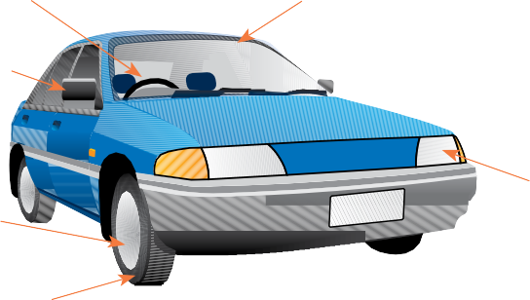
TYRE CONDITION AND TREAD DEPTH TYRE PRESSURE
BRAKES
LIGHTS
REAR VISION MIRRORS
WINDSCREEN WIPERS AND WASHERS, WINDSCREEN CLEAN AND FREE OF CRACKS
STEERING AND HORN

Preparing to drive
PART D - Road craft
Before attempting to drive you must:
  - know the rules of the road as set out in this handbook;
  - know your vehicle and its controls; and
  - make sure your vehicle is safe to drive.

Mechanical checks
  - Brakes - do they operate effectively and evenly? Does the handbrake stop the vehicle from rolling on an incline?
  - Headlights - are they of even power and focus? Does the low-beam switch work? Do the parking and number plate lights work?
- Tail and stop lights - do the tail lights work and show a red light to the rear? Do the stop lights work when you apply the foot brake?
- Turn indicators - check these frequently. Replace bulbs that have blown.
- Wheels - are they properly aligned and balanced? Unbalanced wheels can
cause excessive tyre wear or even loss of control. Do not forget the spare wheel when you check your tyres.
- Steering -does the steering wheel have excessive free movement?
- Windscreen wipers.
- Horn.
- Rear reflectors.

Pre-drive checks
- Look for obvious faults or damage around the outside of your car before you drive away.
- Make sure there is nothing in the way (especially children, bicycles, tricycles or toys).
- Keep your mirrors, windows and headlights clean.
- Do not place stickers or ornaments where they can distract or block your view of the road.
- Make sure there are no loose items in your car that could prove dangerous.
- Close all doors properly.
- Make sure the driver’s seat is properly adjusted.
- Make sure your seating position is high enough to get a clear view of the road.
- Adjust your mirrors after you have adjusted the driver’s seat.
- Make sure you and your passengers are wearing seat belts.
- Check the controls. You should know where each of the controls are and how they work.
- Check gauges and warning lights.
- Be sure you have enough fuel for your trip.

Opening car doors
- A person must not cause a hazard to any person or vehicle by opening a door of a vehicle, leaving a door open or getting off or out of a vehicle.

Getting under-way

Moving off
Before entering traffic remember to:
- ensure there will be no danger to pedestrians;
- look both ways for following and oncoming traffic including bicycles;
- clearly signal your intention.
When leaving a private driveway or an off- street parking area give way to all traffic on the road and pedestrians and cyclists on the footpath.

Keeping a lookout
- Get the big picture. Do not just look at the road in front of your car. Tunnel vision is dangerous.
- Look well into the distance, keep your eyes moving to both sides and check your mirrors.
- Make head checks to help you get the big picture.


The shaded areas are called “blind spots” because you cannot see vehicles travelling there without looking over your shoulder.

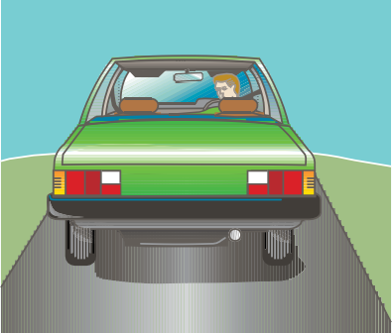
Reversing
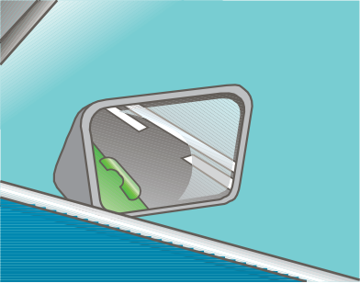
When reversing, do not rely on your mirrors alone. Turn your head and look over your shoulder.
Adjust your mirrors to give the best possible view
Correctly adjusted mirrors provide the widest rear view possible while keeping the blind spots to a minimum.

Keeping your distance
It is important that you do not follow another vehicle too closely. Tailgating (following too close to the rear of another vehicle) is the cause of most chain or ‘concertina’ collisions. If the front vehicle stops suddenly when you are tailgating a crash is inevitable - you will not be able to stop in time.
If you keep plenty of space (a ‘buffer zone’ or space cushion) around your vehicle, you will be better able to avoid a collision. Stay as far away as driving conditions allow. Most motorists underestimate the distance required to stop their vehicle.

Space in front
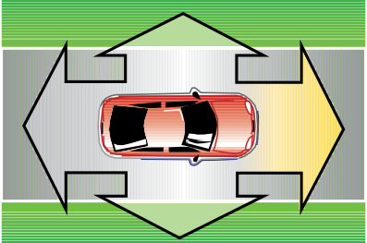
Buffer zone

Safe following distance
When following another vehicle, an estimation of the appropriate following distance can be obtained by using the ‘three second rule’.
To use this following distance rule, you should keep a gap of at least three seconds or more between your vehicle and the one ahead. This means that it should take you at least three seconds (minimum time)
to get to where the car in front is at any given moment.
The three second rule relies on alert drivers driving vehicles in good mechanical condition, fitted with good tyres and driving on a good road surface in good traffic and weather conditions. Otherwise allow more distance.

To check that you are at least three seconds back:

Pick an object by the side of the road, such as a tree or post, that will soon be passed by the vehicle ahead.
As soon as the rear of the vehicle ahead passes the object, say to yourself “one thousand and one, one thousand and two, one thousand and three”.
You should take the full three seconds, or more, that it takes to say this, for the front of your vehicle to reach the same object.
If you get there before you finish saying it - you are too close to the other vehicle.
Novice drivers and drivers of larger vehicles such as buses and trucks, and drivers towing trailers or caravans, will need to allow longer following distances.
In poor road and weather conditions (eg. gravel surfaces or frosty/wet conditions), or if you are tired or driving at night, you should also allow a much
greater distance from the vehicle in front.
In these circumstances, you should at least double the time elapsed, ie from three seconds to at least six or seven seconds, and even more to be certain.
If another vehicle moves between you and the vehicle in front, slow down briefly to allow your vehicle to fall back to a safe following distance.

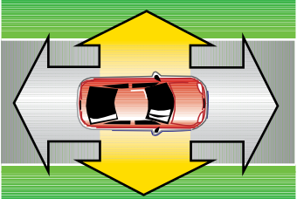
Space to the sides
Buffer zone
Just as you need a buffer zone/space cushion in front, you also need space to the sides to protect you from mistakes. You need to keep sufficient space from vehicles that are:
  - alongside - if you have a choice, do not drive next to another vehicle for too long;
  - oncoming - by keeping to the left you make sure that you reduce the danger of being sideswiped by oncoming vehicles;
  - parked - keep a space between you and parked vehicles. Someone may get out of a parked car suddenly, a pedestrian may step from between cars, or a driver may pull out without looking.
Where possible allow a minimum of 1 metre between your vehicle and the parked vehicle.

Space behind
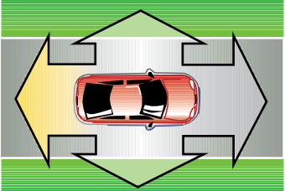
Buffer zone
Rear-end collisions are fairly common and are in fact, the fourth most common injury producing accident.
The driver behind has more control over the space cushion than you do.
However, there is plenty you can do to protect yourself.
When you are driving:
- keep a steady speed;
- signal in advance when you have to slow down;
- do NOT stop suddenly;
- do NOT feel you have to go faster when you are being tailgated (followed too closely);
- let the other driver overtake as soon as possible;
- gradually increase the buffer zone/ space cushion in front to give you more room if a dangerous situation arises.

Steering

A good steering method is fundamental to good driving. Remember the following:
  - position your hands on the steering wheel in the ’10 to 2’ or ‘1/4 to 3’ position - as on a clock;
  - do not allow your hands to drop to the bottom of the wheel or to hang loosely on the steering wheel;
  - turning movements should be made smoothly using the push-pull method or in certain circumstances, the hand- over-hand method;
  - do not rest your elbow on the window frame or grip the roof gutter;
  - do not release your grip of the steering wheel to allow the steering to self centre;
  - keep both hands on the wheel at all times unless operating vehicle controls;

Note: One hand or the other MUST have a firm grip of the steering wheel at ALL TIMES when the vehicle is in motion - otherwise your vehicle is not under safe and proper control.
Letting others know

When a crash happens, it is usually because:
  - one driver does something unexpected;
  - one driver does not know the other is there;
  - one driver does not ‘tune-in’ to others around him or her.

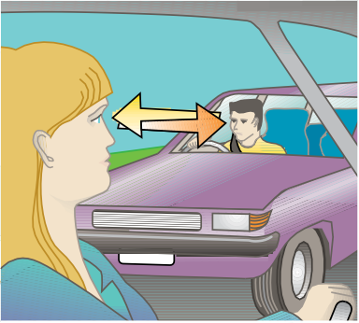
Driver communication is important
Let others know what you are doing by indicating well in advance.
Eye contact between drivers is important. It can allow you to anticipate and avoid mistakes by other drivers or pedestrians.
Tune into the messages that other drivers are giving you. Look and listen and be prepared to react as required to another driver’s communications.

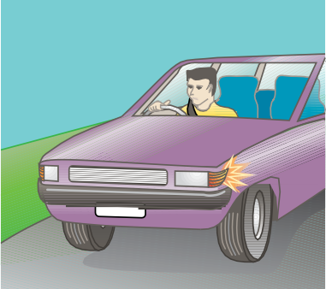

Signalling
When you signal your intention to change lanes or turn, you are giving other drivers advanced warning of your intended movements.

You are required by law to give ample warning when signalling your intentions to turn into or from an intersection or driveway. Usually five seconds prior to changing direction would be sufficient warning.
You MUST also give adequate indication BEFORE YOU START to diverge or change lanes. You MUST give a minimum five seconds indication before pulling out from the kerb.

Note: Make sure that your indicators are cancelled after you have completed the manoeuvre.

Horn use


Only use your horn or warning device to warn other road users of danger.

Lane positioning

If lanes are not marked on the roadway, drivers should drive their vehicles as near to the left-hand side of the road as is practicable.
If lanes are marked, stay within the line markings.
If you are driving on a multi-lane road it is advisable to drive in the left hand lane, leaving other lanes available for overtaking vehicles.
Once in a lane it is best to stay there unless:
    - you wish to overtake a slower moving vehicle, which is in the same lane as
your vehicle; or
- you need to change lanes in order to make a turn.
Drive in the centre of the lane and don’t wander from side to side.

Bus lanes

In the ACT, Bus lanes are for buses but also can be used by:
- Taxis;
- Hire cars;
- Demand responsive vehicles; and
- Motorcycles.
Other vehicles may only drive in bus lanes for a maximum of 100 metres to enter or leave the road.

Keep clear markings

A driver must not stop on an area of a road marked with a keep clear marking.
Keep clear marking means the words “keep clear” marked across all or part of a road, with or without continuous lines marked across all or part of the road.
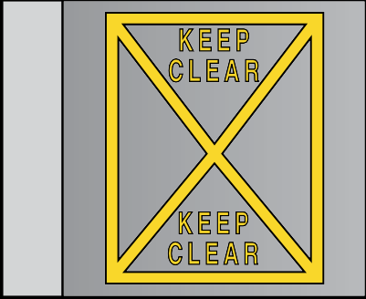
Example 1 - Keep clear marking bounded by line road markings

Example 2 - Keep clear marking without internal line markings

Keeping to the left on a multi-lane road
This rule applies on a multi-lane road where:
  - the speed-limit is over 80 km/h; or
  - a keep left unless overtaking sign applies.
You must not drive in the right lane unless:
  - you are turning right, or making a U– turn from the centre of the road, and are giving a right turn signal;
  - you are overtaking;
  - a left lane must turn left sign or left traffic lane arrows apply to any other lane and you are not turning left;
  - you are required to drive in the right lane;
  - you are avoiding an obstruction;
  - the traffic in the other lanes is congested; or
  - the traffic in every lane is congested.
A keep left unless overtaking sign on a multi-lane road applies to the length of road beginning at the sign and ending at the nearest of the following:
- 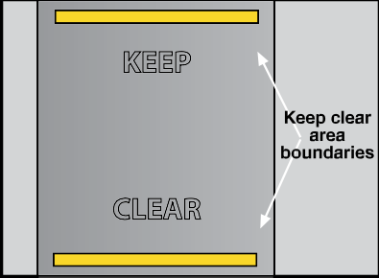an end keep left unless overtaking sign on the road;
KEEP
CLEAR
- a traffic sign or road marking on the road indicating that it is no longer a multi-lane road;
- if the road ends at a T–intersection or dead end — the end of the road.

Keep left unless overtaking sign

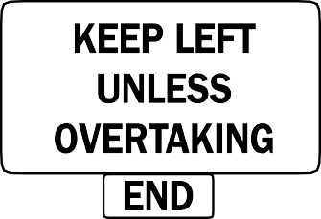
End keep left unless overtaking sign
If there are three or more available lanes, use the left lane. Move with care to the centre lanes if you need to pass slower vehicles. Move back to the left lane once it is again clear. The right lane is normally reserved for overtaking and you must move out of it as soon as it is safe to do so.

Lane changing

If you don’t need to change lanes, DON’T.
Changing lanes can be dangerous if you do not follow safe, set guidelines.
The basic steps to a safe lane change are:
  - check your rear vision mirrors for closely following, fast approaching or overtaking traffic;
  - use your indicators to advise other road users of your intentions (this MUST be done BEFORE you turn your steering wheel);
  - now do a quick head check over your shoulder to make sure that no other motorist is in the lane where you wish to go - if there is, cancel your indicator and be prepared to drive straight ahead until that lane is clear to move into. Adjust your speed slightly up or down, to improve your opportunity of finding a safe gap.
Now and only now is it safe for you to turn your steering wheel to steer into that lane.
Overtaking
Overtake only when you have a clear view of the road ahead, and you can do so safely.
When overtaking, remember to allow for the speed of the vehicle you are overtaking, and also the speed of
oncoming traffic. Remember, two vehicles travelling in opposite directions at 80 km/h are approaching each other at a combined speed of 160 km/h, or 45 metres per second.
It is an offence to exceed the speed limit when you are overtaking.
Before overtaking:
- look in the rear vision mirror and check that you are not about to be overtaken yourself;
- don’t be too close to the vehicle in front. Give yourself enough room to manoeuvre by leaving a three second gap;
- signal your intention, complete a head check, then pull out smoothly and accelerate past;
- do not cut in too soon. Look in the rear vision mirror and when you can clearly see the front of the overtaken vehicle; indicate that you are moving back to the same lane; do a head check to make sure that it is safe for you to move;
- steer back into your original lane.
If you are driving a vehicle that is being overtaken, show consideration by moving as far to the left as practicable. Do NOT increase speed - it is dangerous and against the law.
Leave enough room between your vehicle and the one in front of you so other drivers do not have to overtake two vehicles at once.
It is unwise to pull out blindly and follow another vehicle which is overtaking a line of vehicles further ahead. Its driver may be a poor judge of distances or speed, or there may be no space for you to pull back into.

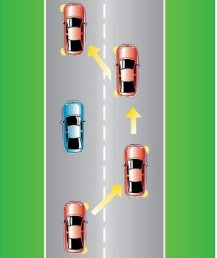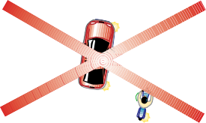

OVERTAKING
Overtaking refers to two vehicles travelling in the same direction.
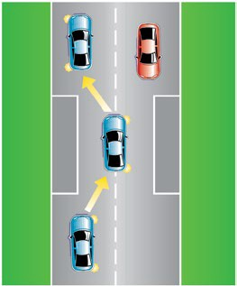
PASSING
Passing refers to two vehicles approaching each other from opposite directions.
Neither vehicle should be attempting to overtake in this situation
Never overtake in these situations:
- approaching the crest of a hill or a curve if you do not have a clear view for at least 150 metres;
- where there are double unbroken lines or an unbroken line on your side of the centre line (unless allowing the required minimum distance to pass a cyclist when it is safe to do so);
- there is insufficient room, or you are unsure what is ahead;
- approaching a pedestrian or school crossing;
- where there is an intersection or the road narrows (eg at a bridge);
- where you would have to exceed the speed limit.
Remember to glance over your shoulder before you move out and signal for a reasonable time.

You must give way to traffic already in the stream you are moving into.
Vehicles should normally be overtaken in the right lane. However, in certain circumstances you may pass a vehicle on the left hand side.
For example:
  - on multi-lane roads you may pass to the left of a vehicle which is in
another lane proceeding in the same direction;
  - on single lane roads, you may pass a vehicle on the left hand side if the driver of the vehicle has signalled an intention to make a right hand turn and has moved across to the centre of the road to allow other drivers sufficient room to pass on the left.

Passing or overtaking a vehicle displaying a ‘Do Not Overtake Turning Vehicle’ sign
Long vehicles can take up more than one lane when they are turning. You must not overtake any vehicle displaying a do not overtake turning vehicle sign that
is turning and giving the relevant turn signal, unless it is safe to do so.

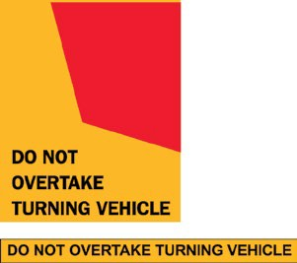
These signs are displayed on certain long vehicles.
Coasting, freewheeling and clutch control
NEVER coast or freewheel your vehicle with the clutch depressed or the gear lever in neutral.
Driving in gear helps your car to remain stable and keep a good grip on the road surface. When travelling downhill your engine can act as a brake if you drive in gear.
If you drive without the engine in gear you lose stability and control of your car’s speed, particularly while cornering. You may lose control and run off the road or roll over.
It is an offence to drive a vehicle unless you have proper control of it. If you drive with the clutch depressed for any distance (other than the last 2 or 3 metres when coming to a stop) you do not have proper control of your vehicle.

Braking and stopping
Stopping distance will depend on how quickly you react to danger and the speed at which you are travelling.
The average reaction time (from the time drivers see danger to when the brakes are applied) is two seconds.

Note: As your speed doubles, your stopping distance more than doubles.
At 60 km/h a vehicle will travel 34 metres while the driver is reacting to the danger, and another 21 metres before the car comes to a stop. Total stopping distance is 55 metres.
Stopping distances shown are for vehicles with good brakes, on a good dry smooth road surface, and fitted with good tyres with the required tread depth.

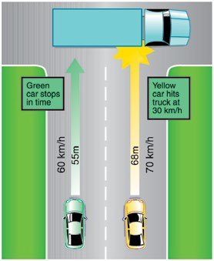
Two cars travelling at different speeds have different stopping distances.
The yellow car is only going 10 km/h faster than the green car. The blue truck suddenly pulls out and blocks the intersection 60 metres away.

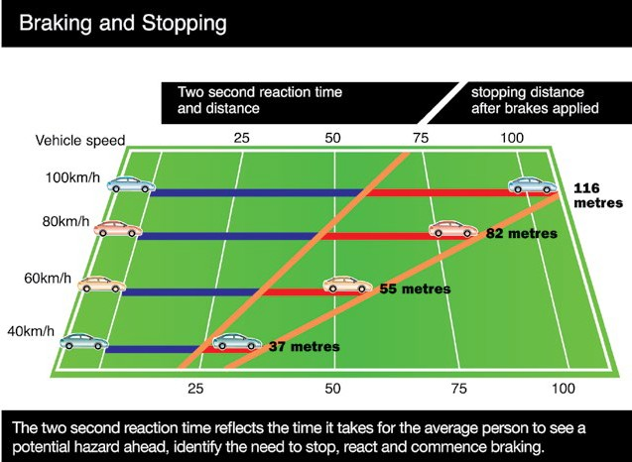

The green car will stop in time - but the yellow car will probably hit the truck at about 30 km/h.

Reaction Time
How fast can you react to a hazard in front of you? It takes a very alert driver at least one second to react to an emergency.
Unless you are giving your complete attention, it will take a lot longer. Reaction time is the distance travelled by a vehicle while a driver sees the need to use the brake and actually starts to physically apply the brake.
Travelling at 60km/h, you will cover about 17 metres per second. If you double your speed, you double the distance you will travel during your reaction time.
Total stopping distance = reaction time + Braking distance.

ABS - Anti-lock Braking System
Anti Lock Braking Systems (ABS) are designed to assist the average motorist in an emergency braking situation. ABS stops the wheels locking during heavy or emergency braking. This permits
the driver to steer the vehicle whilst maintaining maximum braking.

Advantages of ABS:
  - steering is maintained during maximum braking; and
  - stability is maintained when braking on varying surfaces, eg. two wheels on roadway and two wheels on the dirt shoulder of the roadway.

ABS will not:
  - shorten the braking distance of a vehicle; in fact in some situations (gravel roads) it may increase the
braking distance; or
- stop the brakes from fading during heavy or prolonged use, eg driving down a long hill and ‘riding’ the brakes most of the way.

Reversing

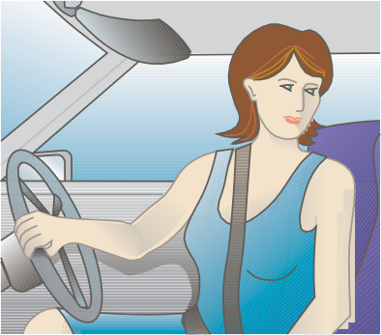
Reversing
Before attempting to reverse, check your inside rear vision mirror, then your left and right hand external mirrors. Only if your way is clear, should you reverse your vehicle.
If you are not certain that the way is clear because of blind spots, get someone else to guide you, or get out and check yourself.
Look over your left shoulder through the rear window when reversing.
Children are often the victims of tragic accidents when run over by reversing cars.
Do’s and don’ts:
- never reverse from a minor road into a major road;
- never reverse for a greater distance than is necessary;
- always try to enter and leave any road in a forward direction.

Major ACT arterial roads

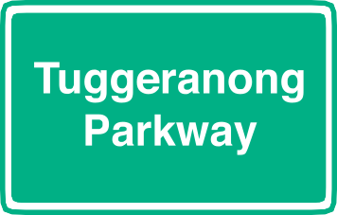
There are no freeways in the ACT and therefore no prohibited users. However, some of the signs and basic rules of freeways are useful for when you drive interstate or use ACT arterial roads such as the Tuggeranong Parkway.
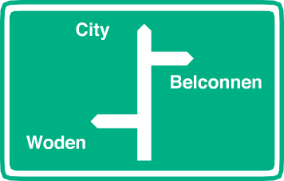

When driving on interstate freeways or major ACT roads such as the Tuggeranong Parkway:
  - do not stop, except in an emergency or in case of a breakdown. If you must stop, use only the emergency lane provided;
  - do not travel in the emergency lanes unless you are stopping;
  - do not make U turns;
  - do not reverse;
  - signal well before changing lanes to compensate for the higher speed of travel;
- be ready and in the correct lane when approaching your exit ramp (if you miss your exit you cannot turn back – continue ahead to the next exit);
- observe lane markings and do not change lanes suddenly or without warning;
- use all lane changing procedures BEFORE attempting to overtake. Make sure you are not being overtaken yourself. If you are, allow the vehicle to pass completely before starting your overtaking manoeuvre. Be sure to signal your intention;
- keep left at all times unless overtaking.

Using the entry ramp/lane
When entering a major road from an entry ramp/lane, accelerate to near the speed limit for the road you are entering. Indicate for its whole length (dependent on road and traffic conditions). Use your mirrors and do a head-check. Look for an appropriate gap to enter, and move onto the major road smoothly. Be prepared to give way to vehicles on the major road
if there are no suitable gaps in the traffic flow.



You MUST give way to any vehicles already travelling on any major arterial road.

When leaving a major arterial road the exit lane will usually be on the left.

Watch for signs warning you that you are approaching an exit ramp.
Move into the left lane in good time, give a left turn signal, and prepare to reduce speed to the ramp advisory speed sign, if displayed. Additional care should be taken in heavy traffic, inclement weather or poor road conditions.
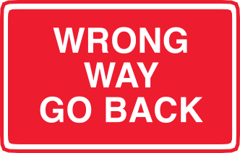
A “Wrong Way - Go Back” sign facing you as you attempt to enter an exit ramp means you are going the wrong way.
If this happens to you:
- pull to the side of the ramp and reverse slowly back the way you came;
- use hazard warning lights to make other drivers aware of possible danger;
- do not attempt to do a U-turn or 3-point-turn while on the ramp.

Driving under difficult  conditions  Night driving  Head and tail lights (not just parking lights) MUST be switched on when you are driving between sunset and sunrise.  The use of lights at other times, such as during the day, or in fog, makes it easier for other drivers to see you.  By law, your vehicle must be fitted with at least two red reflectors (one on either side) at the rear. Red reflectors must not  be fitted to the front of a vehicle; however white ones are permitted on the front.  Points for night driving:  - You can use high beam on any road or street, however, when using high beam you must dip your lights for oncoming vehicles as soon as possible and at least 200 metres away. |  |  | - blinding another driver with your  lights on high beam is both dangerous and illegal;  - when approaching oncoming vehicles, avoid looking directly into their headlights. If the oncoming vehicles headlights remain on high beam, look to the left hand edge of the roadway to avoid the glare. If dazzled, slow down or pull over until your eyes recover;  - always dip your lights when following closer than 200 metres to another vehicle;  - watch out for pedestrians or cyclists;  - watch the road for animals which may be dazzled by your lights - if an animal is dazzled, brake carefully and  sound your horn - if you are unable to stop safely, steer around the animal;  - keep your speed down, and give yourself time to react. You should be able to stop within the distance that you can see with the headlights. On rural and/or unlit roads be prepared for the unexpected.
This driver is driving too fast


Fog lights
Some vehicles are fitted with fog lights. Front fog lights have a unique flat and wide beam pattern with an effective range of up to 50 metres. Rear fog lights are red and have 20 times the luminous intensity of your standard tail lights. Fog lights should only be used when visibility is poor so, if your vehicle is equipped with fog lights, know when to use them.
Front fog lights - must only be used for driving when fog, rain, snow or other hazardous conditions reduce visibility. You will see better in fog if you dip your lights. Do not use high beam as the light will reflect back at you. In severe conditions, it can be beneficial to drive with only the parking and fog lights switched on, further reducing headlight glare.
Rear fog lights (red) - must only be used for driving when fog, rain, snow or other hazardous conditions reduce visibility. If your vehicle does not have a rear fog light, turn on the flashing hazard warning lights instead. You must switch off your rear fog light or hazard warning lights as driving conditions and visibility improve.

Winter and wet weather driving

Make sure your vehicle is in good condition for cold weather motoring.
Points for winter and wet weather driving:
- check the lights, brakes, tyres, windscreen wipers, steering, radiator and battery regularly;
- anti-freeze in the radiator is recommended for the ACT;
- do NOT drive with dirty or fogged up windows;
- try your brakes cautiously to test your vehicles braking ability if the road is wet or icy;
- keep well back from the vehicle ahead. It takes at least twice the distance to stop when the road is wet or icy;
- apply the brakes gently when stopping, as harsh braking may cause the vehicle to skid;
- always test your brakes after driving through water;
- watch for icy patches on the road, in areas shaded by trees, and on timber bridges or exposed windy stretches.

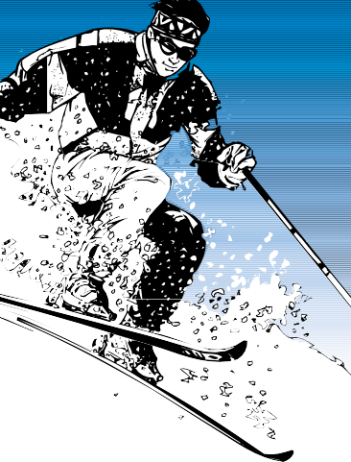
Snowy and icy conditions
Points for snowy and icy driving:
  - even if you do not plan to leave your vehicle, carry adequate warm and protective clothing to ensure
comfort, and survival, in the event of a breakdown or delay;
  - check the tread on all tyres including the spare;
  - use anti-freeze in the radiator;
  - carry a tool kit that includes a jack and wheel brace, a strong tow rope and a shovel;
  - snow chains must be carried in certain areas of the Snowy Mountains, eg Kosciusko National Park;
  - do not put off fitting chains until you have become stuck;
  - find a safe place to fit snow chains to your vehicle. The middle of the road is not a safe place.

Steep hills

Steep descent
Points for steep hills:
- when driving down a steep hill reduce speed and engage a suitable low gear in good time. This applies to both manual and automatic vehicles;
- use the brakes as little as possible.
If you must brake, do so on a straight stretch of road using controlled pressure on the pedal;
- when following another vehicle down hill allow at least three times the following distance you would under normal conditions (ie a six second rule).

Towing
When towing a caravan, trailer or horse float, note the following points:
- a caravan or trailer being towed must be securely attached to the towing vehicle;
- use a safety chain;
- slow down well in advance of corners and accelerate lightly through;
- avoid hard braking through corners;
- be careful when descending hills or overtaking as your vehicle’s braking performance will be reduced;

  - make sure any load in a towed trailer is evenly distributed and secured carefully. Avoidable injuries and deaths have been caused by poorly secured loads;
  - the weight of the trailer and its load may be up to 1.5 times the
unladen weight of the towing vehicle. However, the vehicle or tow bar manufacturer may impose a lower towing limit.

Unsealed roads
When driving on loose surfaces:
  - reduce speed;
  - reduce speed further when approaching another vehicle - loose stones thrown up by a vehicle’s tyres can shatter a windscreen;
  - do not brake or accelerate harshly. Remember, ABS braking may actually increase your braking distance on gravel;
  - do not allow your vehicle to drift out on corners. Loose dirt and gravel builds up on the outside of corners and can cause loss of vehicle traction and steering control;
  - watch for corrugations and potholes in the road;
  - approach all river crossings with caution - they may be deeply rutted.

Emergencies and what
to do

Skids

Skids occur when the force exerted on the tyres by acceleration, braking or cornering overcomes the grip of the tyres on the road. Excessive speed is often a major factor causing skids.
The risk of skidding is also greatly increased when:
- the driver brakes, accelerates or steers harshly;
- the road surface is loose, wet or icy;
- the vehicle’s steering or suspension is worn;
- the brakes grab or pull to one side;
- the tyres are worn, inflated to the wrong pressure, or are mismatched
– eg, a combination of radial and crossply.
To avoid the risk of skidding, you should:
- approach corners cautiously - reduce speed early;
- always brake, accelerate and steer smoothly, when negotiating a corner;
- be aware of your vehicle’s performance and handling characteristics;
- allow for changing road conditions.

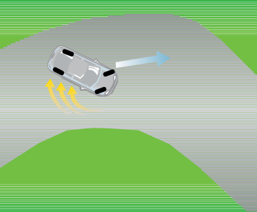
Rear wheel skid
Cause: Excessive braking or deceleration when entering a corner. In rear wheel drive cars, this type of skid can be caused by excessive acceleration when exiting
a corner.
What to do: Ease back on the accelerator (or the brake if braking) and steer in the direction in which the rear of the vehicle is sliding. When the slide is under control, gently steer in the direction you wish the vehicle to travel.

Front wheel skid
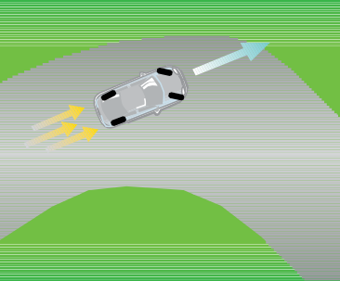
Cause: Excessive speed/excessive braking/ harsh steering when entering a bend or corner. Steering control is lost as the vehicle continues in a straight line instead of following the intended course.
In front wheel drive cars, this skid can also be caused by excessive acceleration while cornering.
What to do:
- if the skid is caused by excessive speed or harsh steering, unwind steering slightly while easing off the accelerator. Brake firmly, but not hard enough to cause the front wheels to lock up;
- when steering control is regained, continue at your reduced speed and steer towards your intended direction;
- if caused by excessive braking, reduce brake pedal pressure sufficiently to allow front wheels to begin rotation again and steering control to be regained.

Four wheel skid
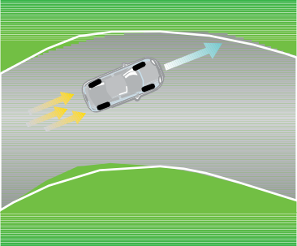
Cause: Excessive braking.
What to do: Release the pressure on the brake pedal but do not remove your foot from the pedal. Then re-apply the brakes so as to not re-lock the wheels.
The best skid is NO skid at all.

Possible head-on collision
If another vehicle is travelling towards you and a head-on collision appears imminent you should:
  - brake firmly without locking the wheels, while flashing your lights and sounding your horn;
  - give the approaching vehicle as much room as possible and look for an escape route if necessary; and
  - prepare for further evasive action which may include pulling off the road away from the path of the oncoming vehicle.

Forced off the road onto gravel
If you have been forced onto the gravel surface at the edge of the road,
  - maintain a firm grip on the wheel while continuing to drive in a straight line; and
  - slow your vehicle speed and check for traffic before re-entering the road again.

Shattered windscreen
Most modern windscreens have laminated safety glass and will crack rather than shatter.
  - some older vehicles may have windscreens that will shatter;
  - if this occurs, slow down by braking smoothly and pull to the side of the road as soon as possible.

Tyre blow-out or rapid puncture
If your vehicle encounters a puncture or rapid tyre deflation you should;
- keep a firm grip on the steering wheel;
- do not oversteer to correct any vehicle swerve or pull;
- take your foot off the accelerator;
- once the vehicle is under control gently apply the brakes;
- slow down and pull over to the side of the road; and
- if your vehicle is fitted with hazard lights, switch them on to warn other motorists.
A front wheel puncture will tend to cause the vehicle to pull in the direction in which the puncture has occurred while a rear wheel puncture will tend to cause the vehicle to swerve from side to side.

Brake failure
If you push the brake pedal down and the vehicle does not stop or slow down, you are experiencing brake failure. If this happens;
- it may help if you pump the brake pedal hard and fast;
- move to a lower gear whether you are driving a manual or automatic vehicle;
- gently apply the handbrake to slow the vehicle being careful not to lock the wheels;
- use your horn and flash your lights to warn other motorists;
- move your vehicle to the side of the road;
- carefully bring the vehicle to a stop using the handbrake; and

  - if your vehicle is fitted with hazard warning lights switch them on to warn other motorists.

Car fire
If you see or smell smoke coming from any part of the vehicle;
  - slow down and stop immediately and turn the engine off;
  - assist all passengers to get out of the vehicle and move well away as petrol may cause an explosion;
  - if a fire extinguisher is available use it to extinguish the flames;
  - disconnect the battery if at all possible or if this is not practicable, rip loose any burning wires with a handy instrument;
- do not touch burning wires or insulation with your bare hands as severe injury could result; and
- call for emergency assistance as soon as possible.

Stuck accelerator
If you release the accelerator pedal to reduce speed and the car continues at the same speed or increases speed, the accelerator is stuck. If this happens;
- depress the clutch in a manual car or select N for Neutral in an automatic vehicle;
- apply firm pressure on the brakes without locking the wheels;
- find a safe place to pull off the road and stop;
- once the vehicle has stopped turn the engine off;
- move your vehicle to the side of the road;
- carefully bring the vehicle to a stop using the handbrake; and
- if your vehicle is fitted with hazard warning lights switch them on to warn other motorists.

Breakdowns and accidents
When a breakdown or accident occurs:
- try to move your vehicle off the road;
- activate vehicle hazard warning lights to alert approaching traffic of potential danger. It is a good idea to carry a
red light or a triangle of red reflective material. In an emergency place the warning sign on the road at least 50 metres before the obstruction on the same side of the road;
- if you are attending a crash scene or a broken down vehicle at night or in fog etc, NEVER obscure the tail-lights;
- in case of a crash, switch off the ignition of crashed vehicles to reduce the risk of fire.

Interfering with the driver’s control of the vehicle
A passenger must not:
- interfere with the driver’s control of the vehicle; or
- obstruct the driver’s view of the road or traffic.

Towing and being towed
Before towing another vehicle or being towed you should note the following points:
  - your tow rope or solid towing bar should be long enough to keep a safe space between the two vehicles. The maximum allowable distance between vehicles is 3.5 metres;
  - a white flag or cloth must be displayed on the tow rope (at night the flag must be illuminated by a white light and the rear of the towed vehicle must carry a red light);
  - the tow rope or other flexible link between the vehicles needs to be kept taut. Slight pressure on the brake pedal can be used to achieve this;
  - a licensed driver must be in charge of the towed vehicle;
  - when stopping or slowing down the towed vehicle should brake first;
  - if moving at low speed or creating a traffic obstruction, warn other road users by switching on the hazard lights;
  - if the vehicle’s engine will not run, power assistance will not be available for steering or brakes and considerable additional effort and pressure will be needed to operate both systems.

What to do after a crash

If you are involved in a crash causing injury or death to any person, or damage to any property or vehicle, the law requires you to stop your vehicle.
If your vehicle is obstructing traffic after a crash, move it to the side of the road, if possible. The law does not require the vehicle to be left where it stopped after a collision.
The law requires you to give your name and address, the vehicle owner’s name and address, and the vehicle’s registration number to any other driver or injured person involved in the crash and the owner of any property or vehicle damaged in the crash.
If any other person is killed or injured or a vehicle involved in the crash is towed away, the driver must provide his or her particulars to a police officer as soon as possible but within 24 hours after the crash.
The police need not be called to attend a crash if damage to vehicles or property is only minor. However, you must report all vehicle crashes to the police as
soon as possible. Except in exceptional circumstances, this means within 24 hours after the crash.

PART E - Vulnerable road users and sharing the road

Vulnerable Road Users
  - Inattentional Blindness
  - Share the road

- Pedestrians, cyclists, motorcyclists
  - Pedestrians and drivers
  - Cyclists and drivers
  - Parking and cyclists
  - Coloured Bicycle Lanes

- Road Rules for Cyclists
  - Bicycle helmets
  - Helmet standards
  - Equipment on a bicycle
  - Riding at night
  - Optional hook turn
  - Giving way on a roundabout
  - Cycle Paths
  - Carrying pillion passengers on motorbikes

- Motorcyclists and drivers
- Horse traffic and drivers
- Sharing the road with trucks and buses
  - Looking out for heavy vehicles
  - Oversize vehicles
  - Looking out for turning heavy vehicles
  - Sharing the road with dangerous loads
  - Sharing the road with local services buses
  - Bus priority traffic signals
  - Giving way to buses
  - Transit lanes

- Emergency vehicles
94

PART E - Vulnerable road users and sharing the road

Vulnerable road users
On the road, our most vulnerable people are pedestrians, cyclists and motorcyclists. These road users are vulnerable because they do not benefit from the level of crash protection which is provided by other vehicles.
Protecting and supporting vulnerable road users is a benefit to everyone in Canberra regardless of which transport mode they regularly use. Action in this area will help reduce the number of road deaths and injuries as there will be fewer cars on the road. Increasing the number of people who walk and cycle will also contribute to
improved environmental and public health outcomes.

Inattentional blindness
Inattentional blindness is an event where the affected person doesn’t see new and unexpected things that appear within their visual field. What this means for road safety is that many drivers are only registering other cars, and not pedestrians, cyclists and motorcyclists. Road collisions in which a driver fails to see another road user that is clearly in view are common and are referred to as “looked-but-failed- to-see” collisions. When driving a car,
you should always drive responsibly and recognise the potential harm you could cause to vulnerable road user.

Share the road
The ‘Share the Road’ initiative is about promoting positive attitudes towards vulnerable road users and educating drivers about how to drive safety in mixed mode environments.
The ‘Share the Road’ initiative focuses on:
- different road users travelling on roads or footpaths at opposing speeds;
- courteous and respectful behaviour between road users to assist in the flow of traffic and to keep our roads safe;
- giving way to police and emergency services vehicles when they approach with lights and sirens on; and
- reducing the rate of injury and fatalities on ACT roads.
Promoting a safe, respectful and harmonious relationship between road users is crucial to reducing the number of collisions on ACT roads. Regardless of how you use the road, road safety is everyone’s responsibility.

Pedestrians, cyclists, motorcyclists and horse traffic

Pedestrians and drivers
Watch for pedestrians:
  - near shared zones, town centres, group centres and aged care facilities; near schools, particularly when children are arriving or leaving;
  - at places where children walk or play;
  - where there are parked cars or stopped buses;
  - when approaching school zones; and
  - near bus stops and pedestrian crossings.

Do not overtake another vehicle at a pedestrian or school crossing. That
driver may be stopped or stopping for a pedestrian you cannot see.

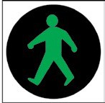
At traffic lights turning vehicles must give way to crossing pedestrians. See page 41.



You must give way to pedestrians when you are leaving private property such as driveways, or car parks, shopping centres and service stations.
If you cannot see whether anyone is coming, sound your horn and then drive out very slowly.
If you are a pedestrian walking along a road that does not have a footpath or nature strip, you should walk on the right hand edge of the road facing oncoming traffic.

Personal mobility device users in the ACT
In the ACT a personal mobility device (e.g. a segway or segway-type device) is a device that:
- is designed to be self-balancing while a person travels on it;
- is propelled by an electric motor;

  - has 2 wheels that operate on a single axis;
  - has a platform anywhere between the 2 wheels for the person to stand on; and
  - has handles mounted on an upright post.
The user of the device is treated, generally, as a pedestrian with some additional requirements including:
  - wearing an approved bicycle helmet that is securely fitted;
  - having a working warning device such as a bell or horn;
  - using lights and reflectors when travelling at night or in hazardous weather conditions where visibility is reduced;
  - keeping left on a footpath or shared path unless impracticable to do so; and
  - giving way to other pedestrians on footpaths and shared paths.
Treating the user of the device as a pedestrian allows personal mobility devices to be used on footpaths, shared paths and nature strips. On-road use is not allowed unless there is no footpath, shared path or nature strip or it is impracticable to travel on the footpath, shared path or nature strip.
Motorists must give way to personal mobility device users travelling across signalised marked foot crossings, children’s crossings and pedestrian crossings. The device user must slow to 10 km/h on the approach to the crossing and check for any approaching traffic and be prepared to
stop. This will allow motorists to see and respond to the personal mobility device user before they make the crossing.
Personal mobility device users are encouraged to abide by the manufacturers’ recommendations as to the age and size of a user.

Pedestrians in Shared Zones
Shared Zones are pedestrian friendly areas in which motorists must give way to pedestrians. Shared zones are signposted but will often have a different look and feel to a normal road environment.
Some features of shared zones in the ACT include:
- a slow speed zone of typically 10 or 20 kilometres per hour;
- raised entry thresholds at each end of the street to show a changed traffic environment;
- additional kerb ramps to improve access for people with mobility impairment as well as pedestrians and cyclists;
- no formal pedestrian crossings;
- street art, landscaping and feature lighting; and
- road pavement raised to footpath level at intersections.
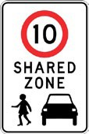

Although the roadway is shared, it is the responsibility of motorists and cyclists to give way to pedestrians. In this context ‘giving way’ means slowing down or coming to a stop to avoid a collision.
All road users need to be mindful of one another.

Cyclists and drivers
Motorists must take care and show consideration when sharing the roads with cyclists, who have the same legal rights and obligations as other road users.
Although Canberra has cycle paths, it is not compulsory for cyclists to use them. Some people prefer to use the roads when riding a bicycle as they often provide a more direct route, a well maintained and even surface, have less curves and fewer interactions with pedestrians than paths. When riding on roads with a marked bicycle lane, cyclists must ride in that lane unless it’s not practical to do so (e.g. a car is parked in the lane or there is debris or other hazards).
All road users must share the responsibility for road safety. However, when driving a car, you need to remember that cyclists have less protection than motorists and are more likely to be injured or killed if a crash happens.

Overtaking a cyclist

Minimum overtaking distance
On the road, cyclists are particularly vulnerable because they are smaller and have less crash protection than motorists. The minimum overtaking rule defines the safe lateral space when overtaking cyclists and will assist in addressing the number of rear end and side swipe crashes involving cyclists.

The rule in a snapshot
- When driving a car you must provide a minimum lateral distance of 1 metre when overtaking a cyclist in speed zones at or below 60km/h and 1.5 metres in speed zones above 60km/h.
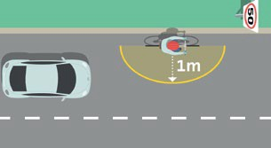
- The distance is measured from the right most part of the bicycle or rider to the left most part of the motor vehicle (or anything projecting at a height that could strike the bicycle or trailer eg. mirror).
- To enable drivers to provide the minimum overtaking distances on narrow roads or roads with narrow lanes, motorists are allowed to cross centre lines, straddle lane-lines and drive on painted islands, provided the driver has a clear view of any approaching traffic and that it is safe to do so.

  - If it is not safe to pass, drivers must wait behind the cyclist until road conditions change.
  - 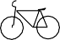Drivers who fail to comply with the rule may be issued an infringement notice and accrue demerit points.
Motorists should exercise care when:
  - opening the vehicle door, check your rear vision mirror and look over your shoulder for cyclists and other motor vehicles;
  - driving near bicycle lanes, if a cyclist is adjacent within a bicycle lane motorists must give way;
  - approaching a pedestrian crossing – a motorist must give way to cyclists who ride or walk across a pedestrian crossing;
  - overtaking cyclists - leave 1 metre in speed zones below 60km/h and 1.5 metres in speed zones above 60km/h in case they need to avoid a rough surface or obstacle on the road;
  - overtaking other vehicles - watch for any oncoming cyclists. Wait until they have passed before you overtake;
  - negotiating intersections at the same time as cyclists - slow down and allow cyclists to negotiate intersections in safety;

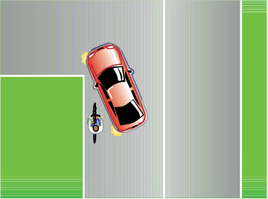
This driver is not sharing the road. The driver should have identified the cyclist and waited for them to pass before turning left.
- driving at night - look for reflectors on bicycle wheels or pedals, not just headlights or tail-lights. It is illegal to ride a bicycle at night without lights but it does happen, so a reflector may be the first thing you will see;
- children are riding - watch out for children on bicycles because they are not always aware of the road rules and their riding is sometimes erratic;
- traffic is stationary- cyclists can proceed on the left hand side of a stationary vehicle.

Parking and cyclists
Check your rear vision mirror and look over your shoulder for cyclists and other motor vehicles before opening the vehicle door. Remember, cyclists generally travel close to the left hand side of the road.
Where a cycle path crosses a street, the crossing is marked by signs. Cyclists are required to give way to all traffic on the roadway and cross only when it is safe to do so.

Bicycle lanes
Bicycle lanes are reserved for the use of bicycle riders only. Bicycle lane markings, including the coloured bicycle lanes at intersections highlight the existence of the ‘bicycle lane’ to motorists and the ‘right
of way’ legally provided to the cyclist. Therefore, where a motorist sees a bicycle lane, he or she must be on the lookout for cyclists as always. If a cyclist is on a bicycle lane the motorist must give way.
While the bicycle lane alerts motorists to cyclist’s ‘right of way’, the bicycle rider also needs to be vigilant, as these areas pose
a much higher risk of collision. The fact that the bicycle lane gives a cyclist ‘right of way’ does not necessarily mean that it will be granted. Cyclists are often difficult to see in adverse conditions and are extremely vulnerable, so as a cyclist, it is far better to be prepared to give way than to have a collision.
A driver of a vehicle and rider of a motorbike may only drive in a bicycle lane for up to 50 metres:
  - to enter or leave the road;
  - to overtake a vehicle that is turning right or making a U turn; and
  - to avoid an obstruction.
  - see page 32.

Road rules for cyclists

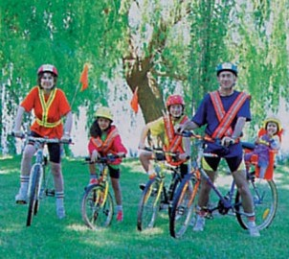
The following road rules for cyclists have been accepted nationally and are a combination of the previous ACT regulations and the Australian Road Rules.

Riding in a bicycle lane on a road
The rider of a bicycle riding on a length of road with a bicycle lane designed for
bicycles travelling in the same direction as the vehicle traffic must ride in the bicycle lane unless it is impracticable to do so.

No overtaking to the left of a turning vehicle
The rider of a bicycle must not ride past or overtake to the left of a vehicle that is turning left and is giving a left change of direction signal.

Cyclists riding across a road on a crossing
In the ACT as part of a two year trial that commenced on 1 November 2015, a rider of a bicycle may ride slowly (no more than 10km/h) across signalised
marked foot crossings, children’s crossings and pedestrian crossings. The rider must slow to 10 km/h on the approach to the crossing and check for any approaching

traffic and be prepared to stop. This will allow motorists to see and respond to the rider before they make the crossing.
A rider of a bicycle must keep to the left of the crossing and give way to any
pedestrian on the crossing. A rider may be issued with a traffic infringement notice for failing to comply with these road rules.

Riding two abreast
Cyclists are permitted to ride two abreast.
Three or more riders riding abreast is not permitted. However, a cyclist can
overtake two other riders cycling abreast. On certain roads riding two abreast may not be the safest option. Commonsense dictates that factors which should be considered include the prevailing road, weather and traffic conditions.
Cyclists - when riding two abreast it is courtesy to move into single file to allow other vehicles to pass.
Motorists - when approaching cyclists who are riding two abreast, slow down if necessary and wait until it is safe to overtake.

Riding on a footpath or shared path
The rider of a bicycle riding on a footpath or shared path must:
    - keep to the left of the footpath or shared path unless it is impracticable to do so; and
    - give way to any pedestrian on the footpath or shared path.

Bicycle riders not to cause a traffic hazard
The rider of a bicycle must not cause a traffic hazard by moving into the path of a driver or pedestrian.

Riding too close to the rear of a motor vehicle
The rider of a bicycle must not ride within 2 metres of the rear of a moving motor vehicle continuously for more than 200 metres.
The rider of a bicycle must wear an approved bicycle helmet securely fitted and fastened on the rider’s head, unless the rider is exempt from wearing a bicycle helmet under another law of this jurisdiction.

Bicycle Helmets
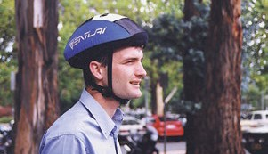
Helmet Standards
Protective bicycle helmets must meet Australian Standards and must display either an AS 2063:1996 or a label confirming it is approved and certified to Snell Standard 1995.

Equipment on a bicycle
A person must not ride a bicycle that does not have:
- at least 1 effective brake; and
- a bell, horn, or similar warning device, in working order.

Riding at night
At night and in reduced visibility conditions you must display:
- a flashing or steady white light that is clearly visible for at least 200 metres from the front of the bicycle; and

  - a flashing or steady red light that is clearly visible for at least 200 metres from the rear of the bicycle; and
  - a red reflector that is clearly visible for at least 50 metres from the rear of the bicycle when a low-beam vehicle headlight shines on it.

Optional hook turn by a bicycle rider
To make a hook turn:
  - approach and enter the intersection from as near as practicable to the far left side of the road that you are leaving;
  - move forward:
- keeping as near as possible to the far left side of the intersection;
- keeping clear of any marked foot crossing; and
- keeping clear, as far as practicable, of any driver turning left from the left of the intersection;
until you are as near as practicable to the far side of the road that you are entering.
  - if there are traffic lights at the intersection, remain at the position reached under step 2, until the traffic lights on the road that you are entering change to green.
  - if there are no traffic lights at the intersection, remain at the position reached under step 2, until you have given way to approaching drivers on the road that you are leaving.
  - turn right into the road that you are entering.

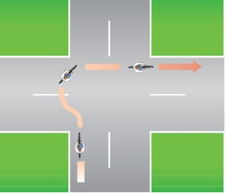
Bicycle rider making a hook turn at an intersection without traffic lights

Giving way by the rider of a bicycle or animal to a vehicle leaving a roundabout
If you are riding in the far left marked lane of a roundabout with 2 or more marked lanes, or the far left line of traffic in a roundabout with 2 or more lines of traffic, you must give way to any vehicle leaving the roundabout.

Cycle Paths
The use of bicycle paths is generally restricted to non-motorised traffic, including bicycles, pedestrians, joggers and motorised wheelchairs.
- Keep to the left of any white centre line that may be on the path.
- Bicycles do NOT have the sole right to use cycle paths. You must give way to any pedestrians.
- If approaching pedestrians from behind, ring your bell to let them know you are coming, slow down as you pass and give them right of way.

Motorcyclists and drivers

Motorcycle riders are over represented in fatal crashes in the ACT.
Drivers should be aware that motorcyclists often position their bikes on the right tyre track of the vehicle ahead because the rider:
  - avoids the oil slick formed in the centre of the lane;
  - can see oncoming vehicles better;
  - knows oncoming drivers can see the rider better;
  - can use the full lane he/she is entitled to, discouraging motorists from crowding into the lane; and
  - knows the driver ahead can probably see the motorcycle in the rear vision mirror.

Motorcycle Lane Filtering

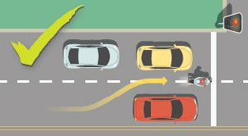
Motorcycle lane filtering is when a motorcyclist moves past stationary or slow moving vehicles in the same lane. It is allowed in NSW, QLD and now in the ACT.
Lane filtering is:
- only allowed when safe to do so;
- not allowed at a speed greater than 30km/h;
- only allowed by fully licensed motorcyclists (i.e. motorcyclists on L or P plates are not allowed to lane filter as they are less experienced);
- not allowed on kerbside next to a footpath or in bicycle lanes or breakdown lanes;
- not allowed in any 40km/hr zone;
- not allowed past heavy vehicles and buses.
Lane filtering is different to the practice known as “lane splitting”, where a motorcycle rider moves past vehicles in the same lane at a higher speed. Lane splitting is illegal.

Carrying pillion passengers on motorcycles
The rider of a motorcycle must not ride with a passenger under 8 years old unless the passenger is in a sidecar.

Head checks
Motorcycles have ‘blind spots’ just as cars do. A blind spot is the area next to you that you are unable to see in your mirrors. When you are about to change your position on the road (e.g. make a turn, exit a roundabout, move off or change lanes), make sure you turn your head and look over your shoulder to see if it is clear. This is called a ‘head check’ and is the only sure way to see objects that are in your blind spot.

Motorcycles in bicycle lanes
Motorcycle riders are not allowed to use a bicycle lane, except for 50 metres when entering or leaving a road or to avoid an obstruction.

Sharing the road with motorcycles
  - Always be on the lookout for motorcycles as they are smaller than cars and harder to see.
  - Do not drive alongside and in the same lane as a motorcycle.
Motorcycles need a full width lane to ride safely.
  - Allow motorcycles as much space as a car when overtaking them.
  - Regularly check your side and rear vision mirrors and the blind spot by looking over your shoulder before merging or changing lanes. Motorcycles can be easily hidden behind a truck or car.
  - Drive at a safe distance from motorcycles as they may need to avoid hazards such as flying debris, oil slicks and poor road conditions.
  - Allow extra time for them to stop.
  - Look for motorcycles before you turn or proceed at intersections.
  - Look out for motorcycles in slow moving traffic as they can manoeuvre faster and could be lane filtering.

Note: Pre-Learner Licence and Pre- provisional motorcycle rider training courses are compulsory. They are designed to help novice riders master the basic skills of riding. For further information contact Access Canberra on 13 22 81 or attend any Access Canberra Service Centre.
Horse traffic and drivers

Canberra has a high rate of horse ownership. Horses are easily startled by:
- noise – do not speed, sound your horn, use airbrakes or call out. In particular, motorcycle noise frightens horses;
- crowding – drive slowly, give horses plenty of room and be prepared to stop if necessary.

Sharing the road with large vehicles

Looking out for heavy vehicles
Trucks and buses play an important role carrying goods and passengers; they are an essential part of our everyday lives. Most heavy vehicle drivers are professionals and will treat other road users with care and courtesy. In turn, you must treat heavy vehicle drivers with respect. Large trucks and buses often weigh 20 times as much as an ordinary car. They take much longer to stop and cannot manoeuvre as easily as cars. If you crash into a heavy vehicle or bus, you may not survive.

Oversize vehicles
Looking out for turning heavy vehicles

Long vehicles displaying a DO NOT OVERTAKE TURNING VEHICLE sign
may use more than one lane when turning left or right.

If you see this sign, the vehicle ahead is wider than normal, longer than normal, or both.
Sometimes an oversize vehicle may be accompanied by the Police or a pilot vehicle (escort vehicle with flashing lights) to warn traffic that the load following is very wide or very long. You should follow any directions given by the Police or the pilot vehicle.
When approaching an oncoming oversize vehicle, you should reduce speed and be prepared to move to the left side of the road. You must be careful and keep left
of the centre line if the vehicle is coming toward you. You should use extreme care when overtaking an oversize vehicle.

Heavy vehicle using two lanes
When a long vehicle with a DO NOT OVERTAKE TURNING VEHICLE sign
is turning, you must not pass on the left or the right of the vehicle. You need to be careful when any large, long vehicles are turning. If you put your vehicle between the turning vehicle and the kerb you may be crushed.

Do not put your car between the kerb and the large vehicle
Large trucks and buses use more road space and take longer to negotiate roundabouts. You should stop and allow these vehicles easy passage through roundabouts and intersections.

Dangerous loads
Many trucks carry loads which are dangerous and which can catch fire, or which may be explosive, corrosive or radioactive. If one of these trucks is
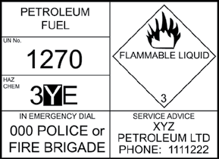
involved in a crash, many lives can be put at risk. There are Emergency Information Panels on the back and each side of these vehicles with information about what they are carrying.
An Emergency Procedures Guide should be in a holder attached to the driver’s door. Follow these procedures if you need to.
If you come across a crash involving a vehicle with a dangerous load, call the Police or Fire Brigade on 000. Try not to touch spilled chemicals or breathe the fumes or dust. Tell bystanders to keep away from the crash.

Buses

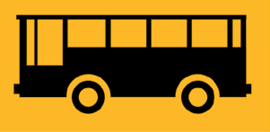
There are four major bus interchanges in the ACT. When driving in the vicinity of bus interchanges and bus stops, remember:
- drivers of private vehicles are not permitted to enter interchange areas;
- to obey all signs relating to the interchanges;
- to watch for bus and pedestrian movement;
- apart from buses, only taxis, hire cars and motorcycles may use bus lanes without restriction. A limit of 100 metres applies to all other vehicles, for purposes such as entering or leaving
a road;

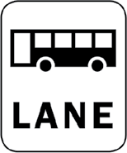
- buses frequently stop to pick up passengers. Watch for pedestrians, especially children and the elderly, in the vicinity of bus stops;
- be prepared to give way to buses pulling out from the kerb;

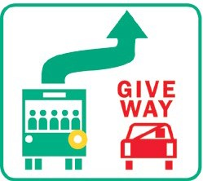
  - when travelling behind buses on suburban streets, to be prepared for them to stop frequently;
  - to take care when overtaking buses because of their extra length;

Bus priority traffic signals
These lights operate at selected intersections to permit buses to move off while other traffic is held by a red light.
Buses sign and is indicating its intention to pull out from the kerb, you MUST slow down or stop to allow the bus to enter the line of traffic.
The rule does not apply if the road or street is divided into multiple traffic lanes travelling in the same direction and you are not driving in the lane that is furthest to the left.
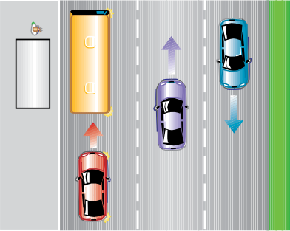

Giving way to buses
When approaching a stationary bus from behind and the bus displays a Give Way to

Red car gives way

Transit lanes
Drivers should be aware that transit lanes are for use by high occupancy and other authorised vehicles during the hours and days displayed on the signs. The lanes may be used by all traffic outside those times.
During the restricted hours, transit lanes can only be used by buses, taxis,
motorcycles and hire cars. Motor vehicles with three or more occupants can travel in a transit lane, if the transit lane sign applying to the transit lane is a transit lane T3 sign.
Motor vehicles with two or more occupants can travel in a T2 transit lane.
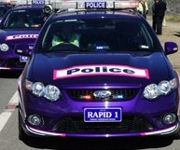
Unauthorised drivers in a Transit Lane may incur a traffic infringement notice.
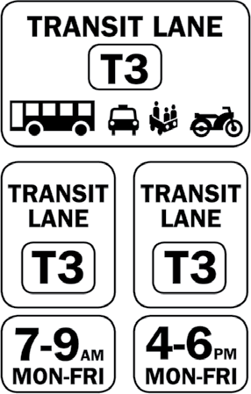
Examples of transit lane signs

Emergency vehicles

Police and other emergency vehicles such as fire engines and ambulances are usually equipped with warning devices such as flashing lights and sirens.
When a police or emergency vehicle approaches sounding a warning or flashing its lights, drivers of other vehicles must clear a passage. This could mean stopping to let it pass or moving out of the way.
You must also give police and emergency vehicles every opportunity to overtake safely. You must slow down to 40km/h when passing a stationary or slow moving emergency vehicle.
These requirements take priority over every other road rule.
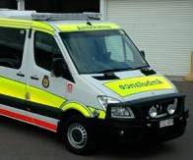

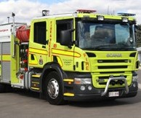

Index

A
ABS - Anti Lock Braking systems 83
Accidents 92
ACT Licence class codes 3
ACT licence classifications 12
ACT demerit points schedule 25
Advisory (Warning) signs 36
Alcohol, other drugs and medication 21
Angle parking 65
Arranging a driving test 9
Arrows and other road turn markings 31

B
Bicycle helmets 101
Bicycle lanes 32, 97
Brake failure 91
Braking and stopping 82
Breakdowns and accidents 92
Buses 105
Bus lanes 77
Bus licences 4
Bus Priority traffic signals 37, 105

C
Car fires 92
Carrying passengers 19
Carrying pillion passengers on motorcycles 103
Centre of road parking 65
Child restraints/harnesses 18
Child restraint rules 18
Coasting/Freewheeling/ Clutch
Control 81
Competency based training and assessment 11
Concrete islands 54
Cornering turning left and right 53, 56
Crossings 60
Cross roads 49
Cycling on a roundabout 53
Cyclists and drivers 97
Cycle paths 100
Cyclists – road rules 99

D
Dangerous loads 105
Demerit points 23, 24
Diagonal bars, painted islands 31
Distractions 27
Driver competencies 10
Driving - alcohol 20
Driving outside the ACT 9
Driving tests 9
Driving under difficult conditions 86
Drugs and driving 20
During a practical driving test 9

E
Effects of alcohol on the body 21
Emergency vehicles 107
Equipment on a bicycle 101
Evidence of change of name 8

F
Failing a breath test 23
Fatigue 25
Fog lights 87
Following distances 73
Forced off road onto gravel 91
Form one lane 30
Freeways 84
Freewheeling/Clutch Control/Coasting 81
Full driver licence (Gold) 12
Further information 15

G
Getting underway 72
Give way to the right 34
Giving way at intersections 42
Giving way to buses 105
Goods vehicles 65

H
Harnesses - child restraints 18
Hazardous loads 105
Heavy vehicles 65, 102
Heavy vehicle licence codes 3
Heavy vehicle licence (Magenta) 13
Helmet standards 101
Hire car licences 4
Hold and turn lines 32
Hook turns for cyclists 101
Horn use 77
Horse traffic and drivers 103
How and where to park 64
How to avoid parking
infringements (PINS) 68
I
Icy conditions 88
Indicating (Signalling) 76, 77
Infant restraints and harnesses 18
Information signs 36
Infringement notices - parking 68, 69
Interfering with the driver’s
control of the vehicle 92
Intersections 41
Intersections - types 48

K
Keeping to the left 78
Keeping a lookout 72
Keeping your distance 73
Keep clear markings 77
Knowledge test 9

L
Lane changing 79
Lane positioning 77
Large vehicles 104
Learner Driver Licences (Green) 5
Left-hand turns 53
Left hand turns using slip lanes 54
Left turn on red 56
Legal alcohol limit 20
Legal penalties for drink driving 20
Letting others know 76
Level crossings 62
Licence classifications 12
Licence class codes 3
Licence eligibility requirements 4
Long vehicle turns 58

Looking out for heavy vehicles 104
‘L’ plates 5

M
Mandatory (Regulatory) signs 35
Medical Information 4
Medication and driving 21
Merging 30
Merging to form a single lane 30
Mixing drugs, alcohol and
medication 21
Mobile Telephones 23
Motorcyclists and drivers 102
Moving off 72

N
Night driving 86
No riding across a road on a crossing 100

O
Opening car doors 72
Overseas applicants 8
Overseas licence holders 8
Oversize vehicles 104
Overtaking 80

P
Painted islands and concrete islands 54
Parallel parking 65
Park ‘n’ Ride/ 3 for FREE parking 66
Parking 63
Parking and cyclists 99
Parking fines 68
Parking signs 67
Parking meters 66
Parking regulations 67
Passing 81
Pedestrian crossings 60
Pedestrians and drivers 96
Pedestrian refuge zones 61
Points demerit scheme 24
Possible head-on collision 91
‘P’ plates 12
Preparing to drive 71
Proof of identity and residency 6
Proof of name change 8
Probationary licences (Blue) 13
Provisional licences (Red) 12
Public vehicle endorsement 4

R
Radar detectors 40
Railway level crossings 62
Random Breath Testing (RBT) 23
Random Drug Testing 23
Red light cameras 39
Refuge zones 61
Regulatory (Mandatory) signs 35
Reversing 83
Riding a bicycle at night 101
Riding in a bicycle lane on a road 100
Right hand turns 56
Risks of alcohol and other drugs 20
Road markings 29
Road Rules for cyclists 99
Road rules test 9
Roundabouts - Approaching,
driving on, leaving, signalling 50, 51

S
Safe following distance 73
Safety helmets for cyclists 101
Safety tips 13
Securing your vehicle 24
School crossings 60
School zones 61
Seat belts and child restraints/
harnesses 17
Shattered windscreen 91
Short stay parking 66
Signalling (Indicating) 77
Signs 35
Skids/skidding 90
Slip lanes 54
Snowy conditions 88
Space cushions - behind,
front, sides 73,75
Speed cameras 39
Speed limits 38
Standard drinks 22
Steep hills 88
Steering 76
Stopping and braking 82
Stuck accelerator 92

T
Tailgating 74
Taxi licences 4
Temporary signs 37
Theory test 9
The Safe System 14
Three point turns 59
Ticket machines 66
T- intersections 48
Towing and being towed 88, 93
Traffic controls 29
Traffic signals 33
Traffic signs 35
Trailers and caravans 89
Transit lanes 107
Turn lines 32
Turning 53, 56
Three second rule 74
Types of intersections 48
Tyre blow out-rapid puncture 91

U
U-Turns and three point turns 58
Unbroken lines 29
Unsealed roads 89

V
Vehicle security 24
Vulnerable road users 95
Vision Zero 14

W
Warning (Advisory) signs 36
Warning signs after taking medication . 21 What is alcohol concentration (BAC) . 22 What to do after a crash 93
Where not to park your vehicle 63
Who is this book for 1
Wet weather driving 87
Winter driving 87
Wombat crossings 60

